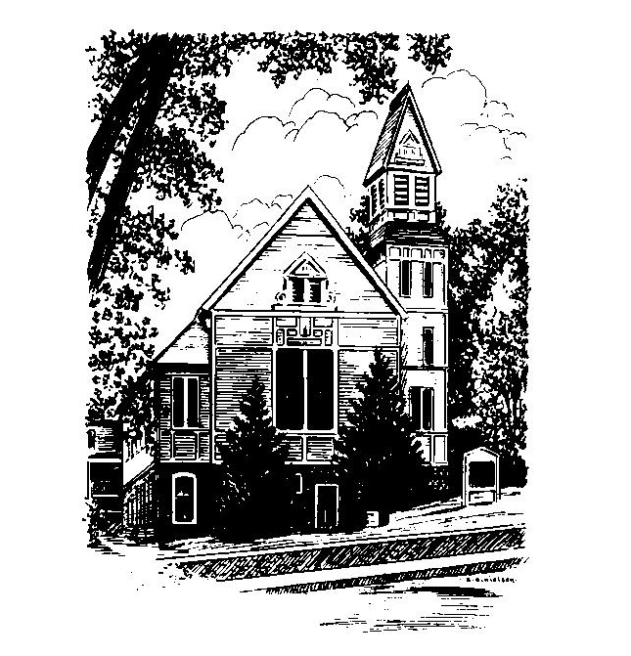
To Contact Us:
Church Office: 978-939-8821
Church website: www.baldwinvillecongochurch.org
Videographers: Larry Messer, Nowell Francis
Church Wi-Fi password: Memorial 1874

Deacon of the Day: Barbara Woodbury

Liturgist: Barbara Woodbury

Our current pulpit supply preacher is Rev. Mike Scott.

Today: Coffee and conversation at the tables.

We will be worshiping downstairs for the summer.

*denotes “All who are able please stand”. Masking is optional

COMMUNION TODAY -We take communion by intinction. We invite all who would share in Christ’s grace to come forward and take bread and dip it in the communion cup and eat with the blessing of Christ.

Meditation Thought

“In the book of Genesis the first word God speaks to a human being is "You" (2:15), and in the book of Revelation the last word a human being speaks in effect to God is "Come, Lord Jesus!" which is to say "Come, you!" (22:20).
It is possible that the whole miracle of creation is to bridge the immeasurable distance between Creator and creature with that one small word, and every time human beings use it to bridge the immeasurable distances between one another, something of that miracle happens again.”

-Frederick Buechner (Originally published in Whistling
in the Dark and later in Beyond Words).

MEMORIAL CONGREGATIONAL CHURCH
U.C.C. BALDWINVILLE, MA.
An Open and Affirming Church of
the United Church of Christ
July 6, 2025

No Matter Who You Are, No Matter Where
You Are on Life’s Journey; You Are Welcome Here!

PRELUDE

WELCOME

CALL TO WORSHIP From Psalm 105

Leader: O give thanks to the Lord, call on God’s name,
make known God’s deeds among the peoples.
People: Sing to the Holy One, sing praises to our
Sovereign; tell of all God’s wonderful works.
Leader Glory in God’s holy name;
People let the hearts of those who seek the Lord rejoice.

*HYMN O Beautiful for Spacious Skies Red Hymnal #720

* OPENING PRAYER (Unison)

We pray this morning, O Lord, for your presence in this hour of worship, and for your presence in our lives, in our nation, and in our world. May your word speak afresh to your people. Help us, we pray, to worship you with humble hearts, and to speak words of insight and integrity. Lead us, we pray, in paths of peace. We pray for this world, that the halls of power would echo with the refrains of justice. And we pray for the people of this church, that we might be beacons of hope as we reflect the light of your grace. Amen.

*SHARING THE PEACE OF CHRIST

One: May the peace of Christ be with you!
Many: And also with you!
--Please “Pass the Peace” however you feel comfortable
as we sing Amen!
*AMEN (Sung twice) Red Hymnal #317

OFFERING OURSELVES AND OUR GIFTS

CALL TO GIVING

As our offering is brought forward let us sing:
Praise God, from whom all blessings flow;
Praise God, all creatures here below;
Alleluia! Alleluia!
Praise God above, you heavenly host;
Praise Father, Son, and Holy Ghost.
Alleluia! Alleluia! Alleluia!
Alleluia! Alleluia!

PRAYER OF DEDICATION

FIRST SCRIPTURE READING 2 Kings 5:1-15c

SPECIAL MUSIC

GOSPEL READING Galatians 6:1-10

MESSAGE Extraordinary, Ordinary Miracles
*HYMN We Sing Your Mighty Power, O God
Red Hymnal #64

SHARING OUR PRAYERS, OUR JOYS, OUR HOPES

PASTORAL PRAYER

THE LORD’S PRAYER
Our father who art in heaven hallowed be thy name. Thy kingdom come thy will be done on earth as it is in heaven. Give us this day our daily bread and forgive us our trespasses as we forgive those who trespass against us. And lead us not into temptation but deliver us from evil. For thine is the kingdom and the power and the glory forever. Amen.
-Response (singing)
Hear our Prayer, O Lord, Hear our prayer O Lord.
Incline thine ear to us, and grant us thy peace.
Amen

INVITATION TO THE TABLE
Everyone, of any age, who seeks Christ’s presence
is welcome at this table!

WORDS OF INSTITUTION

DECLARATION:

Minister: And so, remembering what Christ has done for us,
we come to this table in thanksgiving and commitment,
affirming the ancient creed of our faith:
ALL: (Singing) Christ has died. Christ has Risen.
Christ will come again.

SHARING THE BREAD AND CUP

*HYMN: I Was There to Hear Your Borning Cry
Red Hymnal #75

*BENEDICTION

POSTLUDE
Announcements

Two Dates to mark on your calendar:

On Sunday, July 20, we have been invited to join with two other churches, The First Church of Templeton and the Philipston Congregational Church in a shared worship experience at First Church, Templeton at 1 Wellington Rd. in Templeton to hear our UCC Area Minister, Carol Steinbrecher offer the sermon, then move on to the Philipston Church at 62 The Common, RR1 for a luncheon and conversation with Rev. Steinbrecher. The Deacons have voted to accept the invitation. So on that date, July 20, we will not hold worship here.

(Over)

Then, on Sunday, August 3rd our church service will be held at 10 am at the Cathedral of the Pines at 10 Hale Hill Rd, in Rindge, New Hampshire followed by a picnic lunch. Again, the service will be joined by The First Church of Templeton and the Congregational Church of Phillipston. Please dress for the weather! In case of rain, the service will be held at our church. Please bring sun hats, water bottles, sunglasses, suntan lotion, bug spray, or lawn chairs if you don’t want to sit on wooden benches. There will be an offering to help pay for the rental of the Cathedral of the Pines. Please do not put your weekly pledges in this offering. Please bring your own picnic lunch as there are picnic tables to use.

