To Contact Us:
Church Office: 978-939-8821
Church website: www.baldwinvillecongochurch.org
Organist: Michelle Salvanelli
Videographer: Jeff Salvanelli
Church Wi-Fi password: Memorial 1874

Deacon of the Month: Nancy Heaney

Liturgist: Nancy Heaney

Our current pulpit supply preacher is Rev. Mike Scott.

Today: Coffee and refreshments downstairs.

*denotes “All who are able please stand.”

Meditation Thought

"You are the body of Christ," Paul said, and if you stop to think of it at all, that is a most fateful and devastating word. Christ on this earth was the healer of the sick, the feeder of the hungry, the hope of the hopeless, the sinners' friend, and thank God for that because that means he is also our hope, our friend. Thank God for every time the church remembers that and acts out of that.

-Frederick Buechner (Originally published in A Room Called Remember).

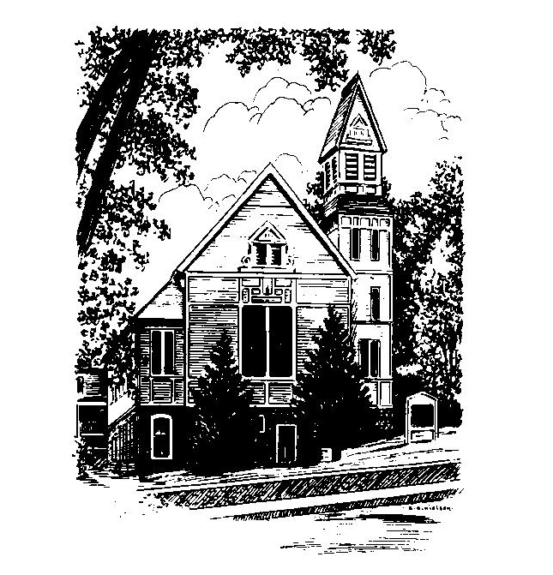
MEMORIAL CONGREGATIONAL
CHURCH
U.C.C. BALDWINVILLE, MA.
An Open and Affirming Church of
the United Church of Christ

June 15, 2025

No Matter Who You Are, No Matter Where
You Are on Life’s Journey; You Are
Welcome Here!

PRELUDE

WELCOME

CALL TO WORSHIP

Leader: Come now to worship in spirit and in truth.
People: Let us be open to the Spirit of Holiness filling
our hearts and binding us together in love.
Leader: Let us unite in our prayers and actions for peace
and justice in our world.
People: Let us serve the Lord with hearts of
compassion and courage.
Leader: May we seek and find in this time of worship
eternal truth, and may that truth set us free.
People: Let our worship be filled with hope and
promise!

*HYMN Sing Praise to God, Who Reigns Above
Red Hymnal #6

*UNISON PRAYER OF INVOCATION

O Lord of All, our hearts are ready on this day. Grant that we may hear your words in the everyday sacraments of our lives, and in the prayers and songs of our worship. May simple things speak to us of your mercy, and tell us that life can be good. And may we be led to remember those whose lives are filled with aching every day. Challenge us in this hour, we pray, to live in gratitude, in love, and in service to our neighbors and to your children everywhere. Amen.

*SHARING THE PEACE OF CHRIST
One: May the peace of Christ be with you!
Many: And also with you!
--Please “Pass the Peace” however you feel comfortable as we sing Amen!
*AMEN (Sung twice) Red Hymnal #317

OFFERING OURSELVES AND OUR GIFTS
CALL TO GIVING
As our offering is brought forward let us sing:
Praise God, from whom all blessings flow;
Praise God, all creatures here below;
Alleluia! Alleluia!
Praise God above, you heavenly host;
Praise Father, Son, and Holy Ghost.
Alleluia! Alleluia! Alleluia!
Alleluia! Alleluia!
PRAYER OF DEDICATION

FIRST SCRIPTURE Psalm 8
SPECIAL MUSIC

SECOND SCRIPTURE Romans 5:1-5

MESSAGE “Sin Boldly!”

*HYMN A Mighty Fortress Is Our God Red Hymnal #65

SHARING OUR PRAYERS, OUR JOYS, OUR HOPES

PASTORAL PRAYER

THE LORD’S PRAYER

Our father who art in heaven hallowed be thy name. Thy kingdom come thy will be done on earth as it is in heaven. Give us this day our daily bread and forgive us our trespasses as we forgive those who trespass against us. And lead us not into temptation but deliver us from evil. For thine is the kingdom and the power and the glory forever. Amen.
-Response (singing)
Hear our Prayer, O Lord, Hear our prayer O Lord.
Incline thine ear to us, and grant us thy peace.
Amen

*HYMN: Rock of Ages, Cleft for Me Red Hymnal #214

*BENEDICTION

POSTLUDE

