To Contact Us:
Church Office: 978-939-8821
Church website: www.baldwinvillecongochurch.org
Organist: Michelle Salvanelli
Videographer: Jeff Salvanelli
Church Wi-Fi password: Memorial 1874

Deacon of the Month: Nancy Heaney

Liturgist: Nancy Heaney

Our current pulpit supply preacher is Rev. Mike Scott.

Today: Coffee and refreshments downstairs.
Deacons will meet following worship.

*denotes “All who are able please stand.”

Meditation Thought

God . . . is Spirit, says the Apostle John (4:24). Thus God is the power of the power of life itself, has breathed and continues to breathe himself into his creation. In-spires it. The spirit of God, Holy Spirit, Holy Ghost, is highly contagious. When Peter and his friends were caught up in it at Jerusalem on Pentecost, everybody thought they were drunk even though the sun wasn't yet over the yardarm (Acts 2). They were.

-Frederick Buechner (Originally published in Wishful Thinking and later in Beyond Words).

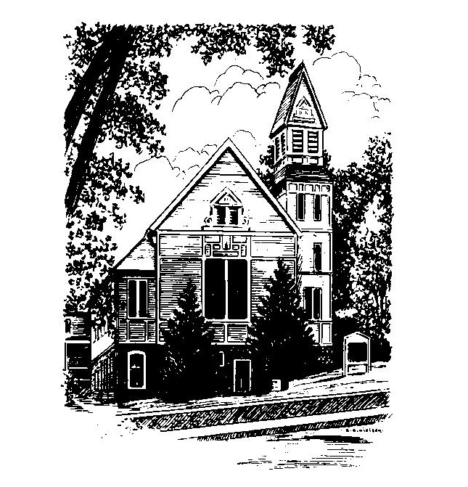
MEMORIAL CONGREGATIONAL
CHURCH
U.C.C. BALDWINVILLE, MA.
An Open and Affirming Church of
the United Church of Christ

June 8, 2025
Pentecost

No Matter Who You Are, No Matter Where
You Are on Life’s Journey; You Are
Welcome Here!

PRELUDE

WELCOME

CALL TO WORSHIP

Leader: Kindling Spirit, build well the fire in our hearts
this day.
People: Fan us to flame that all will see the
Christ-presence of love blazing in our midst.
Leader: Burn the witness on our tongues:
Christ’s Spirit lives among us.
People: Jesus Christ has set his church on fire with
strength, and boldness, and power.
Leader: Kindling Spirit, build well the fire in our hearts
this day.

*HYMN Come, O Sprit, Dwell Among Us
Black Hymnal #267

*UNISON PRAYER OF INVOCATION

Holy Spirit, come like a mighty, rushing wind and awaken us out of our apathy, our indifference. Disturb us, for we are too content to let things go on as they are and to let people go on not encountering you. Penetrate the closed gates of our hearts and make us live again. O Holy Spirit, create among us a mighty revolution of hope, and cast the fear of the unknown out of our lives. Amen.

*SHARING THE PEACE OF CHRIST
One: May the peace of Christ be with you!
Many: And also with you!
--Please “Pass the Peace” however you feel comfortable as we sing Amen!
*AMEN (Sung twice) Red Hymnal #317

OFFERING OURSELVES AND OUR GIFTS
CALL TO GIVING
As our offering is brought forward let us sing:
Praise God, from whom all blessings flow;
Praise God, all creatures here below;
Alleluia! Alleluia!
Praise God above, you heavenly host;
Praise Father, Son, and Holy Ghost.
Alleluia! Alleluia! Alleluia!
Alleluia! Alleluia!
PRAYER OF DEDICATION

FIRST SCRIPTURE Psalm 104:24-34, 35b

SPECIAL MUSIC

SECOND SCRIP[TURE Acts 2:1-21

MESSAGE Drunk with Fire?

*HYMN Hymn to Joy (Insert)

SHARING OUR PRAYERS, OUR JOYS, OUR HOPES

PASTORAL PRAYER

THE LORD’S PRAYER

Our father who art in heaven hallowed be thy name. Thy kingdom come thy will be done on earth as it is in heaven. Give us this day our daily bread and forgive us our trespasses as we forgive those who trespass against us. And lead us not into temptation but deliver us from evil. For thine is the kingdom and the power and the glory forever. Amen.
-Response (singing)
Hear our Prayer, O Lord, Hear our prayer O Lord.
Incline thine ear to us, and grant us thy peace.
Amen

*HYMN: Like the Murmur of the Dove's Song
Black Hymnal #270

*BENEDICTION

POSTLUDE

