To Contact Us:
Church Office: 978-939-8821
Church website: www.baldwinvillecongochurch.org
Organist: Michelle Salvanelli
Videographer: Jeff Salvanelli
Church Wi-Fi password: Memorial 1874

Deacon of the Day: Nancy Heaney

Liturgist: Nancy Heaney

Our current pulpit supply preacher is Rev. Mike Scott.

Today: Coffee and refreshments downstairs.

*denotes “All who are able please stand.”

Meditation Thought

I am afraid that prayer is really not for the wise. The wise avoid it on two bases, at least two. In the first place, if there really is a God who has this power to heal, to make whole, then it is wise to be very cautious indeed because if you go to him for healing, healing may be exactly what you will receive, and are you entirely sure that you want to be healed? By all accounts, after all, the process is not necessarily either quick or easy. And in the meanwhile, things could be a great deal worse. "Lord, take my sin from me—but not yet," Saint Augustine is said to have prayed. It is a wise man who bewares of God bearing gifts.

-Frederick Buechner (Originally published in The Magnificent Defeat).

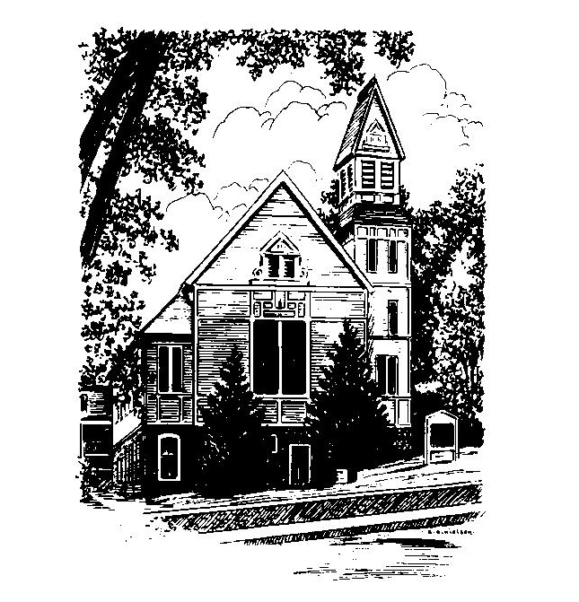
MEMORIAL CONGREGATIONAL
CHURCH
U.C.C. BALDWINVILLE, MA.
An Open and Affirming Church of
the United Church of Christ

May 25, 2025

No Matter Who You Are, No Matter Where
You Are on Life’s Journey; You Are
Welcome Here!

PRELUDE

WELCOME

CALL TO WORSHIP

Leader: This is the day the Lord has made.
People: Let us rejoice and be glad.
Leader: This day, as every day, that same Lord holds out
to us the promise of new life.
People: We are called to respond.
Leader: So, let us respond with hope, expectation, courage
and praise.
People: Come, let us worship.

*HYMN Praise to the Living God
Black Hymnal #8

*UNISON PRAYER OF INVOCATION

We gather today, O Holy Lord, to give thanks for the priceless gifts of renewal and transformation. We pray that in this service of worship you would free our spirits to live fully, confidently, hopefully, like a butterfly is freed from its cocoon. Help us to respond to your amazing grace with open hearts and open minds, that we might reflect the joy of resurrection every day of our lives. Amen.

*SHARING THE PEACE OF CHRIST
One: May the peace of Christ be with you!
Many: And also with you!
--Please “Pass the Peace” however you feel comfortable as we sing Amen!
*AMEN (Sung twice) Red Hymnal #317

OFFERING OURSELVES AND OUR GIFTS
CALL TO GIVING
As our offering is brought forward let us sing:
Praise God, from whom all blessings flow;
Praise God, all creatures here below;
Alleluia! Alleluia!
Praise God above, you heavenly host;
Praise Father, Son, and Holy Ghost.
Alleluia! Alleluia! Alleluia!
Alleluia! Alleluia!
PRAYER OF DEDICATION

FIRST SCRIPTURE READING Psalm 67

SPECIAL MUSIC

SECOND SCRIP[TURE READING John 5:1-9

MESSAGE What Do You Want?

*HYMN We Yearn, O Christ, for Wholeness
Black Hymnal #179

SHARING OUR PRAYERS, OUR JOYS, OUR HOPES

PASTORAL PRAYER

THE LORD’S PRAYER

Our father who art in heaven hallowed be thy name. Thy kingdom come thy will be done on earth as it is in heaven. Give us this day our daily bread and forgive us our trespasses as we forgive those who trespass against us. And lead us not into temptation but deliver us from evil. For thine is the kingdom and the power and the glory forever. Amen.
-Response (singing)
Hear our Prayer, O Lord, Hear our prayer O Lord.
Incline thine ear to us, and grant us thy peace.
Amen

*HYMN: Amazing Grace Black Hymnal #547

*BENEDICTION

POSTLUDE

