To Contact Us:
Church Office: 978-939-8821
Church website: www.baldwinvillecongochurch.org
Substitute Organist: John Rondeau
Substitute Videographer: Larry Messer
Church Wi-Fi password: Memorial 1874

Deacon of the Month: Barbara Woodbury
Liturgist: Barbara Woodbury
Our current pulpit supply preacher is Rev. Mike Scott.

Today: Coffee and refreshments downstairs.

*denotes “All who are able please stand.”

Meditation Thought

Beyond time is the phrase that I have used to describe this leg of my journey because it was then that I think I first began to have a pale version of the experience that Saint Paul describes in his letter to the Philippians. "Work out your own salvation with fear and trembling," he writes, "for God is at work in you both to will and to work for his good pleasure." I was a long way from thinking in terms of my own salvation or anybody else's, but through the people I met like the drunken boy at the Nass and the black man at the head of the line, through the courses I happened to take and the books I happened to read, through such events as eating that muddy turnip in Alabama, through my revulsion at my own weaknesses as well as through such satisfaction as I had in my own strengths, it seems to me now that a power from beyond time was working to achieve its own aim through my aimless life in time as it works through the lives of all of us and all our times. -Frederick Buechner (Originally in The Sacred Journey).

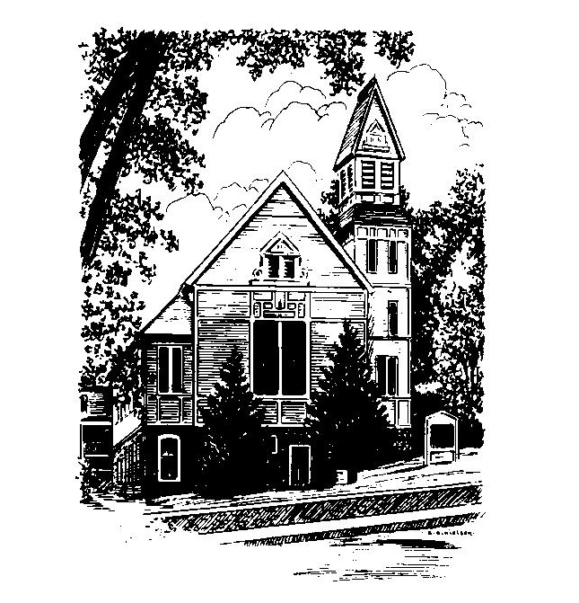
MEMORIAL CONGREGATIONAL
CHURCH
U.C.C. BALDWINVILLE, MA.
An Open and Affirming Church of
the United Church of Christ

May 11, 2025

No Matter Who You Are, No Matter Where
You Are on Life’s Journey; You Are
Welcome Here!

PRELUDE

WELCOME

CALL TO WORSHIP

Leader: We are gathered here as children of the Most High, sisters and brothers in Christ.
People: As members of the same family, then, let us
worship as one.
Leader: Let us unite our hearts in praise and thanksgiving,
People: not only with words, but in Spirit and in truth!

*HYMN God of Grace and God of Glory
Black Hymnal #436

*UNISON PRAYER OF INVOCATION

Lord of our Lives, we thank you for all we have received through the nurture of our mothers and fathers, for the lessons we have learned from times of trial in our families, and for the support and love of our church family. We pray for your blessing upon homes and families around the world and upon our own. May this time of worship be an opportunity for us to rededicate ourselves to the nurturing love that we know adds abundance to life. We pray this in the spirit and the name of Christ. Amen.

*SHARING THE PEACE OF CHRIST
One: May the peace of Christ be with you!
Many: And also with you!
--Please “Pass the Peace” however you feel comfortable as we sing Amen!
*AMEN (Sung twice) Red Hymnal #317

OFFERING OURSELVES AND OUR GIFTS
CALL TO GIVING
As our offering is brought forward let us sing:
Praise God, from whom all blessings flow;
Praise God, all creatures here below;
Alleluia! Alleluia!
Praise God above, you heavenly host;
Praise Father, Son, and Holy Ghost.
Alleluia! Alleluia! Alleluia!
Alleluia! Alleluia!
PRAYER OF DEDICATION

FIRST SCRIPTURE READING Acts 9:36-43

SPECIAL MUSIC

SECOND SCRIP[TURE READING John 10:22-39

MESSAGE “You Are Gods”

*HYMN From the Crush of Wealth and Power
Black Hymnal #552

SHARING OUR PRAYERS, OUR JOYS, OUR HOPES

PASTORAL PRAYER

THE LORD’S PRAYER

Our father who art in heaven hallowed be thy name. Thy kingdom come thy will be done on earth as it is in heaven. Give us this day our daily bread and forgive us our trespasses as we forgive those who trespass against us. And lead us not into temptation but deliver us from evil. For thine is the kingdom and the power and the glory forever. Amen.
-Response (singing)
Hear our Prayer, O Lord, Hear our prayer O Lord.
Incline thine ear to us, and grant us thy peace.
Amen

*HYMN: There Is a Balm in Gilead Black Hymnal #553

*BENEDICTION

POSTLUDE

