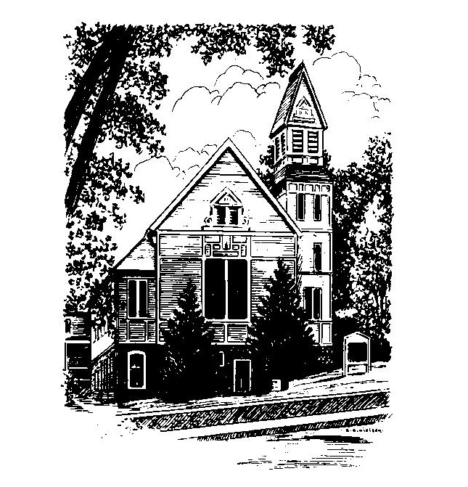
To Contact Us:
Church Office: 978-939-8821
Church website: www.baldwinvillecongochurch.org
Substitute Organist: John Rondeau
Substitute Videographer: Nowell Francis
Church Wi-Fi password: Memorial 1874

Deacon of the Month: Barbara Woodbury
Liturgist: Barbara Woodbury
Our current pulpit supply preacher is Rev. Mike Scott.
Today: Coffee and conversation downstairs.

*denotes “All who are able please stand”. Masking is optional

COMMUNION TODAY -We take communion by intinction. We invite all who would share in Christ’s grace to come forward and take bread and dip it in the communion cup and eat with the blessing of Christ.

Meditation Thought
“According to Paul, the first person Jesus came back to see after Easter morning was Peter. What he said and what Peter said nobody will ever know, and maybe that's just as well. Their last conversation on this earth, however, is reported in the Gospel of John.
lt was on the beach, at daybreak. Some of the other disciples were there, and Jesus cooked them breakfast. When it was over, he said to Peter (only again he called him Simon, son of John, because if ever he meant business, this was it), "Simon, son of John, do you love me?" and Peter said he did….
Then Jesus said, "Feed my lambs. Feed my sheep," and you get the feeling that this time Peter didn't miss the point (John21:9-19). From fisher of fish to fisher of people to keeper of the keys to shepherd. It was the Rock's final promotion, and from that day forward he never let the head office down again.”

-Frederick Buechner (Originally published in Peculiar Treasures and reprinted in Beyond Words).
MEMORIAL CONGREGATIONAL CHURCH
U.C.C. BALDWINVILLE, MA.
An Open and Affirming Church of
the United Church of Christ
May 4, 2025

No Matter Who You Are, No Matter Where
You Are on Life’s Journey; You Are Welcome Here!

PRELUDE

WELCOME

CALL TO WORSHIP

Leader: We come to this place seeking to know more
clearly the love of the Lord;
People: We come desiring to see more fully Christ’s
example reflected in our lives;
Leader: We come looking for enlightenment, for wisdom,
and for guidance;
People: But more than anything, we come to rededicate
ourselves to the mission that has been set
before us! Come, let us worship, and together let us follow in the footsteps of Christ.

*HYMN All Hail the Power of Jesus’ Name
Red Hymnal #92

*UNISON PRAYER OF INVOCATION
Eternal Lord of Hosts, into the peace of your presence we bring our restless lives. Fill our imaginations with your beauty, we pray, our minds with your truth, and our hearts with your love. Refresh our faith, restore our confidence, and lay your guiding hand upon our lives. We ask this in the name of Jesus Christ, our Lord. Amen.
*SHARING THE PEACE OF CHRIST

One: May the peace of Christ be with you!
Many: And also with you!
--Please “Pass the Peace” however you feel comfortable
as we sing Amen!
*AMEN (Sung twice) Red Hymnal #317

OFFERING OURSELVES AND OUR GIFTS

CALL TO GIVING

As our offering is brought forward let us sing:
Praise God, from whom all blessings flow;
Praise God, all creatures here below;
Alleluia! Alleluia!
Praise God above, you heavenly host;
Praise Father, Son, and Holy Ghost.
Alleluia! Alleluia! Alleluia!
Alleluia! Alleluia!

PRAYER OF DEDICATION

FIRST SCRIPTURE READING 1 Corinthians 4:14-21

SPECIAL MUSIC

GOSPEL READING John 21:1-19

MESSAGE Talk or Power?
*HYMN Jesus Calls Us, o’er the Tumult
Red Hymnal #337

SHARING OUR PRAYERS, OUR JOYS, OUR HOPES

PASTORAL PRAYER
THE LORD’S PRAYER
Our father who art in heaven hallowed be thy name. Thy kingdom come thy will be done on earth as it is in heaven. Give us this day our daily bread and forgive us our trespasses as we forgive those who trespass against us. And lead us not into temptation but deliver us from evil. For thine is the kingdom and the power and the glory forever. Amen.
-Response (singing)
Hear our Prayer, O Lord, Hear our prayer O Lord.
Incline thine ear to us, and grant us thy peace.
Amen

INVITATION TO THE TABLE
Everyone, of any age, who seeks Christ’s presence
is welcome at this table!

WORDS OF INSTITUTION

DECLARATION:
Minister: And so, remembering what Christ has done for us,
we come to this table in thanksgiving and commitment,
affirming the ancient creed of our faith:
ALL: (Singing) Christ has died. Christ has Risen.
Christ will come again.

SHARING THE BREAD AND CUP

*HYMN: Joyful, Joyful, We Adore Thee
Red Hymnal #2

*BENEDICTION

POSTLUDE

