To Contact Us:
Church Office: 978-939-8821
Church website: www.baldwinvillecongochurch.org
Substitute Organist: John Rondeau
Substitute Videographer: Larry Messer
Church Wi-Fi password: Memorial 1874

Deacon of the Month: Joanne Francis
Liturgist: Joanne Francis
Our current pulpit supply preacher is Rev. Mike Scott.

Today:
Coffee and refreshments downstairs.

*denotes “All who are able please stand.”

Meditation Thought

Spirit can be transmitted across great distances of time and space. For better or worse, you can catch the spirit of men long dead (Socrates or the Marquis de Sade), of men whose faces you have never seen and whose languages you cannot speak.
God also has a spirit - is Spirit, says the Apostle John (4:24). Thus God is the power of the power of life itself, has breathed and continues to breathe himself into his creation. In-spires it. The spirit of God, Holy Spirit, Holy Ghost, is highly contagious. When Peter and his friends were caught up in it at Jerusalem on Pentecost, everybody thought they were drunk even though the sun wasn't yet over the yardarm (Acts 2). They were.

-Frederick Buechner (first published in Wishful Thinking and later in Beyond Words).

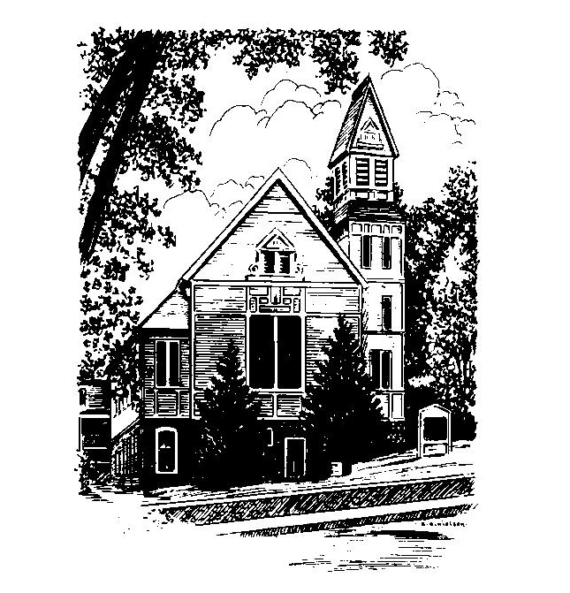
MEMORIAL CONGREGATIONAL
CHURCH
U.C.C. BALDWINVILLE, MA.
An Open and Affirming Church of
the United Church of Christ

April 27, 2025

No Matter Who You Are, No Matter Where
You Are on Life’s Journey; You Are
Welcome Here!

PRELUDE

WELCOME

CALL TO WORSHIP

Leader: Rejoice for the Spirit is among us.
People: Give thanks, for in Christ we are new people.
Leader: Sing praise for we have come to worship the Lord
of Life.

People: Let our voices ring out in song!

*HYMN He Lives! Red Hymnal #226

*UNISON PRAYER OF INVOCATION

Bounteous Creator, bless us with your Spirit of Holiness as we gather before you. Pour out your love upon us and shower us with your grace. As we turn to you, we pray that you will fill our hearts with kindness, faithfulness, gentleness, and self-control. And so, strengthened in faith, may we share your generosity and love with all the world. Amen.

*SHARING THE PEACE OF CHRIST
One: May the peace of Christ be with you!
Many: And also with you!
--Please “Pass the Peace” however you feel comfortable as we sing Amen!
*AMEN (Sung twice) Red Hymnal #317

OFFERING OURSELVES AND OUR GIFTS
CALL TO GIVING
As our offering is brought forward let us sing:
Praise God, from whom all blessings flow;
Praise God, all creatures here below;
Alleluia! Alleluia!
Praise God above, you heavenly host;
Praise Father, Son, and Holy Ghost.
Alleluia! Alleluia! Alleluia!
Alleluia! Alleluia!
PRAYER OF DEDICATION

FIRST SCRIPTURE READING Genesis 1:1-5; 2:4b-7

SPECIAL MUSIC

SECOND SCRIP[TURE READING John 20:19-23

MESSAGE On the Breath of Life
and Grasping the Wind

*HYMN O Breath of Life Red Hymnal #250

SHARING OUR PRAYERS, OUR JOYS, OUR HOPES

PASTORAL PRAYER

THE LORD’S PRAYER

Our father who art in heaven hallowed be thy name. Thy kingdom come thy will be done on earth as it is in heaven. Give us this day our daily bread and forgive us our trespasses as we forgive those who trespass against us. And lead us not into temptation but deliver us from evil. For thine is the kingdom and the power and the glory forever. Amen.
-Response (singing)
Hear our Prayer, O Lord, Hear our prayer O Lord.
Incline thine ear to us, and grant us thy peace.
Amen

*HYMN: Spirit Red Hymnal #249

*BENEDICTION

POSTLUDE

