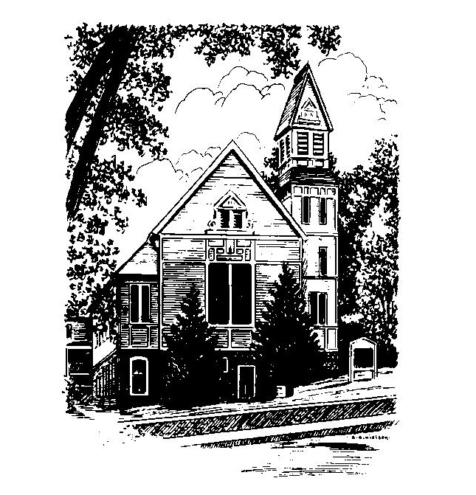
MEMORIAL CONGREGATIONAL CHURCH
U.C.C. BALDWINVILLE, MA.
An Open and Affirming Church of
the United Church of Christ

April 20, 2025
No Matter Who You Are, No Matter Where
You Are on Life’s Journey; You Are Welcome Here!

EASTER SUNDAY

PRELUDE

WELCOME AND ANNOUNCEMENTS

CALL TO WORSHIP

Leader: Alleluia. Christ is risen.
People: The Lord is risen indeed. Alleluia.
Leader: May his grace and peace be with you.
People: May he fill our hearts with joy.

*OPENING HYMN Christ the Lord Is Risen Today
Red hymnal #216

OPENING PRAYER (unison) Almighty and ever-living Ruler of the Universe, we gather to marvel at the mystery of Christ’s resurrection. You exalted the humble, empowering the weak. You snatched victory from the jaws of death. You brought forth life and love from the tomb of hate and destruction. Today we celebrate your good news for all people and raise our voices in praise. Amen.

*SHARING THE PEACE OF CHRIST

One: May the peace of Christ be with you!
Many: And also with you!
--Please “Pass the Peace” however you feel comfortable
as we sing Amen!
*AMEN (Sung twice) Red Hymnal #317
Amen, Amen, Amen, Amen, Amen

OFFERING OURSELVES AND OUR GIFTS

CALL TO GIVING

As our offering is brought forward let us sing:
Praise God, from whom all blessings flow;
Praise God, all creatures here below;
Alleluia! Alleluia!
Praise God above, you heavenly host;
Praise Father, Son, and Holy Ghost.
Alleluia! Alleluia! Alleluia!
Alleluia! Alleluia!

PRAYER OF DEDICATION

FIRST SCRIPTURE Psalm 118:1-2, 14-24
SPECIAL MUSIC
THE EASTER STORY Mark 16:1-8
SERMON The Unfinished Story
HYMN Rejoice the Lord Is King Red Hymnal # 699

SHARING OUR PRAYERS, OUR JOYS, OUR HOPES
PASTORAL PRAYER
THE LORD’S PRAYER

Our father who art in heaven hallowed be thy name. Thy kingdom come thy will be done on earth as it is in heaven. Give us this day our daily bread and forgive us our trespasses as we forgive those who trespass against us. And lead us not into temptation but deliver us from evil. For thine is the kingdom and the power and the glory forever. Amen.
-Response (singing)
Hear our Prayer, O Lord, Hear our prayer O Lord.
Incline thine ear to us, and grant us thy peace. Amen

*HYMN: Thine Is the Glory Red Hymnal # 218
BENEDICTION
One: Go from this place with the Spirit stirring your hearts
towards all that is good, all that is lovely, all that makes the
world a better place.
ALL: We go form this place encouraged in hope and
committing ourselves anew to share Christ’s love in all
the places our lives touch.
One: May the grace of the Lord go with you and strengthen you
always.
ALL: Amen!

POSTLUDE
To Contact Us:
Church Office: 978-939-8821
Church website: www.baldwinvillecongochurch.org
Organist: Michelle Salvanelli
Videographer: Jeff Salvanelli
Church Wi-Fi password: Memorial 1874

Deacon of the Month: Joanne Francis
Liturgist: Joanne Francis
Our current supply preacher is Rev. Mike Scott.

*denotes “All who are able please stand”. Masking is optional

Meditation Thought
In this dark world where you and I see so little because of our unrecognizing eyes, he, whose eye is on the sparrow, sees each one of us as the child in red. And I believe that because he sees us, not even in the darkness of death are we lost to him or lost to each other. I believe that whether we recognize him or not, or believe in him or not, or even know his name, again and again he comes and walks a little way with us along whatever road we're following. And I believe that through something that happens to us, or something we see, or somebody we know—who can ever guess how or when or where?—he offers us, the way he did at Emmaus, the bread of life, offers us a new hope, a new vision of light that not even the dark world can overcome.
That is the word that on Easter Sunday is sounded forth on silver trumpets. And when Easter is past and the silver trumpets have faded away to hardly more than a distant echo, that is the word that is whispered to us like a secret in the dark, the saving and holy word that flickers among us like a red dress in a gray world.
-Frederick Buechner (first published in The Longing for Home and again in Secrets in the Dark.)

To Contact Us:
Church Office: 978-939-8821
Church website: www.baldwinvillecongochurch.org
Organist: Michelle Salvanelli
Videographer: Jeff Salvanelli
Church Wi-Fi password: Memorial 1874

Deacon of the Month: Joanne Francis
Liturgist: Joanne Francis
Our current supply preacher is Rev. Mike Scott.

*denotes “All who are able please stand”. Masking is optional

Meditation Thought
In this dark world where you and I see so little because of our unrecognizing eyes, he, whose eye is on the sparrow, sees each one of us as the child in red. And I believe that because he sees us, not even in the darkness of death are we lost to him or lost to each other. I believe that whether we recognize him or not, or believe in him or not, or even know his name, again and again he comes and walks a little way with us along whatever road we're following. And I believe that through something that happens to us, or something we see, or somebody we know—who can ever guess how or when or where?—he offers us, the way he did at Emmaus, the bread of life, offers us a new hope, a new vision of light that not even the dark world can overcome.
That is the word that on Easter Sunday is sounded forth on silver trumpets. And when Easter is past and the silver trumpets have faded away to hardly more than a distant echo, that is the word that is whispered to us like a secret in the dark, the saving and holy word that flickers among us like a red dress in a gray world.
-Frederick Buechner (first published in The Longing for Home and again in Secrets in the Dark.)

