To Contact Us:
Church Office: 978-939-8821
Church website: www.baldwinvillecongochurch.org
Substitute Organist: John Rondeau
Substitute Videographer: Larry Messer
Church Wi-Fi password: Memorial 1874

Deacon of the Month: Joanne Francis
Liturgist: Joanne Francis
Our current pulpit supply preacher is Rev. Mike Scott.

Today:
Coffee and refreshments downstairs
Deacons will be meeting following worship.

*denotes “All who are able please stand.”

Meditation Thought

Despair and hope. They travel the road to Jerusalem together, as together they travel every road we take—despair at what in our madness we are bringing down on our own heads and hope in him who travels the road with us and for us and who is the only one of us all who is not mad. Hope in the King who approaches every human heart like a city. And it is a very great hope as hopes go and well worth all our singing and dancing and sad little palms because not even death can prevail against this King and not even the end of the world, when end it does, will be the end of him and of the mystery and majesty of his love. Blessed be he.
-Frederick Buechner (From Buechner’s Palm Sunday sermon entitled “The Things That Make For Peace” from A Room Called Remember).

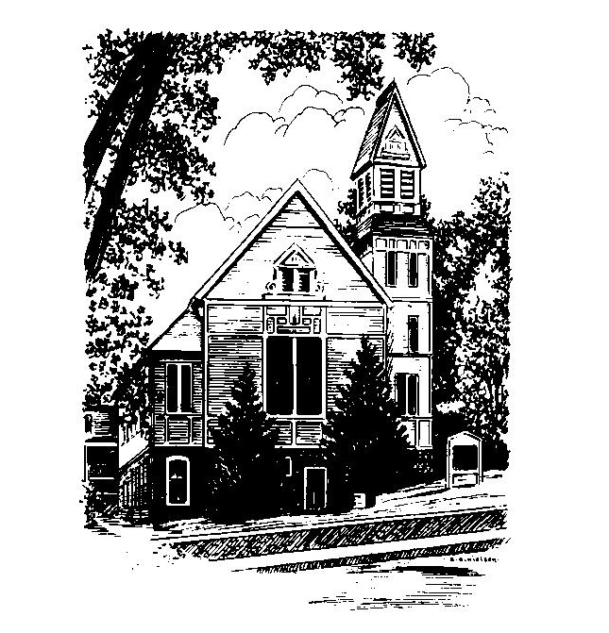
MEMORIAL CONGREGATIONAL
CHURCH
U.C.C. BALDWINVILLE, MA.
An Open and Affirming Church of
the United Church of Christ

April 13, 2025

Palm Sunday

No Matter Who You Are, No Matter Where
You Are on Life’s Journey; You Are
Welcome Here!

PRELUDE

WELCOME

CALL TO WORSHIP

Leader: Jesus set his face resolutely toward Jerusalem.
People: We gather this day to be strengthened to
follow his example.
Leader: Jesus entered the city to shouts of "Hosanna!"
People: We gather this day to raise the cry of praise
and welcome.
Leader: Jesus took up his cross and taught the meaning of
love.
People: We gather this day to learn the cost and joy of
discipleship!

*HYMN All Glory, Laud, and Honor
Black Hymnal #216
*OPENING PRAYER (Unison)

O Lord, we are like the people of Jerusalem long ago. We are hungry for a hero. We crave some glimpse of greatness. We yearn for grand answers. We are gathered here like those on the roadside who watched for the Messiah. As we wait upon your Spirit let us not be disappointed when the special one appears even though we are certain to be surprised; and give us courage to follow where the one on the donkey might lead us. Amen.

*SHARING THE PEACE OF CHRIST
One: May the peace of Christ be with you!
Many: And also with you!
--Please “Pass the Peace” however you feel comfortable as we sing Amen!
*AMEN (Sung twice) Red Hymnal #317

OFFERING OURSELVES AND OUR GIFTS
CALL TO GIVING
As our offering is brought forward let us sing:
Praise God, from whom all blessings flow;
Praise God, all creatures here below;
Alleluia! Alleluia!
Praise God above, you heavenly host;
Praise Father, Son, and Holy Ghost.
Alleluia! Alleluia! Alleluia!
Alleluia! Alleluia!
PRAYER OF DEDICATION

FIRST SCRIPTURE READING Luke 14:25-33

SPECIAL MUSIC
SECOND SCRIP[TURE READING Luke 19:28-47

MESSAGE On the Road to Calvary:
Jesus, the Way, the Truth, and the Life

*HYMN Hosanna, Loud Hosanna Black Hymnal #213

SHARING OUR PRAYERS, OUR JOYS, OUR HOPES

PASTORAL PRAYER

THE LORD’S PRAYER

Our father who art in heaven hallowed be thy name. Thy kingdom come thy will be done on earth as it is in heaven. Give us this day our daily bread and forgive us our trespasses as we forgive those who trespass against us. And lead us not into temptation but deliver us from evil. For thine is the kingdom and the power and the glory forever. Amen.
-Response (singing)
Hear our Prayer, O Lord, Hear our prayer O Lord.
Incline thine ear to us, and grant us thy peace.
Amen

*HYMN: Before Your Cross, O Jesus
Black Hymnal #191

*BENEDICTION

POSTLUDE

