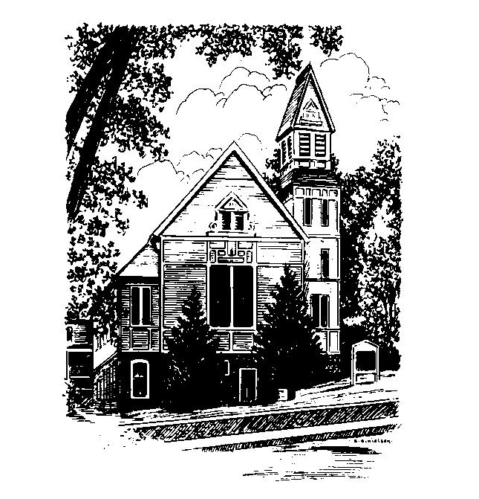
To Contact Us:
Church Office: 978-939-8821
Church website: www.baldwinvillecongochurch.org
Substitute Organist: John Rondeau
Videographer: Larry Messer
Church Wi-Fi password: Memorial 1874

Deacon of the Month: Joanne Francis
Liturgist: Joanne Francis
Our current pulpit supply preacher is Rev. Mike Scott.
Today: Coffee and conversation downstairs.

*denotes “All who are able please stand”. Masking is optional

COMMUNION TODAY -We take communion by intinction. We invite all who would share in Christ’s grace to come forward and take bread and dip it in the communion cup and eat with the blessing of Christ.

Meditation Thought
“When Jesus says that he has come to bear witness to the truth, Pilate asks, "What is truth?" (John 18:38). Contrary to the traditional view that his question is cynical, it is possible that he asks it with a lump in his throat. Instead of truth, Pilate has only expedience. His decision to throw Jesus to the wolves is expedient. Pilate views humankind as alone in the universe with nothing but its own courage and ingenuity to see it through. That is enough to choke up anybody.
Pilate asks "What is truth?" and for years there have been politicians, scientists, theologians, philosophers, poets, and so on to tell him. The sound they make is like the sound of crickets chirping.
Jesus doesn't answer Pilate's question. He just stands there. Stands, and stands there.”

-Frederick Buechner (Originally published in Wishful Thinking and later in Beyond Words).
MEMORIAL CONGREGATIONAL CHURCH
U.C.C. BALDWINVILLE, MA.
An Open and Affirming Church of
the United Church of Christ
April 6, 2025

No Matter Who You Are, No Matter Where
You Are on Life’s Journey; You Are Welcome Here!

PRELUDE

WELCOME

CALL TO WORSHIP

Leader: Rejoice in the Lord always!
People: Again, I say, rejoice!
Leader: We are gathered to worship in spirit and in truth,
People: and to know the joyful unity of being one with
Christ.
Leader: Rejoice in the Lord always!
People: Again, I say, rejoice!

*HYMN When Morning Gilds the Skies
Red Hymnal #100

*UNISON PRAYER OF INVOCATION
Your steadfast love to us is our joy, O Lord of Hosts. We gather to rejoice in your grace and mercy which greet us each day with the rising sun. We gather to sing praises to you for all good gifts. You have called us to faith and service and have given us strength to respond to your calling. You have joined us together in love. Hear our prayers and our praise in Christ’s name. Amen.

*SHARING THE PEACE OF CHRIST

One: May the peace of Christ be with you!
Many: And also with you!
--Please “Pass the Peace” however you feel comfortable
as we sing Amen!
*AMEN (Sung twice) Red Hymnal #317

OFFERING OURSELVES AND OUR GIFTS

CALL TO GIVING

As our offering is brought forward let us sing:
Praise God, from whom all blessings flow;
Praise God, all creatures here below;
Alleluia! Alleluia!
Praise God above, you heavenly host;
Praise Father, Son, and Holy Ghost.
Alleluia! Alleluia! Alleluia!
Alleluia! Alleluia!

PRAYER OF DEDICATION

FIRST SCRIPTURE READING Philippians 3:4b-14

SPECIAL MUSIC

GOSPEL READING John 18:28 -19:16

MESSAGE On the Road to Calvary:
Jesus Before Pilate
*HYMN One Bread, One Body Red Hymnal #393

SHARING OUR PRAYERS, OUR JOYS, OUR HOPES

PASTORAL PRAYER

THE LORD’S PRAYER
Our father who art in heaven hallowed be thy name. Thy kingdom come thy will be done on earth as it is in heaven. Give us this day our daily bread and forgive us our trespasses as we forgive those who trespass against us. And lead us not into temptation but deliver us from evil. For thine is the kingdom and the power and the glory forever. Amen.
-Response (singing)
Hear our Prayer, O Lord, Hear our prayer O Lord.
Incline thine ear to us, and grant us thy peace.
Amen

INVITATION TO THE TABLE
Everyone, of any age, who seeks Christ’s presence
is welcome at this table!

WORDS OF INSTITUTION

DECLARATION:
Minister: And so, remembering what Christ has done for us,
we come to this table in thanksgiving and commitment,
affirming the ancient creed of our faith:
ALL: (Singing) Christ has died. Christ has Risen.
Christ will come again.

SHARING THE BREAD AND CUP

*HYMN: Beneath the Cross of Jesus
Red Hymnal #197

*BENEDICTION

POSTLUDE

