To Contact Us:
Church Office: 978-939-8821
Church website: www.baldwinvillecongochurch.org
Substitute Organist: John Rondeau
Substitute Videographer: Larry Messer
Church Wi-Fi password: Memorial 1874

Deacon of the Day: Joanne Francis
Liturgist: Joanne Francis
Our current pulpit supply preacher is Rev. Mike Scott.

Today:
Coffee and refreshments downstairs following
worship. Everyone is invited.

*denotes “All who are able please stand.”
Masking is optional

Meditation Thought

Nobody can be sure, of course, why Judas sold Jesus out, although according to John's Gospel, he already had a reputation for dipping into the poor box from time to time, so the cash may have been part of it. If, like the other disciples, he was perennially worried about where he stood in the pecking order, he may also have been reacting to some imagined slight. Maybe he thought his job as treasurer to the outfit was beneath him. Another possibility is that he had gotten fed up with waiting for Jesus to take the world by storm and hoped that betraying him might force him to show his hand at last. Or maybe, because nothing human is ever uncomplicated, something of all of these was involved. Anyway, whatever his reasons were, the whole thing went sour for him soon enough.

-Frederick Buechner (Originally published in Peculiar Treasures and later in Beyond Words).

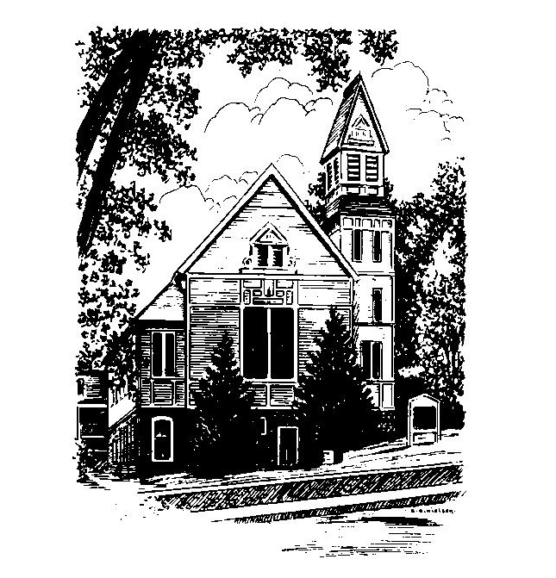
MEMORIAL CONGREGATIONAL
CHURCH
U.C.C. BALDWINVILLE, MA.
An Open and Affirming Church of
the United Church of Christ

March 30, 2025

The Fourth Sunday in Lent

No Matter Who You Are, No Matter Where
You Are on Life’s Journey; You Are
Welcome Here!

PRELUDE

WELCOME

CALL TO WORSHIP

Leader: Out of the fullness of life we have come to sing
and celebrate the Lord of Life.
People: Let us bring our joy and our hopefulness.
Leader: Out of our sorrow and incompleteness we have
come to pray and seek guidance.
People: Let us bring the integrity of our real selves.
Leader: Let us bring full hearts, open minds, and yearning
spirits.
People: Come, let us worship!

*HYMN Come, Thou Almighty King
Red Hymnal #27

*UNISON PRAYER OF INVOCATION Based on Psalm 131

O Lord, our eyes are not raised too high this morning. We do not occupy ourselves with things too great and too marvelous for us. But we have come here to calm and quiet our hearts, that we might, like children who are drawn to their mother’s love, be brought closer to you and to the hope you offer to every soul and in every age. Amen.

*SHARING THE PEACE OF CHRIST
One: May the peace of Christ be with you!
Many: And also with you!
--Please “Pass the Peace” however you feel comfortable as we sing Amen!
*AMEN (Sung twice) Red Hymnal #317

OFFERING OURSELVES AND OUR GIFTS
CALL TO GIVING
As our offering is brought forward let us sing:
Praise God, from whom all blessings flow;
Praise God, all creatures here below;
Alleluia! Alleluia!
Praise God above, you heavenly host;
Praise Father, Son, and Holy Ghost.
Alleluia! Alleluia! Alleluia!
Alleluia! Alleluia!
PRAYER OF DEDICATION

FIRST SCRIPTURE READING 2 Corinthians 5:16-21

SPECIAL MUSIC

GOSPEL READING Matthew 26:1-16, 27:3-10

MESSAGE On the Road to Calvary:
Judas, The Betrayer

*HYMN Jesus Walked This Lonesome Valley
Red Hymnal #211

SHARING OUR PRAYERS, OUR JOYS, OUR HOPES

PASTORAL PRAYER

THE LORD’S PRAYER

Our father who art in heaven hallowed be thy name. Thy kingdom come thy will be done on earth as it is in heaven. Give us this day our daily bread and forgive us our trespasses as we forgive those who trespass against us. And lead us not into temptation but deliver us from evil. For thine is the kingdom and the power and the glory forever. Amen.
-Response (singing)
Hear our Prayer, O Lord, Hear our prayer O Lord.
Incline thine ear to us, and grant us thy peace.
Amen

*HYMN: Rock of Ages, Cleft for Me
Red Hymnal #214

*BENEDICTION

POSTLUDE

