To Contact Us:
Church Office: 978-939-8821
Church website: www.baldwinvillecongochurch.org
Organist: Michelle Salvanelli
Videographer: Jeff Salvanelli
Church Wi-Fi password: Memorial 1874

Deacon of the Month: Lei Messer
Liturgist: Lei Messer
Our current pulpit supply preacher is Rev. Mike Scott.

Today:
Coffee and refreshments downstairs following
worship. Everyone is invited.

*denotes “All who are able please stand.”
Masking is optional

Meditation Thought

Matthew the tax-collector and Thomas the doubter. Peter the Rock and Judas the traitor. Mary Magdalene and Lazarus's sister Martha. And the popcorn-eating old woman. And the fat man in the pick-up. They are all our family, and you and I are their family and each other's family, because that is what Jesus has called us as the Church to be. . . . Be the light of the world, he says. Where there are dark places, be the light especially there. Be the salt of the earth. Bring out the true flavor of what it is to be alive truly. Be truly alive. Be life-givers to others. That is what Jesus tells the disciples to be. That is what Jesus tells his Church, tells us, to be and do. Love each other.

-Frederick Buechner (Originally published in The Clown in the Belfry).

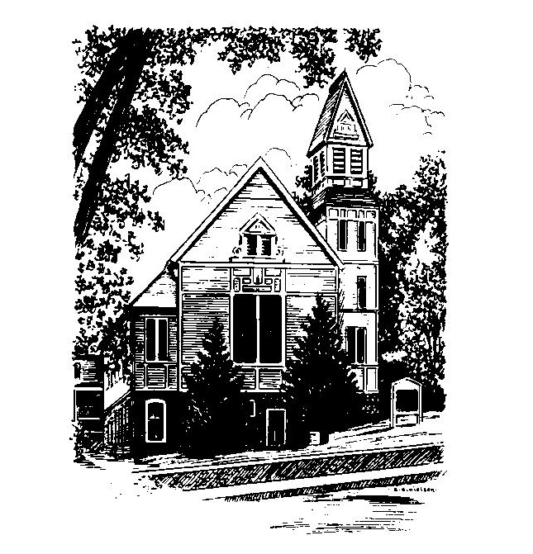
MEMORIAL CONGREGATIONAL
CHURCH
U.C.C. BALDWINVILLE, MA.
An Open and Affirming Church of
the United Church of Christ

March 23, 2025

The Third Sunday in Lent

No Matter Who You Are, No Matter Where
You Are on Life’s Journey; You Are
Welcome Here!

PRELUDE

WELCOME

CALL TO WORSHIP

Leader: We come to this place, each one of us on our
own journey, to find here that the journey is
shared. We share our lives, our experiences,
our hopes and fears.
People: With joy and thanksgiving we welcome other
travelers, to learn from each other, to laugh
and cry with each other, to be at home with
each other. Let us journey together in
worship.

*HYMN Come, O Fount of Every Blessing
Red Hymnal #16

*UNISON PRAYER OF INVOCATION

Lord of life, we rejoice in your love which renews us each day and calls us to share in abundant life. We are thankful for Jesus who revealed most fully your loving purpose for all people. We celebrate your Spirit of Holiness that draws all humanity into your circle of love. Make us open, we pray, to your presence in our lives and in our worship, that we might truly reflect your love in all we say and do. Amen.

*SHARING THE PEACE OF CHRIST
One: May the peace of Christ be with you!
Many: And also with you!
--Please “Pass the Peace” however you feel comfortable as we sing Amen!
*AMEN (Sung twice) Red Hymnal #317

OFFERING OURSELVES AND OUR GIFTS
CALL TO GIVING
As our offering is brought forward let us sing:
Praise God, from whom all blessings flow;
Praise God, all creatures here below;
Alleluia! Alleluia!
Praise God above, you heavenly host;
Praise Father, Son, and Holy Ghost.
Alleluia! Alleluia! Alleluia!
Alleluia! Alleluia!
PRAYER OF DEDICATION

FIRST SCRIPTURE READING Matthew 21:1-11

SPECIAL MUSIC

SECOND SCRIPTURE READING John 19:25b-27

MESSAGE On the Road to Calvary:
The Disciple Whom Jesus Loved

*HYMN Jesus Loves Me Red Hymnal #113

SHARING OUR PRAYERS, OUR JOYS, OUR HOPES

PASTORAL PRAYER

THE LORD’S PRAYER

Our father who art in heaven hallowed be thy name. Thy kingdom come thy will be done on earth as it is in heaven. Give us this day our daily bread and forgive us our trespasses as we forgive those who trespass against us. And lead us not into temptation but deliver us from evil. For thine is the kingdom and the power and the glory forever. Amen.
-Response (singing)
Hear our Prayer, O Lord, Hear our prayer O Lord.
Incline thine ear to us, and grant us thy peace.
Amen

*HYMN: Spirit of God, Descend upon My Heart
Red Hymnal #265

*BENEDICTION

POSTLUDE

