To Contact Us:
Church Office: 978-939-8821
Church website: www.baldwinvillecongochurch.org
Organist: Michelle Salvanelli
Videographer: Jeff Salvanelli
Church Wi-Fi password: Memorial 1874

Deacon of the Month: Lei Messer
Liturgist: Lei Messer
Our current pulpit supply preacher is Rev. Mike Scott.

Today:
Coffee and refreshments downstairs following
worship. Everyone is invited.
Deacons will meet following worship.

*denotes “All who are able please stand.”
Masking is optional

Meditation Thought

One of the titles by which Jesus is known is Prince of Peace, and he used the word himself in what seem at first glance to be two radically contradictory utterances. On one occasion he said to the disciples, "Do not think that I have come to bring peace on earth; I have not come to bring peace, but a sword" (Matthew 10:34). And later on, the last time they ate together, he said to them, "Peace I leave with you; my peace I give to you" (John 14:27).
The contradiction is resolved when you realize that, for Jesus, peace seems to have meant not the absence of struggle, but the presence of love.

-Frederick Buechner (Originally published in Wishful Thinking and later in Beyond Words).

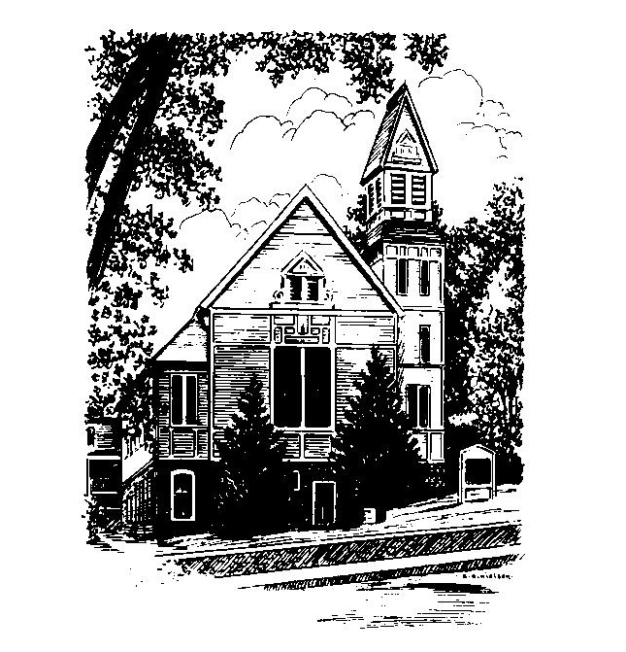
MEMORIAL CONGREGATIONAL
CHURCH
U.C.C. BALDWINVILLE, MA.
An Open and Affirming Church of
the United Church of Christ

March 16, 2025

The second Sunday in Lent

No Matter Who You Are, No Matter Where
You Are on Life’s Journey; You Are
Welcome Here!

PRELUDE

WELCOME

CALL TO WORSHIP Psalm 46:8-11

Leader: Come, behold the works of God,
who has wrought desolations in the earth.
People: Making wars to cease to the end of the earth,
breaking the bow, shattering the spear,
and burning the chariots with fire!
Leader: “Be still, and know that I am God!
I am exalted among the nations,
I am exalted in the earth.”
People: The God of hosts is with us;
the God of Jacob is our refuge.

*HYMN Day by Day Red Hymnal #599
(Twice through)

*RESPONSIVE PRAYER FOR PEACE

(See Insert)

*SHARING THE PEACE OF CHRIST
One: May the peace of Christ be with you!
Many: And also with you!
--Please “Pass the Peace” however you feel comfortable as we sing Amen!
*AMEN (Sung twice) Red Hymnal #317

OFFERING OURSELVES AND OUR GIFTS
CALL TO GIVING
As our offering is brought forward let us sing:
Praise God, from whom all blessings flow;
Praise God, all creatures here below;
Alleluia! Alleluia!
Praise God above, you heavenly host;
Praise Father, Son, and Holy Ghost.
Alleluia! Alleluia! Alleluia!
Alleluia! Alleluia!
PRAYER OF DEDICATION

FIRST SCRIPTURE READING Psalm 27

SPECIAL MUSIC

GOSPEL READING Luke 13:31-35a; 19:41-42

MESSAGE On the Road to Calvary:
The Things That Make for Peace

*HYMN Down by the Riverside
Red Hymnal #673

SHARING OUR PRAYERS, OUR JOYS, OUR HOPES

PASTORAL PRAYER

THE LORD’S PRAYER

Our father who art in heaven hallowed be thy name. Thy kingdom come thy will be done on earth as it is in heaven. Give us this day our daily bread and forgive us our trespasses as we forgive those who trespass against us. And lead us not into temptation but deliver us from evil. For thine is the kingdom and the power and the glory forever. Amen.
-Response (singing)
Hear our Prayer, O Lord, Hear our prayer O Lord.
Incline thine ear to us, and grant us thy peace.
Amen

*HYMN: This Is My Song Red Hymnal #722

*BENEDICTION

POSTLUDE

RESPONSIVE PRAYER FOR PEACE

Leader: Remember, O Lord, the peoples of the world divided into many nations and tongues; deliver us from every evil that obstructs your saving purpose; and fulfill your promise of old to establish your realm of peace. From the curse of war and all that begets it,
People: O Lord, deliver us.
Leader: From believing and speaking lies against other peoples and nations,
People: O Lord, deliver us.
Leader: From narrow loyalties and selfish isolation,
People: O Lord, deliver us.
Leader: From the lust for riches that often drives people and nations to violence,
People: O Lord, deliver us.
Leader: From putting our trust only in weapons of war, and from want of faith in the power of justice and goodwill,
People: O Lord, deliver us.
Leader: From every thought, word, and deed that divides the human family and separates us from the ultimate realization of your love,
People: O Lord, deliver us.

RESPONSIVE PRAYER FOR PEACE

Leader: Remember, O Lord, the peoples of the world divided into many nations and tongues; deliver us from every evil that obstructs your saving purpose; and fulfill your promise of old to establish your realm of peace. From the curse of war and all that begets it,
People: O Lord, deliver us.
Leader: From believing and speaking lies against other peoples and nations,
People: O Lord, deliver us.
Leader: From narrow loyalties and selfish isolation,
People: O Lord, deliver us.
Leader: From the lust for riches that often drives people and nations to violence,
People: O Lord, deliver us.
Leader: From putting our trust only in weapons of war, and from want of faith in the power of justice and goodwill,
People: O Lord, deliver us.
Leader: From every thought, word, and deed that divides the human family and separates us from the ultimate realization of your love,
People: O Lord, deliver us.

