To Contact Us:
Church Office: 978-939-8821
Church website: www.baldwinvillecongochurch.org
Organist: Michelle Salvanelli
Videographer: Jeff Salvanelli
Church Wi-Fi password: Memorial 1874

Deacon of the Month: Lei Messer
Liturgist: Lei Messer
Our current pulpit supply preacher is Rev. Mike Scott.

Today:
Coffee and refreshments downstairs following
worship. Everyone is invited.
Deacons will meet following worship.

*denotes “All who are able please stand.”
Masking is optional

Meditation Thought

Idolatry is always popular among religious people, but idols made out of things like the denomination, the Bible, the liturgy, the holy images are apt to seem so limited in real power even to their idolaters that there is always the hope that in time they will overthrow themselves.
It is among the unreligious that idolatry is a particular menace. Having ushered God out once and for all through the front door, the unbeliever is under constant temptation to replace God with something spirited in through the service entrance. From the moment the eighteenth-century French revolutionaries set up the goddess of Reason on the high altar of Notre Dame, there wasn't a head in all Paris that was safe.

-Frederick Buechner (Originally published in Wishful Thinking and later in Beyond Words).

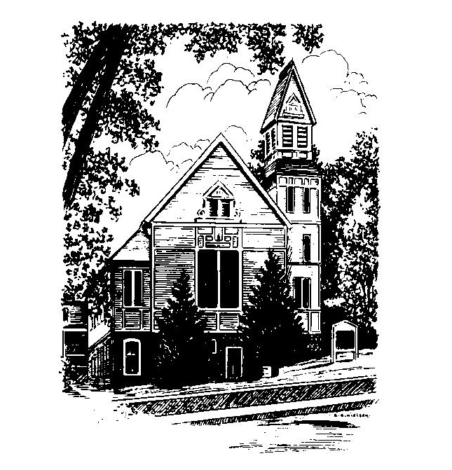
MEMORIAL CONGREGATIONAL
CHURCH
U.C.C. BALDWINVILLE, MA.
An Open and Affirming Church of
the United Church of Christ

March 9, 2025

The first Sunday in Lent

No Matter Who You Are, No Matter Where
You Are on Life’s Journey; You Are
Welcome Here!

PRELUDE

WELCOME

CALL TO WORSHIP

Leader: Sisters and brothers, we are called.
People: Called to follow Jesus through trial and
triumph.
Leader: Called to move, as he did, among those in need,
and offer hope.
People: Called to name, as he did, the mercy, and to
be ambassadors of grace.
Leader: Brothers and sisters, we are called by the Spirit.
People: Let us respond to that calling this day with
determination and with joy!

*HYMN How Firm a Foundation Red Hymnal #372

*UNISON PRAYER OF INVOCATION

Gather us close to your heart, O Lord. Lift us up from where we have fallen. Help us to respond to your persistent call in this time of worship. Tell us once more that your love is constant in spite of our weakness and waywardness. And, turning to you in this hour of worship, may we be rededicated in faithfulness to your purposes. Amen.

*SHARING THE PEACE OF CHRIST
One: May the peace of Christ be with you!
Many: And also with you!
--Please “Pass the Peace” however you feel comfortable as we sing Amen!
*AMEN (Sung twice) Red Hymnal #317

OFFERING OURSELVES AND OUR GIFTS
CALL TO GIVING
As our offering is brought forward let us sing:
Praise God, from whom all blessings flow;
Praise God, all creatures here below;
Alleluia! Alleluia!
Praise God above, you heavenly host;
Praise Father, Son, and Holy Ghost.
Alleluia! Alleluia! Alleluia!
Alleluia! Alleluia!
PRAYER OF DEDICATION

FIRST SCRIPTURE READING Psalm 91:1-2, 9-16

SPECIAL MUSIC

GOSPEL READING Luke 4:1-13

MESSAGE It’s Tempting

*HYMN Lord, Who Throughout These Forty Days
Red Hymnal #180

SHARING OUR PRAYERS, OUR JOYS, OUR HOPES

PASTORAL PRAYER

THE LORD’S PRAYER

Our father who art in heaven hallowed be thy name. Thy kingdom come thy will be done on earth as it is in heaven. Give us this day our daily bread and forgive us our trespasses as we forgive those who trespass against us. And lead us not into temptation but deliver us from evil. For thine is the kingdom and the power and the glory forever. Amen.
-Response (singing)
Hear our Prayer, O Lord, Hear our prayer O Lord.
Incline thine ear to us, and grant us thy peace.
Amen

*HYMN: I Want Jesus to Walk with Me
Red Hymnal #627

*BENEDICTION

POSTLUDE

