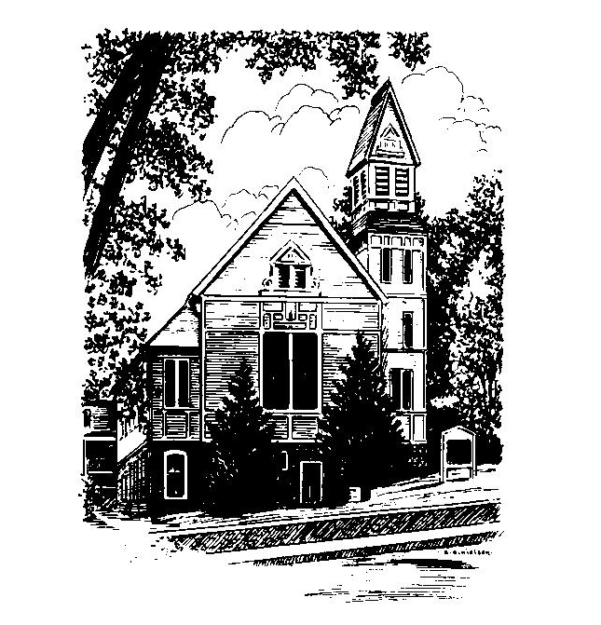
To Contact Us:
Church Office: 978-939-8821
Church website: www.baldwinvillecongochurch.org
Organist: Michelle Salvanelli
Videographer: Jeff Salvanelli
Church Wi-Fi password: Memorial 1874

Deacon of the Month: Lei Messer
Liturgist: Lei Messer
Our current pulpit supply preacher is Rev. Mike Scott.
Today: Coffee and conversation downstairs.

*denotes “All who are able please stand”. Masking is optional

COMMUNION TODAY -We take communion by intinction. We invite all who would share in Christ’s grace to come forward and take bread and dip it in the communion cup and eat with the blessing of Christ.

Meditation Thought
“Cleanse the thoughts of our hearts by the inspiration of thy Holy Spirit," the collect goes, "that we may perfectly love" if not thee, because we are such a feckless and faithless crowd most of us, then at least ourselves, at least each other. If, as someone has said, we are as sick as our secrets, then to get well is to air those secrets if only in our own hearts, which the prayer asks God himself to air and cleanse. When our secrets are guilty secrets, like the burden [of expecting too much from them] I had unwittingly placed on my own children, we can start to make amends, to change what can be changed; we can start to heal. When they are sad and hurtful secrets, like my father's death, we can in a way honor the hurt by letting ourselves feel it as we never let ourselves feel it before, and then, having felt it, by laying it aside; we can start to take care of ourselves the way we take care of people we love. To love our neighbors as we love ourselves means also to love ourselves as we love our neighbors.
-Frederick Buechner (Originally published in Telling Secrets)
MEMORIAL CONGREGATIONAL CHURCH
U.C.C. BALDWINVILLE, MA.
An Open and Affirming Church of
the United Church of Christ
March 2, 2025

No Matter Who You Are, No Matter Where
You Are on Life’s Journey; You Are Welcome Here!

PRELUDE

WELCOME

CALL TO WORSHIP
Leader: Come away in this hour from the tumult of the
world, that we may focus our minds and hearts.
People: We come to see our lives and our world more
clearly, and to reconnect to the source of our
strength and hope.
Leader: Let us emerge in this hour from the isolation
that so often fills our lives, and enter into true
community.
People: We come to share our journey with one another,
and to find together the inspiration that lights our
path. Come, let us worship together!

*HYMN O How Glorious, Full of Wonder
Black Hymnal #558

*UNISON PRAYER OF INVOCATION
Merciful Lord, we thank you for the example of Christ, and for the great love he revealed. We thank you that we can identify with him because of our shared experience of life. Open our eyes, our minds, and our hearts in this time of worship that we might see him more clearly, comprehend his love, and follow where he leads. Amen.
*SHARING THE PEACE OF CHRIST

One: May the peace of Christ be with you!
Many: And also with you!
--Please “Pass the Peace” however you feel comfortable
as we sing Amen!
*AMEN (Sung twice) Red Hymnal #317

OFFERING OURSELVES AND OUR GIFTS

CALL TO GIVING

As our offering is brought forward let us sing:
Praise God, from whom all blessings flow;
Praise God, all creatures here below;
Alleluia! Alleluia!
Praise God above, you heavenly host;
Praise Father, Son, and Holy Ghost.
Alleluia! Alleluia! Alleluia!
Alleluia! Alleluia!

PRAYER OF DEDICATION

FIRST SCRIPTURE READING 2 Corinthians 3:17- 4:2

SPECIAL MUSIC

GOSPEL READING Luke 9:38-43a

MESSAGE Awesome
*HYMN Amazing Grace, How Sweet the Sound
Black Hymnal #547

SHARING OUR PRAYERS, OUR JOYS, OUR HOPES

PASTORAL PRAYER

THE LORD’S PRAYER
Our father who art in heaven hallowed be thy name. Thy kingdom come thy will be done on earth as it is in heaven. Give us this day our daily bread and forgive us our trespasses as we forgive those who trespass against us. And lead us not into temptation but deliver us from evil. For thine is the kingdom and the power and the glory forever. Amen.
-Response (singing)
Hear our Prayer, O Lord, Hear our prayer O Lord.
Incline thine ear to us, and grant us thy peace.
Amen

INVITATION TO THE TABLE
Everyone, of any age, who seeks Christ’s presence
is welcome at this table!

WORDS OF INSTITUTION

DECLARATION:
Minister: And so, remembering what Christ has done for us,
we come to this table in thanksgiving and commitment,
affirming the ancient creed of our faith:
ALL: (Singing) Christ has died. Christ has Risen.
Christ will come again.

SHARING THE BREAD AND CUP

*HYMN: We Cannot Own the Sunlit Sky
Black Hymnal #563

*BENEDICTION

POSTLUDE

