To Contact Us:
Church Office: 978-939-8821
Church website: www.baldwinvillecongochurch.org
Organist: Michelle Salvanelli
Videographer: Jeff Salvanelli
Church Wi-Fi password: Memorial 1874

Deacon of the Month: Barbara Woodbury
Liturgist: Barbara Woodbury
Our current pulpit supply preacher is Rev. Mike Scott.

Today:
Coffee and refreshments downstairs following
worship. Everyone is invited.
Deacons will meet following worship

*denotes “All who are able please stand”.
Masking is optional

Meditation Thought

Buechner commenting on the experience of Noah:
“With the rainbow tied around his little finger to jog his memory, surely God would never forget what he'd said. No matter what new meanness people might think up, surely the terrible thing would never happen again. As an expert in hoping against hope, the old sailor told himself that the worst was over and that as sure as God made little green apples, a new, green world would blossom up out of the sodden wreckage of the old.
-Frederick Buechner (Originally published in Peculiar Treasures and later in Beyond Words).

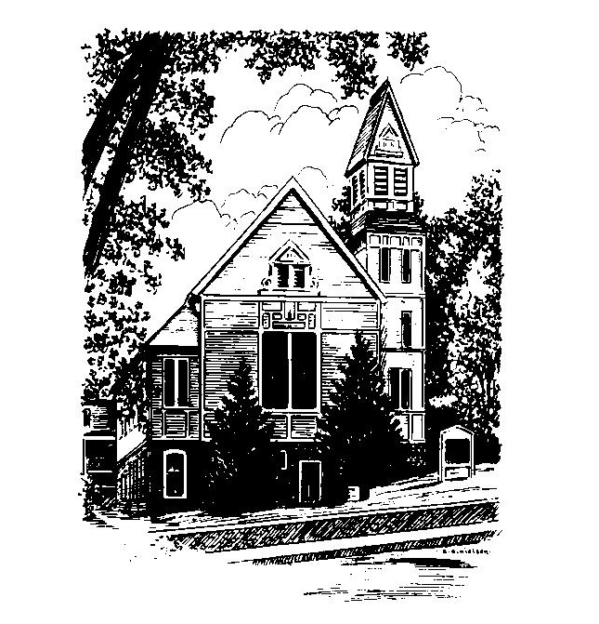
MEMORIAL CONGREGATIONAL
CHURCH
U.C.C. BALDWINVILLE, MA.
An Open and Affirming Church of
the United Church of Christ

February 23, 2025

No Matter Who You Are, No Matter Where
You Are on Life’s Journey; You Are
Welcome Here!

PRELUDE

WELCOME

CALL TO WORSHIP

Leader: The Lord of Hosts calls us out of our isolation to
join hands with our sisters and brothers in this
community of faith and throughout all creation.
People: We are called out of the hype and double-talk
of our world to hear the voice of eternity speak to
us through the word and inspire us by the Spirit.
Leader: We are called to embrace life, and to proclaim
love.
People: Let us worship in spirit and in truth!

*HYMN Morning Has Broken Red Hymnal #53

*UNISON PRAYER OF INVOCATION

Lord of Life, we gather as your people to worship you and to receive your goodness into our lives. Lend flavor to our lives that we may be the salt of the earth. Light us with the fire of your Spirit that we may shine as lights of prophetic truth. Strengthen us in this hour that our words and deeds might flow forth from this place and nourish the growth of love and justice and peace in your world. Amen.

*SHARING THE PEACE OF CHRIST
One: May the peace of Christ be with you!
Many: And also with you!
--Please “Pass the Peace” however you feel comfortable as we sing Amen!
*AMEN (Sung twice) Red Hymnal #317

OFFERING OURSELVES AND OUR GIFTS
CALL TO GIVING
As our offering is brought forward let us sing:
Praise God, from whom all blessings flow;
Praise God, all creatures here below;
Alleluia! Alleluia!
Praise God above, you heavenly host;
Praise Father, Son, and Holy Ghost.
Alleluia! Alleluia! Alleluia!
Alleluia! Alleluia!
PRAYER OF DEDICATION

FIRST SCRIPTURE READING Genesis 9:8-17

SPECIAL MUSIC

SECOND SCRIPTURE READING 1 Peter 3:18-22

MESSAGE Just a Reminder

*HYMN For the Beauty of the Earth Red Hymnal #56

SHARING OUR PRAYERS, OUR JOYS, OUR HOPES

PASTORAL PRAYER

THE LORD’S PRAYER

Our father who art in heaven hallowed be thy name. Thy kingdom come thy will be done on earth as it is in heaven. Give us this day our daily bread and forgive us our trespasses as we forgive those who trespass against us. And lead us not into temptation but deliver us from evil. For thine is the kingdom and the power and the glory forever. Amen.
-Response (singing)
Hear our Prayer, O Lord, Hear our prayer O Lord.
Incline thine ear to us, and grant us thy peace.
Amen

*HYMN: Love Divine, All Loves Excelling
Red Hymnal #517

*BENEDICTION

POSTLUDE

