To Contact Us:
Church Office: 978-939-8821
Church website: www.baldwinvillecongochurch.org
Organist: Michelle Salvanelli
Videographer: Jeff Salvanelli
Church Wi-Fi password: Memorial 1874

Deacon of the Month: Barbara Woodbury
Liturgist: Barbara Woodbury
Our current pulpit supply preacher is Rev. Mike Scott.

Today:
Coffee and refreshments downstairs following
worship. Everyone is invited.
Deacons will meet following worship

*denotes “All who are able please stand”.
Masking is optional

Meditation Thought

If your prayer isn't answered, this may tell you more about you and your prayer than it does about God. Don't try too hard to feel religious, to generate some healing power of your own. Think of yourself instead (if you have to think of yourself at all) as a rather small-gauge clogged-up pipe that a little of God's power may be able to filter through if you can just stay loose enough. Tell the one you're praying for to stay loose too.
If God doesn't seem to be giving you what you ask, maybe he's giving you something else.
-Frederick Buechner (Originally published in Wishful Thinking and later in Beyond Words).
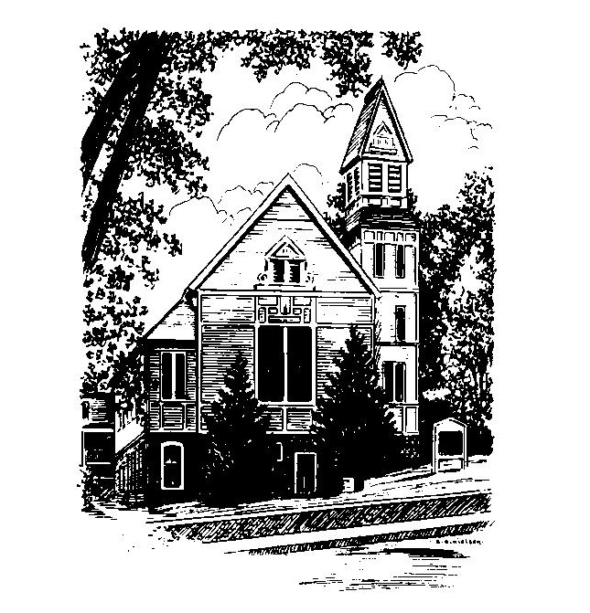
MEMORIAL CONGREGATIONAL
CHURCH
U.C.C. BALDWINVILLE, MA.
An Open and Affirming Church of
the United Church of Christ

February 16, 2025

No Matter Who You Are, No Matter Where
You Are on Life’s Journey; You Are
Welcome Here!

PRELUDE

WELCOME

CALL TO WORSHIP

Leader: We come seeking the holy love of the Lord,
that we may become whole and loving.
People: We come seeking the Spirit
that fills the world with hope,
that we might be filled with that same
Spirit.
Leader: In humbleness, faith, and thanksgiving,
let us rejoice in that Spirit’s presence.
People: Come, let us worship.

*HYMN Sweet, Sweet Spirit Red Hymnal #261

*UNISON PRAYER OF INVOCATION

We thank you, O Divine Author of Hope, for calling us into your church to be your servant people in the world. We are ready to hear your word; speak to us, give us courage to hear and do your will. Give us patience to wait for the wind of your Spirit. With all our doubts and fears and shortcomings, we hope to follow Jesus in our time and place. Guide us by your loving Spirit. We pray in Jesus’ name. Amen.

*SHARING THE PEACE OF CHRIST
One: May the peace of Christ be with you!
Many: And also with you!
--Please “Pass the Peace” however you feel comfortable as we sing Amen!
*AMEN (Sung twice) Red Hymnal #317

OFFERING OURSELVES AND OUR GIFTS
CALL TO GIVING
As our offering is brought forward let us sing:
Praise God, from whom all blessings flow;
Praise God, all creatures here below;
Alleluia! Alleluia!
Praise God above, you heavenly host;
Praise Father, Son, and Holy Ghost.
Alleluia! Alleluia! Alleluia!
Alleluia! Alleluia!
PRAYER OF DEDICATION

FIRST SCRIPTURE READING Jeremiah 17:5-10

SPECIAL MUSIC

GOSPEL READING Luke 6:17-26

MESSAGE A Cure for Heart Disease

*HYMN There Is a Balm in Gilead Red Hymnal #501

SHARING OUR PRAYERS, OUR JOYS, OUR HOPES

PASTORAL PRAYER

THE LORD’S PRAYER

Our father who art in heaven hallowed be thy name. Thy kingdom come thy will be done on earth as it is in heaven. Give us this day our daily bread and forgive us our trespasses as we forgive those who trespass against us. And lead us not into temptation but deliver us from evil. For thine is the kingdom and the power and the glory forever. Amen.
-Response (singing)
Hear our Prayer, O Lord, Hear our prayer O Lord.
Incline thine ear to us, and grant us thy peace.
Amen

*HYMN: Renew Your Church Red Hymnal #463

*BENEDICTION

POSTLUDE

