To Contact Us:
Church Office: 978-939-8821
Church website: www.baldwinvillecongochurch.org
Organist: Michelle Salvanelli
Videographer: Jeff Salvanelli
Church Wi-Fi password: Memorial 1874

Deacon of the Month: Barbara Woodbury
Liturgist: Barbara Woodbury
Our current pulpit supply preacher is Rev. Mike Scott.

Today:
Coffee and refreshments downstairs following
worship. Everyone is invited.
Deacons will meet following worship

*denotes “All who are able please stand”.
Masking is optional

Meditation Thought

The Word become flesh. Ultimate Mystery born with a skull you could crush one-handed. Incarnation. It is not tame. It is not touching. It is not beautiful. It is uninhabitable terror. It is unthinkable darkness riven with unbearable light. Agonized laboring led to it, vast upheavals of intergalactic space/time split apart, a wrenching and tearing of the very sinews of reality itself. You can only cover your eyes and shudder before it, before this: "God of God, Light of Light, very God of very God . . . who for us and for our salvation," as the Nicene Creed puts it, "came down from heaven."
-Frederick Buechner (Originally published in Whistling in the Dark and later in Beyond Words).
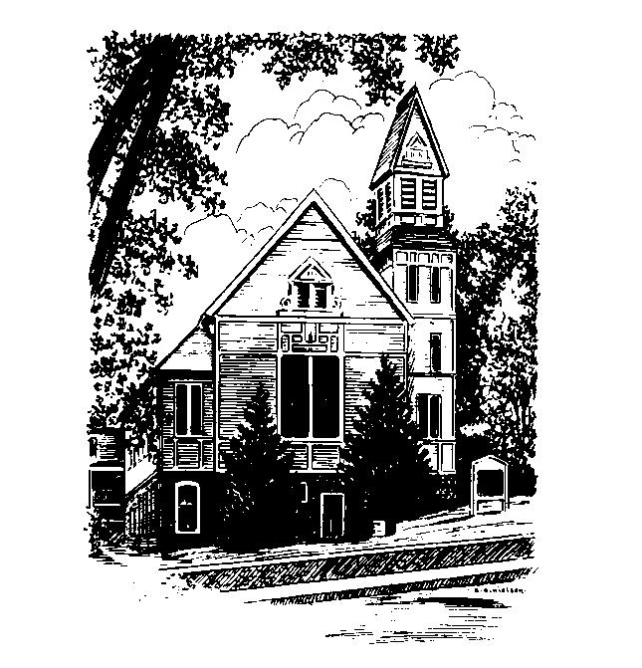
MEMORIAL CONGREGATIONAL
CHURCH
U.C.C. BALDWINVILLE, MA.
An Open and Affirming Church of
the United Church of Christ

February 9, 2025

No Matter Who You Are, No Matter Where
You Are on Life’s Journey; You Are
Welcome Here!

PRELUDE

WELCOME

CALL TO WORSHIP (Based on Jeremiah 17:7-8)

Leader: Let us praise the One who gives us living water
to restore our souls.
People: Like trees planted by the water are those who
trust in the Lord.
Leader: Like trees with deep roots are those whose faith
is in the Everlasting Power of Love.
People: Like green trees in winter are those who bear
the fruit of the Spirit. Let us Praise the Lord, our
source of life and joy!

*HYMN Spirit Red Hymnal #249

*UNISON PRAYER OF INVOCATION

Living Lord, come, be known among us. Help us to perceive your presence, as near as breath, yet hidden. Help us to seek you as you are seeking us. Speak your word of love, your word of healing and of hope. Make us true disciples of Christ. Transform us through your Spirit. Amen.

*SHARING THE PEACE OF CHRIST
One: May the peace of Christ be with you!
Many: And also with you!
--Please “Pass the Peace” however you feel comfortable as we sing Amen!
*AMEN (Sung twice) Red Hymnal #317

OFFERING OURSELVES AND OUR GIFTS
CALL TO GIVING
As our offering is brought forward let us sing:
Praise God, from whom all blessings flow;
Praise God, all creatures here below;
Alleluia! Alleluia!
Praise God above, you heavenly host;
Praise Father, Son, and Holy Ghost.
Alleluia! Alleluia! Alleluia!
Alleluia! Alleluia!
PRAYER OF DEDICATION

FIRST SCRIPTURE READING Isaiah 6:1-8

SPECIAL MUSIC

GOSPEL READING Luke 5:1-11

MESSAGE A Holy Terror

*HYMN Holy, Holy, Holy! Lord God Almighty
Red Hymnal #4

SHARING OUR PRAYERS, OUR JOYS, OUR HOPES

PASTORAL PRAYER

THE LORD’S PRAYER

Our father who art in heaven hallowed be thy name. Thy kingdom come thy will be done on earth as it is in heaven. Give us this day our daily bread and forgive us our trespasses as we forgive those who trespass against us. And lead us not into temptation but deliver us from evil. For thine is the kingdom and the power and the glory forever. Amen.
-Response (singing)
Hear our Prayer, O Lord, Hear our prayer O Lord.
Incline thine ear to us, and grant us thy peace.
Amen

*HYMN: God of Grace and God of Glory
Red Hymnal #464

*BENEDICTION

POSTLUDE

