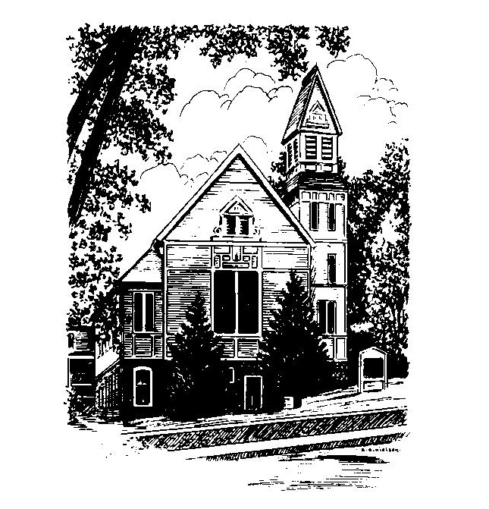
To Contact Us:
Church Office: 978-939-8821
Church website: www.baldwinvillecongochurch.org
Organist: Michelle Salvanelli
Videographer: Jeff Salvanelli
Church Wi-Fi password: Memorial 1874

Deacon of the Month: Barbara Woodbury
Liturgist: Barbara Woodbury
Our current pulpit supply preacher is Rev. Mike Scott.
Today: Coffee and conversation downstairs.

*denotes “All who are able please stand”. Masking is optional

COMMUNION TODAY -We take communion by intinction. We invite all who would share in Christ’s grace to come forward and take bread and dip it in the communion cup and eat with the blessing of Christ.

Meditation Thought

The visible church is all the people who get together from time to time in God's name. Anybody can find out who they are by going to church to look.
The invisible church is all the people God uses for his hands and feet in this world. Nobody can find out who they are except God.
Think of them as two circles. The optimist says they are concentric. The cynic says they don't even touch. The realist says they occasionally overlap.
In a fit of high inspiration, the author of the book of Revelation states that there is no temple in the New Jerusalem, thus squelching once and for all the tedious quip that since heaven is an endless church service, anybody with two wits to rub together would prefer hell.
-Frederick Buechner
(Originally published in Wishful Thinking and later in Beyond Words)
MEMORIAL CONGREGATIONAL CHURCH
U.C.C. BALDWINVILLE, MA.
An Open and Affirming Church of
the United Church of Christ
February 2, 2025

No Matter Who You Are, No Matter Where
You Are on Life’s Journey; You Are Welcome Here!

PRELUDE

WELCOME

CALL TO WORSHIP
Leader: We come this morning with hopes high and
imaginations intact.
People: We come ready to step boldly into the future.
Leader: Let us set aside every weight that hinders us and
journey together with grace and joy.
People: Let us come before the Lord in eagerness and
expectation.

*HYMN In Christ There Is No East or West
Black Hymnal #395

*UNISON PRAYER OF INVOCATION
God of all times and all peoples, we come before you carrying our hopes and dreams, our plans and agendas. When we look at how ordered and predictable we try to make our lives and how unruly and capricious your Spirit of Holiness is, we are a little embarrassed. Open our eyes this day, and open our minds, that we might be receptive to the new thing you are about to do in our midst. Grant us, we pray, the grace of your creative spirit, that we might rejoice at your glorious surprises and become your own ambassadors of joy. Amen.

*SHARING THE PEACE OF CHRIST

One: May the peace of Christ be with you!
Many: And also with you!
--Please “Pass the Peace” however you feel comfortable
as we sing Amen!
*AMEN (Sung twice) Red Hymnal #317

OFFERING OURSELVES AND OUR GIFTS

CALL TO GIVING

As our offering is brought forward let us sing:
Praise God, from whom all blessings flow;
Praise God, all creatures here below;
Alleluia! Alleluia!
Praise God above, you heavenly host;
Praise Father, Son, and Holy Ghost.
Alleluia! Alleluia! Alleluia!
Alleluia! Alleluia!

PRAYER OF DEDICATION

FIRST SCRIPTURE READING Ephesians 3:1-12

SPECIAL MUSIC

GOSPEL READING Matthew 2:1-12

MESSAGE Running in Circles
*HYMN Bread of the World, in Mercy Broken
Black Hymnal #346

SHARING OUR PRAYERS, OUR JOYS, OUR HOPES

PASTORAL PRAYER

THE LORD’S PRAYER
Our father who art in heaven hallowed be thy name. Thy kingdom come thy will be done on earth as it is in heaven. Give us this day our daily bread and forgive us our trespasses as we forgive those who trespass against us. And lead us not into temptation but deliver us from evil. For thine is the kingdom and the power and the glory forever. Amen.
-Response (singing)
Hear our Prayer, O Lord, Hear our prayer O Lord.
Incline thine ear to us, and grant us thy peace.
Amen

INVITATION TO THE TABLE
Everyone, of any age, who seeks Christ’s presence
is welcome at this table!.

WORDS OF INSTITUTION

DECLARATION:
Minister: And so, remembering what Christ has done for us,
we come to this table in thanksgiving and commitment,
affirming the ancient creed of our faith:
ALL: (Singing) Christ has died. Christ has Risen.
Christ will come again.

SHARING THE BREAD AND CUP

*HYMN: Sent Forth by God’s Blessing Black Hymnal #76

*BENEDICTION

POSTLUDE

