To Contact Us:
Church Office: 978-939-8821
Church website: www.baldwinvillecongochurch.org
Organist: Michelle Salvanelli
Videographer: Jeff Salvanelli
Church Wi-Fi password: Memorial 1874

Deacon of the Month: Nancy Heaney
Liturgist: Nancy Heaney
Our current pulpit supply preacher is Rev. Mike Scott.

Today:
The Annual Meeting of our church will be held in the
sanctuary after worship.
Following the Annual Meeting, a light luncheon will be
served downstairs. Thank you, Lei and Carol.

*denotes “All who are able please stand”.
Masking is optional

Meditation Thought

God was making a body for Christ, Paul said. Christ didn't have a regular body any more so God was making him one out of anybody he could find who looked as if he might just possibly do. He was using other people's hands to be Christ's hands and other people's feet to be Christ's feet, and when there was some place where Christ was needed in a hurry and needed bad, he put the finger on some maybe-not-all-that-innocent bystander and got him to go and be Christ in that place himself for lack of anybody better.

-Fredrich Buechner (first published in Peculiar Treasures and later in Beyond Words).

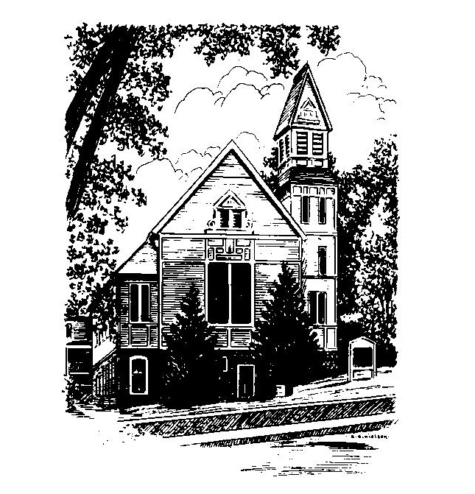
MEMORIAL CONGREGATIONAL
CHURCH
U.C.C. BALDWINVILLE, MA.
An Open and Affirming Church of
the United Church of Christ

January 26, 2025

No Matter Who You Are, No Matter Where
You Are on Life’s Journey; You Are
Welcome Here!

PRELUDE

WELCOME

CALL TO WORSHIP AND CONFESSION

Leader May the One whose Word is good news for us
open our hearts
People that we may listen and hear,
Leader open our minds
People that we may appreciate and understand how
blessed we are to join hands here and touch
holiness!

*HYMN O God of Vision Red Hymnal #288

*UNISON PRAYER OF INVOCATION

O Lord, distant yet near, we gather as witnesses to your promise that if we seek you with all our hearts, we will find you. Be among us this day. Hear the yearnings of our hearts. Help us change the narrowness of our vision and the pettiness of our living. Make us new again with your grace. Grant to us your spirit that our worship may have integrity and energy, ever witnessing to your holy presence in our lives. Amen.

*SHARING THE PEACE OF CHRIST
One: May the peace of Christ be with you!
Many: And also with you!
--Please “Pass the Peace” however you feel comfortable as we sing Amen!
*AMEN (Sung twice) Red Hymnal #317

OFFERING OURSELVES AND OUR GIFTS
CALL TO GIVING
As our offering is brought forward let us sing:
Praise God, from whom all blessings flow;
Praise God, all creatures here below;
Alleluia! Alleluia!
Praise God above, you heavenly host;
Praise Father, Son, and Holy Ghost.
Alleluia! Alleluia! Alleluia!
Alleluia! Alleluia!
PRAYER OF DEDICATION

FIRST SCRIPTURE READING
1 Corinthians 12:12-31a

SPECIAL MUSIC

GOSPEL READING Luke 4:14-21

MESSAGE Body Parts

*HYMN They'll Know We Are Christians
Red Hymnal #494

SHARING OUR PRAYERS, OUR JOYS, OUR HOPES

PASTORAL PRAYER

THE LORD’S PRAYER

Our father who art in heaven hallowed be thy name. Thy kingdom come thy will be done on earth as it is in heaven. Give us this day our daily bread and forgive us our trespasses as we forgive those who trespass against us. And lead us not into temptation but deliver us from evil. For thine is the kingdom and the power and the glory forever. Amen.
-Response (singing)
Hear our Prayer, O Lord, Hear our prayer O Lord.
Incline thine ear to us, and grant us thy peace.
Amen

*HYMN: Blest Be the Tie That Binds
Red Hymnal #433

*BENEDICTION

POSTLUDE

