To Contact Us:
Church Office: 978-939-8821
Church website: www.baldwinvillecongochurch.org
Organist: Michelle Salvanelli
Videographer: Jeff Salvanelli
Church Wi-Fi password: Memorial 1874

Deacon of the Month: Nancy Heaney
Liturgist: Nancy Heaney
Our current pulpit supply preacher is Rev. Mike Scott.

Today:
Coffee and Conversation downstairs following worship

*denotes “All who are able please stand”. Masking is optional

Meditation Thought

“Everybody can be great...because anybody can serve. You don't have to have a college degree to serve. You don't have to make your subject and verb agree to serve. You only need a heart full of grace. A soul generated by love.”

― Martin Luther King Jr.

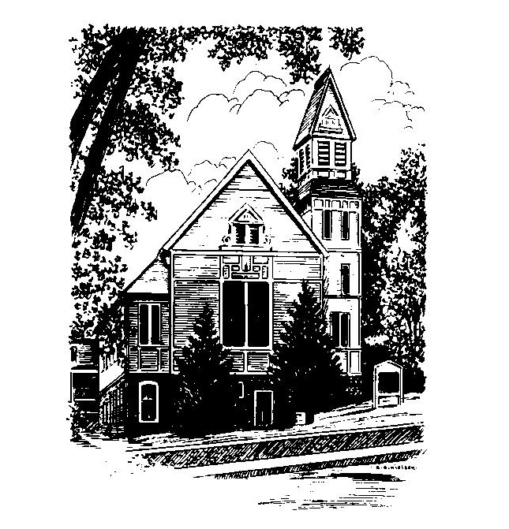
MEMORIAL CONGREGATIONAL
CHURCH
U.C.C. BALDWINVILLE, MA.
An Open and Affirming Church of
the United Church of Christ
January 19, 2025

No Matter Who You Are, No Matter Where
You Are on Life’s Journey; You Are
Welcome Here!

PRELUDE

WELCOME

CALL TO WORSHIP AND CONFESSION

Leader: We gather here to celebrate life, and to devote
ourselves to the ministry of reconciliation.
People: But we have much to confess even as we
celebrate:
Leader: The tools of science we have created bring both
medical miracles and the devastation of war.
People: The pleasures we chase often end up leaving
us empty.
Leader: Our love of wealth and power often crowd out
the loving relationships that would fill our hearts with
the joy and peace for which we long.
People: Have faith, the Lord of Life grants us new life
and new opportunity each day!
Leader: Let us seize this day and this hour to turn our
hearts toward Divine grace, hope, and peace.
People: Let us sing and celebrate the joy of forgiving
love!

*HYMN Stars and Planets Flung in Orbit
Black Hymnal #567

*UNISON PRAYER OF INVOCATION
O Lord, who has made all people to dwell on the earth as one family: we join our hearts and voices on this day to dedicate ourselves to breaking down the barriers of fear and suspicion that divide us, building bridges of love and justice, learning to recognize one another as brothers and sisters, and embracing one another in reconciling love. Gathering us hand to hand, lead us to join with you to make justice roll down like waters on this earth and to make life a blessing to all. We pray this in the name of our brother, Jesus. Amen.

*SHARING THE PEACE OF CHRIST
One: May the peace of Christ be with you!
Many: And also with you!
--Please “Pass the Peace” however you feel comfortable as we sing Amen!
*AMEN (Sung twice) Red Hymnal #317

OFFERING OURSELVES AND OUR GIFTS
CALL TO GIVING
As our offering is brought forward let us sing:
Praise God, from whom all blessings flow;
Praise God, all creatures here below;
Alleluia! Alleluia!
Praise God above, you heavenly host;
Praise Father, Son, and Holy Ghost.
Alleluia! Alleluia! Alleluia!
Alleluia! Alleluia!
PRAYER OF DEDICATION
FIRST SCRIPTURE READING Psalm 139:1-18

SPECIAL MUSIC

SECOND SCRIPTURE READING
1 Corinthians 12:1-11

MESSAGE Fearfully and Wonderfully Made

*HYMN De Colores Black Hymnal #402

SHARING OUR PRAYERS, OUR JOYS, OUR HOPES

PASTORAL PRAYER

THE LORD’S PRAYER

Our father who art in heaven hallowed be thy name. Thy kingdom come thy will be done on earth as it is in heaven. Give us this day our daily bread and forgive us our trespasses as we forgive those who trespass against us. And lead us not into temptation but deliver us from evil. For thine is the kingdom and the power and the glory forever. Amen.
-Response (singing)
Hear our Prayer, O Lord, Hear our prayer O Lord.
Incline thine ear to us, and grant us thy peace.
Amen

*HYMN: We Shall Overcome Black Hymnal #570

*BENEDICTION

POSTLUDE

