To Contact Us:
Church Office: 978-939-8821
Church website: www.baldwinvillecongochurch.org
Organist: Michelle Salvanelli
Videographer: Jeff Salvanelli
Church Wi-Fi password: Memorial 1874

Deacon of the Month: Nancy Heaney
Liturgist: Nancy Heaney
Our current pulpit supply preacher is Rev. Mike Scott.

Today:
Coffee and Conversation downstairs following worship

*denotes “All who are able please stand”. Masking is optional

Meditation Thought

You can think of God as a great . . . cosmic artist, a singer, say, of such power and magnificence and so caught up in the incandescence of his own art that he never notices that he has long since ruptured the eardrums of his listeners and reduced them to quivering pulp. "Have you an arm like God, and can you thunder with a voice like his?" he asked [Job]. (Job 40:9)

-Frederick Buechner
(Originally published in Peculiar Treasures and later in Beyond Words)

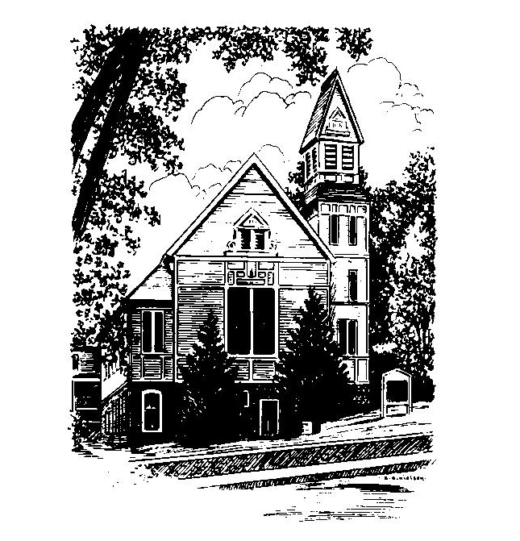
MEMORIAL CONGREGATIONAL
CHURCH
U.C.C. BALDWINVILLE, MA.
An Open and Affirming Church of
the United Church of Christ
January 12, 2025

No Matter Who You Are, No Matter Where
You Are on Life’s Journey; You Are
Welcome Here!

PRELUDE

WELCOME

CALL TO WORSHIP

Leader: Sisters and brothers, we are here to claim the joy
and proclaim the wonder of saving grace.
People: Let the sea roar, and all that fills it;
the world and those who live in it.
Let the floods clap their hands;
let the hills sing together for joy
Leader: We are here to take up the high calling
of the Lord's liberating truth.
People: Let justice roll down like waters,
and righteousness like an everflowing
stream.

*HYMN Sing Praise to God Who Reigns Above
Red Hymnal #6
*UNISON PRAYER OF INVOCATION

Lord and Ruler of all peoples, we gather here as a small group of your beloved children, and pray that you would bind our hearts in this hour to all the myriads around the globe who gather also in your presence and sing your praises. Shatter the barriers in our own hearts, we pray, that we might be inspired and strengthened to break down walls and build bridges in the name of the one who came to reveal your boundless love, Jesus Christ, our Lord.

*SHARING THE PEACE OF CHRIST
One: May the peace of Christ be with you!
Many: And also with you!
--Please “Pass the Peace” however you feel comfortable
as we sing Amen!
*AMEN (Sung twice) Red Hymnal #317

OFFERING OURSELVES AND OUR GIFTS

CALL TO GIVING
As our offering is brought forward let us sing:
Praise God, from whom all blessings flow;
Praise God, all creatures here below;
Alleluia! Alleluia!
Praise God above, you heavenly host;
Praise Father, Son, and Holy Ghost.
Alleluia! Alleluia! Alleluia!
Alleluia! Alleluia!

PRAYER OF DEDICATION
FIRST SCRIPTURE READING Psalm 29

SPECIAL MUSIC

GOSPEL READING Luke 3:15-17, 21-22

MESSAGE The Voice of the Lord Thunders

*HYMN O Worship the King
Red Hymnal #17

SHARING OUR PRAYERS, OUR JOYS, OUR HOPES

PASTORAL PRAYER

THE LORD’S PRAYER

Our father who art in heaven hallowed be thy name. Thy kingdom come thy will be done on earth as it is in heaven. Give us this day our daily bread and forgive us our trespasses as we forgive those who trespass against us. And lead us not into temptation but deliver us from evil. For thine is the kingdom and the power and the glory forever. Amen.
-Response (singing)
Hear our Prayer, O Lord, Hear our prayer O Lord.
Incline thine ear to us, and grant us thy peace.
Amen

*HYMN: Praise to the Lord, the Almighty
Red Hymnal #25

*BENEDICTION

POSTLUDE

