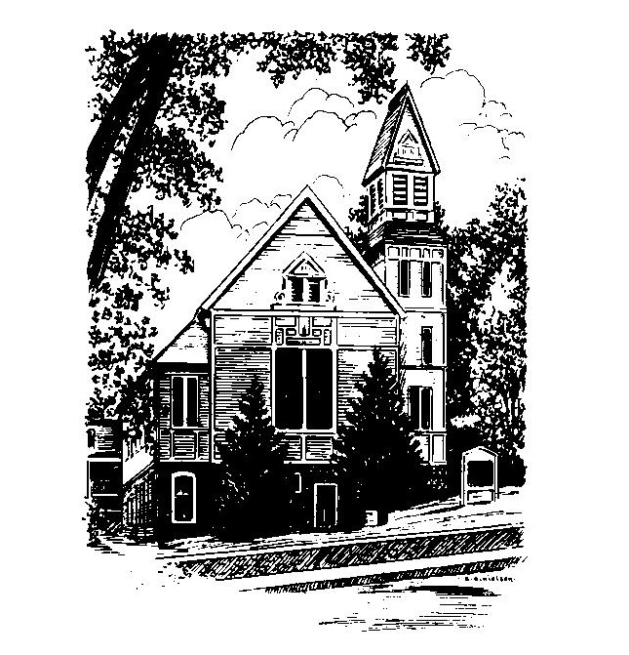
To Contact Us:
Church Office: 978-939-8821
Church website: www.baldwinvillecongochurch.org
Organist: Michelle Salvanelli
Videographer: Jeff Salvanelli
Church Wi-Fi password: Memorial 1874

Deacon of the Month: Nancy Heaney
Liturgist: Nancy Heaney
Our current pulpit supply preacher is Rev. Mike Scott.
Today: Coffee and conversation downstairs.

*denotes “All who are able please stand”. Masking is optional

COMMUNION TODAY -We take communion by intinction. We invite all who would share in Christ’s grace to come forward and take bread and dip it in the communion cup and eat with the blessing of Christ.

Meditation Thought

The gifts that the three Wise Men, or Kings, or Magi, brought to the manger in Bethlehem cost them plenty but seem hardly appropriate to the occasion. Maybe they were all they could think of for the child who had everything. In any case, they set them down on the straw—the gold, the frankincense, the myrrh—worshiped briefly, and then returned to the East where they had come from. It gives you pause to consider how, for all their great wisdom, they overlooked the one gift that the child would have been genuinely pleased to have someday, and that was the gift of themselves and their love.

-Frederick Buechner

(Originally published in Peculiar Treasures and later in Listening to Your Life)

MEMORIAL CONGREGATIONAL CHURCH
U.C.C. BALDWINVILLE, MA.
An Open and Affirming Church of
the United Church of Christ
January 5, 2025
Epiphany Sunday

No Matter Who You Are, No Matter Where
You Are on Life’s Journey; You Are Welcome Here!

PRELUDE

WELCOME

CALL TO WORSHIP
Leader: Come, that we may be strengthened with the gift of
peace.
People: Then justice will dwell in the wilderness,
and righteousness abide in the fruitful field.
Leader: The effect of righteousness will be peace,
And the result of righteousness, quietness and
trust. Hear the promise of the Lord: I will grant
peace in the land, And you shall lie down, and
no one shall make you afraid.
People: Blessed are the peacemakers, for they will be
called children of the Most High.
Praise the Lord.

*HYMN God of Our Life Red Hymnal #713

*UNISON PRAYER OF INVOCATION
O Lord, you call us into this new year still to be named. Help us travel light in faith and expectation. Guide us in the venture of imagination you set before us. Make us bold witnesses to the in-breaking of your future. Let us rest our times in yours, confident that we do not enter this new year alone. Amen..
*SHARING THE PEACE OF CHRIST

One: May the peace of Christ be with you!
Many: And also with you!
--Please “Pass the Peace” however you feel comfortable
as we sing Amen!
*AMEN (Sung twice) Red Hymnal #317

OFFERING OURSELVES AND OUR GIFTS

CALL TO GIVING

As our offering is brought forward let us sing:
Praise God, from whom all blessings flow;
Praise God, all creatures here below;
Alleluia! Alleluia!
Praise God above, you heavenly host;
Praise Father, Son, and Holy Ghost.
Alleluia! Alleluia! Alleluia!
Alleluia! Alleluia!

PRAYER OF DEDICATION

FIRST SCRIPTURE READING Ephesians 3:1-12

SPECIAL MUSIC

GOSPEL READING Matthew 2:1-12

MESSAGE Epiphany
*HYMN We Three Kings Red Hymnal #172

SHARING OUR PRAYERS, OUR JOYS, OUR HOPES

PASTORAL PRAYER

THE LORD’S PRAYER

Our father who art in heaven hallowed be thy name. Thy kingdom come thy will be done on earth as it is in heaven. Give us this day our daily bread and forgive us our trespasses as we forgive those who trespass against us. And lead us not into temptation but deliver us from evil. For thine is the kingdom and the power and the glory forever. Amen.
-Response (singing)
Hear our Prayer, O Lord, Hear our prayer O Lord.
Incline thine ear to us, and grant us thy peace.
Amen

INVITATION TO THE TABLE
Everyone, of any age, who seeks Christ’s presence
is welcome at this table!.

WORDS OF INSTITUTION

DECLARATION:
Minister: And so, remembering what Christ has done for us,
we come to this table in thanksgiving and commitment,
affirming the ancient creed of our faith:
ALL: (Singing) Christ has died. Christ has Risen.
Christ will come again.

SHARING THE BREAD AND CUP

*HYMN: Arise, Your Light Is Come Black Hymnal #164

*BENEDICTION

POSTLUDE

