To Contact Us:
Church Office: 978-939-8821
Church website: www.baldwinvillecongochurch.org
Organist: Michelle Salvanelli
Videographer: Jeff Salvanelli
Church Wi-Fi password: Memorial 1874

Deacon of the Month: Joanne Francis
Liturgist: Nowell Francis
Our current pulpit supply preacher is Rev. Mike Scott.

Today:
Coffee and conversation downstairs after worship

*denotes “All who are able please stand”. Masking is optional

Meditation Thought
As we think about the changing of the calendar at midnight Tuesday night, a word from Frederick Buechner about time:

The Greek word chronos means "time" in a quantitative sense, chronological time, time that you can divide into minutes and years, time as duration. It is the sense that we mean when we say, "What time is it?" or "How much time do I have?" or "Time like an ever-flowing stream," in one of the hymns that we sing. But in Greek there is also the word kairos, which means "time" in a qualitative sense—not the kind that a clock measures but time that cannot be measured at all, time that is characterized by what happens in it. Kairos time is the kind that you mean when you say that "the time is ripe" to do something, "It's time to tell the truth," a truth-telling kind of time. Or " I had a good time"—the time had something about it that made me glad. The ancient poet who wrote the Book of Ecclesiastes was using time in a kairos sense when he wrote of a time to weep and a time to laugh, a time to keep silence and a time to speak.
-Frederick Buechner
(Originally published in The Hungering Dark and later in Listening to Your Life)

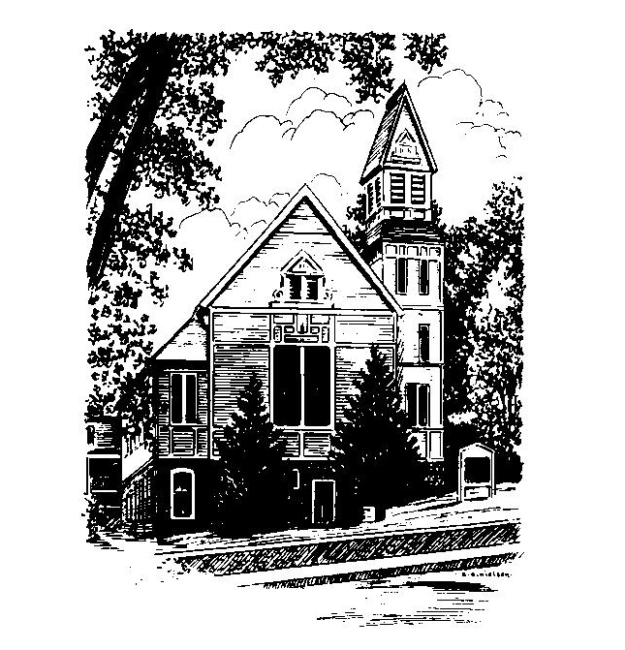
MEMORIAL CONGREGATIONAL
CHURCH
U.C.C. BALDWINVILLE, MA.
An Open and Affirming Church of
the United Church of Christ
December 29, 2024

No Matter Who You Are, No Matter Where
You Are on Life’s Journey; You Are Welcome Here!

PRELUDE

WELCOME

CALL TO WORSHIP

Leader: We come into God’s presence
seeking courage and strength for the year ahead.
People: We come praying that we will be saved
from timidity and doubt.
Leader: We come seeking the joy of simple pleasures.
People: We come seeking noble tasks for our energies.
Leader: We come glowing in the blessing of friendship.
People: Let us worship in joy and gladness,
seeking growth, vision, and dedication to service
in the new year.

*HYMN Good Christian Friends, Rejoice
Red Hymnal #164

* OPENING PRAYER (UNISON)
Everlasting Author of all the years, you have been our companion through all the mysteries of the past to uphold us when we did not know the way. Take our hands now and share our pilgrimage to an unknown future. Open our eyes to recognize your presence with us this day that we may give you praise and celebrate the goodness of your guidance. Renew us. Refresh us. Fill us with your Spirit. Amen.

*SHARING THE PEACE OF CHRIST
One: May the peace of Christ be with you!
Many: And also with you!
--Please “Pass the Peace” however you feel comfortable
as we sing Amen!
*AMEN (Sung twice) Red Hymnal #317

OFFERING OURSELVES AND OUR GIFTS

CALL TO GIVING
As our offering is brought forward let us sing:
Praise God, from whom all blessings flow;
Praise God, all creatures here below;
Alleluia! Alleluia!
Praise God above, you heavenly host;
Praise Father, Son, and Holy Ghost.
Alleluia! Alleluia! Alleluia!
Alleluia! Alleluia!

PRAYER OF DEDICATION

FIRST SCRIPTURE READING 1 Samuel 2:18-20, 26

SPECIAL MUSIC

GOSPEL READING Luke 2:41-52

MESSAGE Letting Go

*HYMN Be Still, My Soul Red Hymnal #566

SHARING OUR PRAYERS, OUR JOYS, OUR HOPES

PASTORAL PRAYER

THE LORD’S PRAYER

Our father who art in heaven hallowed be thy name. Thy kingdom come thy will be done on earth as it is in heaven. Give us this day our daily bread and forgive us our trespasses as we forgive those who trespass against us. And lead us not into temptation but deliver us from evil. For thine is the kingdom and the power and the glory forever. Amen.
-Response (singing)
Hear our Prayer, O Lord, Hear our prayer O Lord.
Incline thine ear to us, and grant us thy peace.
Amen

*HYMN: Go, Tell It on the Mountain Red Hymnal #167

*BENEDICTION

POSTLUDE

