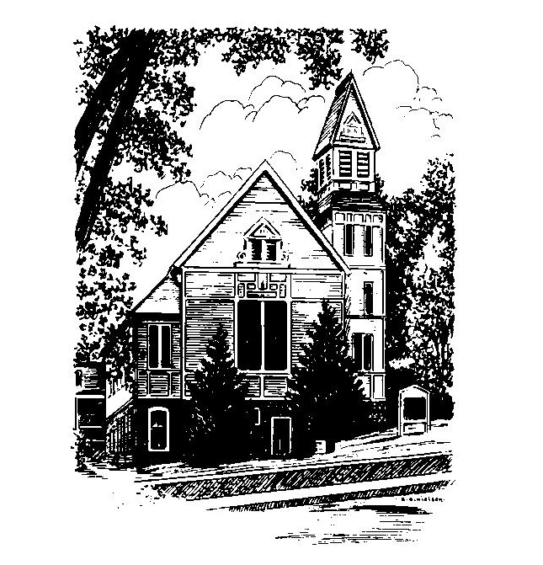
To Contact Us:
Church Office: 978-939-8821
Church website: www.baldwinvillecongochurch.org
Organist: Michelle Salvanelli
Videographer: Jeff Salvanelli
Church Wi-Fi password: Memorial 1874

Deacon of the Month: Joanne Francis
Liturgist: Nowell Francis
Our current supply preacher is Rev. Mike Scott.
Today: Coffee and conversation downstairs

Don’t forget our Christmas Eve service of candles, music, and readings. Tuesday evening at 5:00.

*denotes “All who are able please stand”. Masking is optional

Meditation Thought
The love for equals is a human thing—of friend for friend, brother for brother. It is to love what is loving and lovely. The world smiles.
The love for the less fortunate is a beautiful thing—the love for those who suffer, for those who are poor, the sick, the failures, the unlovely. This is compassion, and it touches the heart of the world.
The love for the more fortunate is a rare thing—to love those who succeed where we fail, to rejoice without envy with those who rejoice, the love of the poor for the rich, of the black man for the white man. The world is always bewildered by its saints.
And then there is the love for the enemy—love for the one who does not love you but mocks, threatens, and inflicts pain. The tortured's love for the torturer. This is God's love. It conquers the world.
-Frederick Buechner
(Originally published in The Magnificent Defeat)
MEMORIAL CONGREGATIONAL CHURCH U.C.C. BALDWINVILLE, MA.
An Open and Affirming Church of
the United Church of Christ
December 22, 2024

No Matter Who You Are, No Matter Where
You Are on Life’s Journey; You Are Welcome Here!

The Church Family Gathers
for the Fourth Sunday of Advent

PRELUDE

WELCOME

CALL TO WORSHIP

Leader: Now is the time of watching and waiting.
People: The time of expectation and new life.
Leader: Now is the season of hope unfolding.
People: Let us come before the Lord with receptive and willing spirits.
Leader: May we hear and celebrate Divine promises.
People: Let us rejoice! The Babe of Bethlehem brings us life and hope.

*HYMN Once In Royal David’s City Red Hymnal #165

*OPENING PRAYER (unison)
Lord of Love, we need the light of your love today to shine in all the corners of the world. Come to us and let your spirit shine in our lives, that we may reflect your love to everyone around us. Amen.

LIGHTING THE FOURTH CANDLE
ON THE ADVENT WREATH
Lei and Larry Messer
CONGREGATIONAL RESPONSE
One Candle Is Lit (Verse 4 only) Red Hymnal #128

*SHARING THE PEACE OF CHRIST
One: May the peace of Christ be with you!
Many: And also with you!
--Please “Pass the Peace” however you feel comfortable
as we sing Amen!
*AMEN (Sung twice) Red Hymnal #317
Amen, Amen, Amen, Amen, Amen

OFFERING OURSELVES AND OUR GIFTS
CALL TO GIVING
As our offering is brought forward let us sing:
Praise God, from whom all blessings flow;
Praise God, all creatures here below;
Alleluia! Alleluia!
Praise God above, you heavenly host;
Praise Father, Son, and Holy Ghost.
Alleluia! Alleluia! Alleluia!
Alleluia! Alleluia!

PRAYER OF DEDICATION

FIRST SCRIPTURE 1 John 4:7-12

SPECIAL MUSIC

SECOND SCRIPTURE John 2:1-5,14, 16

MESSAGE Poetry for Advent
“a certain height” On Love

*HYMN Love Divine, All Loves Excelling
Red Hymnal #517

SHARING OUR PRAYERS, OUR JOYS, OUR HOPES

PASTORAL PRAYER

THE LORD’S PRAYER
Our father who art in heaven hallowed be thy name. Thy kingdom come thy will be done on earth as it is in heaven. Give us this day our daily bread and forgive us our trespasses as we forgive those who trespass against us. And lead us not into temptation but deliver us from evil. For thine is the kingdom and the power and the glory forever. Amen.
-Response (sung)
Hear our Prayer, O Lord, Hear our prayer O Lord.
Incline thine ear to us, and grant us thy peace. Amen

*HYMN: O Little Town of Bethlehem
Red Hymnal # 144

*BENEDICTION

POSTLUDE

