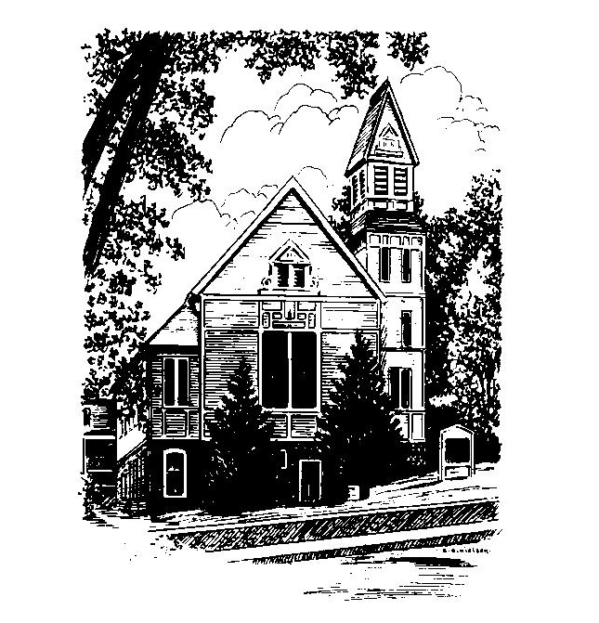
To Contact Us:
Church Office: 978-939-8821
Church website: www.baldwinvillecongochurch.org
Organist: Michelle Salvanelli
Videographer: Jeff Salvanelli
Church Wi-Fi password: Memorial 1874

Deacon of the Month: Joanne Francis

Liturgist: Nowell Francis

Our current supply preacher is Rev. Mike Scott.
Today: Coffee and conversation downstairs

The Discernment Committee will meet following worship today.

*denotes “All who are able please stand”. Masking is optional

Meditation Thought

In the gospel of john, Jesus sums up pretty much everything by saying, "These things I have spoken to you, that my joy may be in you, and that your joy may be full" (John 15:11). He said it at the supper that he knew was the last one at which he'd have a mouth to eat with.
Happiness turns up more or less where you'd expect it to—a good marriage, a rewarding job, a pleasant vacation. Joy, on the other hand, is as notoriously unpredictable as the one who bequeaths it.
-Frederick Buechner (Originally published in
Wishful Thinking, and later in Beyond Words)

MEMORIAL CONGREGATIONAL CHURCH U.C.C. BALDWINVILLE, MA.
An Open and Affirming Church of
the United Church of Christ
December 15, 2024

No Matter Who You Are, No Matter Where
You Are on Life’s Journey; You Are Welcome Here!

The Church Family Gathers
for the Third Sunday of Advent

PRELUDE

WELCOME

CALL TO WORSHIP

Leader: The wilderness shall be glad
and the desert shall blossom.
People: We open our hearts to the promise of new life.
Leader: You with weak hands, God will strengthen you!
You who are fearful, take heart!
People: We look for the birth of Divine Love
on the starry hillsides
and in the quiet stables of our world.
Leader: They shall obtain joy and gladness,
and sorrow and sighing shall flee away.
People: Let us rejoice and sing, for Christ comes to us
and to our world!

*HYMN Lift Up Your Heads, O Mighty Gates
Red Hymnal #129

*OPENING PRAYER (unison)
Eternal Source of hope and human destiny, we seek you in this hour. Come to us, we pray, and fill our lives, our homes, our world with the joy of giving, the devotion to service, and the peace that passes all understanding. Amen.
LIGHTING THE THIRD CANDLE
ON THE ADVENT WREATH
Linda and Jim Bevan
CONGREGATIONAL RESPONSE
One Candle Is Lit (Verse 3 only) Red Hymnal #128

*SHARING THE PEACE OF CHRIST
One: May the peace of Christ be with you!
Many: And also with you!
--Please “Pass the Peace” however you feel comfortable
as we sing Amen!
*AMEN (Sung twice) Red Hymnal #317
Amen, Amen, Amen, Amen, Amen

OFFERING OURSELVES AND OUR GIFTS
CALL TO GIVING
As our offering is brought forward let us sing:
Praise God, from whom all blessings flow;
Praise God, all creatures here below;
Alleluia! Alleluia!
Praise God above, you heavenly host;
Praise Father, Son, and Holy Ghost.
Alleluia! Alleluia! Alleluia!
Alleluia! Alleluia!

PRAYER OF DEDICATION

FIRST SCRIPTURE John 10:7-10

SPECIAL MUSIC

SECOND SCRIPTURE Luke 1:39-55

MESSAGE Poetry for Advent
“Let joy kill you!” On Joy

*HYMN How Great Our Joy Red Hymnal #170

SHARING OUR PRAYERS, OUR JOYS, OUR HOPES

PASTORAL PRAYER

THE LORD’S PRAYER
Our father who art in heaven hallowed be thy name. Thy kingdom come thy will be done on earth as it is in heaven. Give us this day our daily bread and forgive us our trespasses as we forgive those who trespass against us. And lead us not into temptation but deliver us from evil. For thine is the kingdom and the power and the glory forever. Amen.
-Response (sung)
Hear our Prayer, O Lord, Hear our prayer O Lord.
Incline thine ear to us, and grant us thy peace. Amen

*HYMN: Joy to the World! the Lord Is Come
Red Hymnal # 143

*BENEDICTION

POSTLUDE

