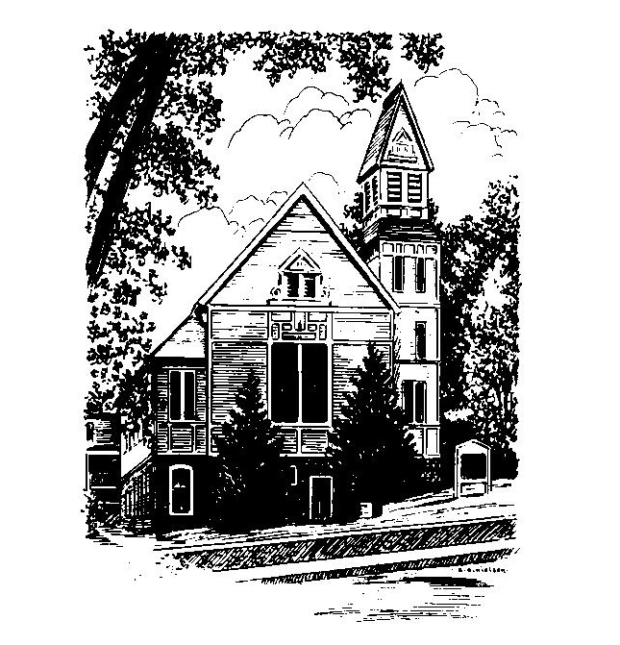
To Contact Us:
Church Office: 978-939-8821
Church website: www.baldwinvillecongochurch.org
Organist: Michelle Salvanelli
Videographer: Jeff Salvanelli
Church Wi-Fi password: Memorial 1874

Deacon of the Month: Joanne Francis
Liturgist: Nowell Francis
Our current supply preacher is Rev. Mike Scott.
Today: Coffee and conversation downstairs

The Deacons will meet following worship today.

*denotes “All who are able please stand”. Masking is optional

Meditation Thought

Peace has come to mean the time when there aren't any wars or even when there aren't any major wars. Beggars can't be choosers; we'd most of us settle for that. But in Hebrew peace, shalom, means fullness, means having everything you need to be wholly and happily yourself.
One of the titles by which Jesus is known is Prince of Peace, and he used the word himself in what seem at first glance to be two radically contradictory utterances. On one occasion he said to the disciples, "Do not think that I have come to bring peace on earth; I have not come to bring peace, but a sword" (Matthew 10:34). And later on, the last time they ate together, he said to them, "Peace I leave with you; my peace I give to you" . . .
The contradiction is resolved when you realize that, for Jesus, peace seems to have meant not the absence of struggle, but the presence of love.
-Frederick Buechner (Originally published in
Wishful Thinking, and later in Beyond Words)
MEMORIAL CONGREGATIONAL CHURCH U.C.C. BALDWINVILLE, MA.
An Open and Affirming Church of
the United Church of Christ
December 8, 2024

No Matter Who You Are, No Matter Where
You Are on Life’s Journey; You Are Welcome Here!

The Church Family Gathers
for the Second Sunday of Advent

PRELUDE

WELCOME

CALL TO WORSHIP

Leader: We have heard the promise. The light of truth is coming to the world.
People: We long for the light, the fulfillment of the promise of Bethlehem.
Leader: The Spirit of Holiness will be with us. Our hope will not be in vain.
People: We wait and watch for the dawning of Divine grace in our lives.

*HYMN Come, O Long Expected Jesus Red Hymnal #125

*Opening Prayer (unison)
Lord of Hope, with expectant hearts we, your people, await Christ’s coming. May the Peace of Christmas enter our lives and transform us. May the Love of Christ find an open door at our hearts and an eager welcome. And may the Joy of his coming overtake us in this holy season. Amen

LIGHTING THE SECOND CANDLE
ON THE ADVENT WREATH
Nowell and Joanne Francis
CONGREGATIONAL RESPONSE
One Candle Is Lit (Verse 2 only) Red Hymnal #128

*SHARING THE PEACE OF CHRIST
One: May the peace of Christ be with you!
Many: And also with you!
--Please “Pass the Peace” however you feel comfortable
as we sing Amen!
*AMEN (Sung twice) Red Hymnal #317
Amen, Amen, Amen, Amen, Amen

OFFERING OURSELVES AND OUR GIFTS
CALL TO GIVING
As our offering is brought forward let us sing:
Praise God, from whom all blessings flow;
Praise God, all creatures here below;
Alleluia! Alleluia!
Praise God above, you heavenly host;
Praise Father, Son, and Holy Ghost.
Alleluia! Alleluia! Alleluia!
Alleluia! Alleluia!
PRAYER OF DEDICATION

FIRST SCRIPTURE James 3:13-18
SPECIAL MUSIC

GOSPEL READING Luke 19:41-44
MESSAGE Poetry for Advent
“long pauses. . . .” On Peace

*HYMN It Is Well With My Soul Red Hymnal #561

SHARING OUR PRAYERS, OUR JOYS, OUR HOPES

PASTORAL PRAYER
THE LORD’S PRAYER
Our father who art in heaven hallowed be thy name. Thy kingdom come thy will be done on earth as it is in heaven. Give us this day our daily bread and forgive us our trespasses as we forgive those who trespass against us. And lead us not into temptation but deliver us from evil. For thine is the kingdom and the power and the glory forever. Amen.
-Response (sung)
Hear our Prayer, O Lord, Hear our prayer O Lord.
Incline thine ear to us, and grant us thy peace. Amen

*HYMN: It Came Upon the Midnight Clear
Red Hymnal # 153

*BENEDICTION

POSTLUDE

