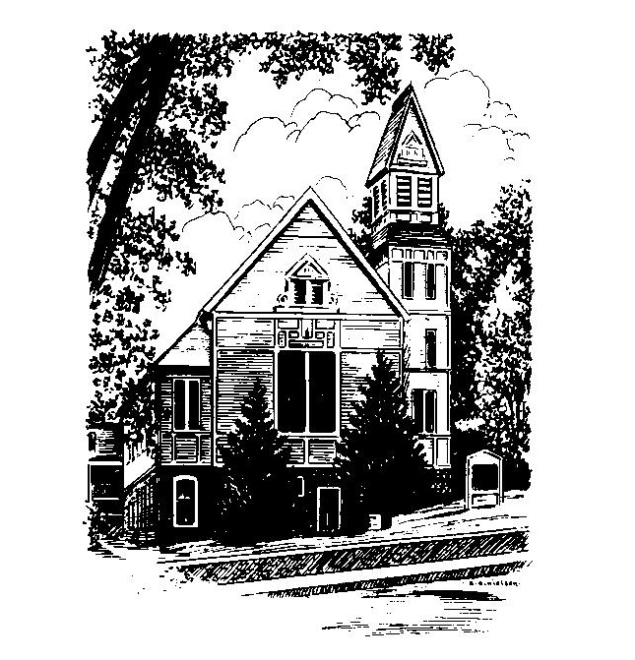
To Contact Us:
Church Office: 978-939-8821
Church website: www.baldwinvillecongochurch.org
Organist: Michelle Salvanelli
Videographer: Jeff Salvanelli
Church Wi-Fi password: Memorial 1874

Deacon of the Month: Joanne Francis
Liturgist: Nowell Francis
Our current supply preacher is Rev. Mike Scott.
Today: Coffee and conversation downstairs
COMMUNION TODAY:
We take communion by intinction. We invite all who would share in Christ’s grace to come forward and take bread and dip it in the communion cup and eat with the blessing of Christ.
*denotes “All who are able please stand”. Masking is optional

Meditation Thought

"Advent" means "coming" of course, and the promise of Advent is that what is coming is an unimaginable invasion. The mythology of our age has to do with flying saucers and invasions from outer space, and that is unimaginable enough. But what is upon us now is even more so—a close encounter not of the third kind but of a different kind altogether. An invasion of holiness. That is what Advent is about.
- Frederick Buechner

(Originally published in The Clown in the Belfry)

MEMORIAL CONGREGATIONAL CHURCH U.C.C. BALDWINVILLE, MA.
An Open and Affirming Church of
the United Church of Christ
December 1, 2024
No Matter Who You Are, No Matter Where
You Are on Life’s Journey; You Are Welcome Here!

The Church Family Gathers
for the First Sunday of Advent

PRELUDE

WELCOME

CALL TO WORSHIP

Leader: Come to Bethlehem
and behold Divinity and humanity made one.
People: Let us quiet our hearts
and prepare for the advent of Christ.
Leader: Come, and be received just as you are.
People: We come to this time of worship
and prepare our hearts to be filled
with the spirit of Christmas.

*HYMN O Come, O Come, Emmanuel Red Hymnal #119

*Opening Prayer (unison)
Eternal Source of All Wisdom, our hearts yearn for the warmth of your love, and our minds search for the light of your word. Strengthen us to grow in love, that at the dawn of his coming we may rejoice in his presence and welcome the light of his truth. This we ask in Christ’s name. Amen.
LIGHTING THE FIRST CANDLE
ON THE ADVENT WREATH
Bettye McCrillis and family
CONGREGATIONAL RESPONSE
One Candle Is Lit (Verse 1 only) Red Hymnal #128

*SHARING THE PEACE OF CHRIST
One: May the peace of Christ be with you!
Many: And also with you!
--Please “Pass the Peace” however you feel comfortable
as we sing Amen!
*AMEN (Sung twice) Red Hymnal #317
Amen, Amen, Amen, Amen, Amen

OFFERING OURSELVES AND OUR GIFTS
CALL TO GIVING
As our offering is brought forward let us sing:
Praise God, from whom all blessings flow;
Praise God, all creatures here below;
Alleluia! Alleluia!
Praise God above, you heavenly host;
Praise Father, Son, and Holy Ghost.
Alleluia! Alleluia! Alleluia!
Alleluia! Alleluia!
PRAYER OF DEDICATION

FIRST SCRIPTURE Jeremiah 33:14-16
SPECIAL MUSIC
SECOND SCRIPTURE Romans 5:1-5
MESSAGE Poetry for Advent
“To mingle with the Universe” On Hope

*HYMN Lo, How a Rose E’er Blooming Red Hymnal #160

SHARING OUR PRAYERS, OUR JOYS, OUR HOPES

PASTORAL PRAYER
THE LORD’S PRAYER
Our father who art in heaven hallowed be thy name. Thy kingdom come thy will be done on earth as it is in heaven. Give us this day our daily bread and forgive us our trespasses as we forgive those who trespass against us. And lead us not into temptation but deliver us from evil. For thine is the kingdom and the power and the glory forever. Amen.
-Response (sung)
Hear our Prayer, O Lord, Hear our prayer O Lord.
Incline thine ear to us, and grant us thy peace. Amen

INVITATION TO THE TABLE
Everyone, of any age, who seeks Christ’s presence
is welcome at this table!.

WORDS OF INSTITUTION

DECLARATION:
Minister: And so, remembering what Christ has done for us,
we come to this table in thanksgiving and commitment,
affirming the ancient creed of our faith:
ALL: (Sung) Christ has died. Christ has Risen.
Christ will come again.

SHARING THE BREAD AND CUP

*HYMN: In the Bulb There Is a Flower Red Hymnal # 638

*BENEDICTION

POSTLUDE

