To Contact Us:
Church Office: 978-939-8821
Church website: www.baldwinvillecongochurch.org
Organist: Michelle Salvanelli
Videographer: Jeff Salvanelli
Church Wi-Fi password: Memorial 1874

Deacon of the Month: Barbara Woodbury
Liturgist: Jim Bevan
Our current pulpit supply preacher is Rev. Mike Scott.

Today:
We will be decorating the sanctuary for the Christmas season following worship today. Linda Bevan is providing salad rolls!

*denotes “All who are able please stand”. Masking is optional

Meditation Thought

Jesus said, "I am the way, and the truth, and the life; no one comes to the Father, but by me" (John 14:6). He didn't say that any particular ethic, doctrine, or religion was the way, the truth, and the life. He said that he was. He didn't say that it was by believing or doing anything in particular that you could "come to the Father." He said that it was only by him—by living, participating in, being caught up by the way of life that he embodied, that was his way.
Thus it is possible to be on Christ's way and with his mark upon you without ever having heard of Christ, and for that reason to be on your way to God though maybe you don't even believe in God.
A Christian is one who is on the way, though not necessarily very far along it, and who has at least some dim and half-baked idea of whom to thank.

-Frederick Buechner
(Originally published in Wishful Thinking and later in
Beyond Words)

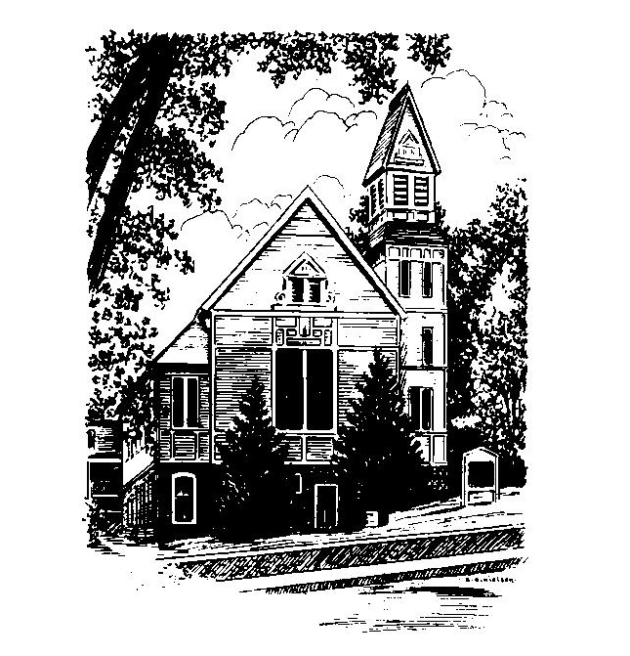
MEMORIAL CONGREGATIONAL
CHURCH
U.C.C. BALDWINVILLE, MA.
An Open and Affirming Church of
the United Church of Christ
November 24, 2024

No Matter Who You Are, No Matter Where
You Are on Life’s Journey; You Are Welcome Here!

PRELUDE

WELCOME

CALL TO WORSHIP

Leader: Let us gather together in thanksgiving for the
wonder of creation..
People: For the Lord has made us and this earth
which gives us nurture.
Leader: Let us gather together in gratitude to one another.
People: For we are the bearers of Divine blessing and
love.
Leader: Let us praise the Lord; let us join our voices in
song;
People: let us sing our thankfulness for the blessings of
life.

*HYMN Come, Ye Thankful People, Come
Red Hymnal #718

* OPENING PRAYER (UNISON)
We gather this day in thanksgiving, O Lord of Hosts, for the beauty and wonder of your creation, in earth and sky and sea, for all that is gracious in the lives of men and women, revealing the divine image you have placed within us, for our homes and families and friends, for minds to think, and hearts to love, and hands to serve, for health and strength to work, and leisure to rest and play, for the courageous souls among us who are patient in suffering and faithful in adversity, for all who join in seeking after truth, liberty and justice, we gather to lift our voices in praise.

*SHARING THE PEACE OF CHRIST
One: May the peace of Christ be with you!
Many: And also with you!
--Please “Pass the Peace” however you feel comfortable
as we sing Amen!
*AMEN (Sung twice) Red Hymnal #317

STEWARDSHIP MOMENT Nowell Francis

OFFERING OURSELVES AND OUR GIFTS

CALL TO GIVING
As our offering is brought forward let us sing:
Praise God, from whom all blessings flow;
Praise God, all creatures here below;
Alleluia! Alleluia!
Praise God above, you heavenly host;
Praise Father, Son, and Holy Ghost.
Alleluia! Alleluia! Alleluia!
Alleluia! Alleluia!

PRAYER OF DEDICATION

FIRST SCRIPTURE READING Psalm 100

SPECIAL MUSIC

GOSPEL READING Matthew 6:25-33

MESSAGE It Ain't Just a Big Dinner

*HYMN For the Fruit of All Creation Red Hymnal #714

SHARING OUR PRAYERS, OUR JOYS, OUR HOPES

PASTORAL PRAYER

THE LORD’S PRAYER

Our father who art in heaven hallowed be thy name. Thy kingdom come thy will be done on earth as it is in heaven. Give us this day our daily bread and forgive us our trespasses as we forgive those who trespass against us. And lead us not into temptation but deliver us from evil. For thine is the kingdom and the power and the glory forever. Amen.
-Response (singing)
Hear our Prayer, O Lord, Hear our prayer O Lord.
Incline thine ear to us, and grant us thy peace.
Amen

*HYMN: Now Thank We All Our God Red Hymnal #715

*BENEDICTION

POSTLUDE

