To Contact Us:
Church Office: 978-939-8821
Church website: www.baldwinvillecongochurch.org
Organist: Michelle Salvanelli
Videographer: Jeff Salvanelli
Church Wi-Fi password: Memorial 1874

Deacon of the Month: Barbara Woodbury
Liturgist: Barbara Woodbury
Our current pulpit supply preacher is Rev. Mike Scott.

Today:

Coffee and conversation downstairs. Everyone is invited.

*denotes “All who are able please stand”. Masking is optional

Meditation Thought

“In a sense we are all hungry and in need, but most of us don't recognize it. With plenty to eat in the deep freeze, with a roof over our heads and a car in the garage, we assume that the empty feeling inside must be just a case of the blues that can be cured by a Florida vacation, a new TV, an extra drink before supper.
“The poor, on the other hand, are under no such delusion. When Jesus says, "Come unto me all ye who labor and are heavy laden, and I will give you rest" (Matthew 11:28), the poor stand a better chance than most of knowing what he's talking about and knowing that he's talking to them. In desperation they may even be willing to consider the possibility of accepting his offer. This is perhaps why Jesus on several occasions called them peculiarly blessed.”

-Frederick Buechner
(Originally published in Wishful Thinking and later in
Beyond Words)

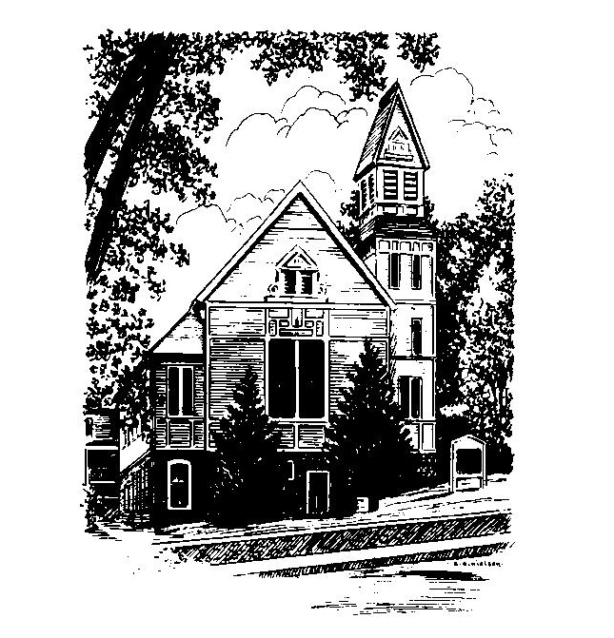
MEMORIAL CONGREGATIONAL
CHURCH
U.C.C. BALDWINVILLE, MA.
An Open and Affirming Church of
the United Church of Christ
November 17, 2024

No Matter Who You Are, No Matter Where
You Are on Life’s Journey; You Are Welcome Here!

PRELUDE

WELCOME

CALL TO WORSHIP

Leader: In the beauty of this hour of worship,
the Prince of Peace waits for us.
People: We bring our hopes and fears,
and set them before the throne of grace.
Leader: In the majesty of worship, the Spirit
challenges us.
People: We come to praise the Lord,
knowing that our praise will lead us to
places we have not known.
We come in comfort and affliction.
We come ready to be revived,
and ready to be remade.
We come to worship.

*HYMN How Beautiful, Our Spacious Skies
Black Hymnal #594

* OPENING PRAYER (UNISON)

We come before you this morning, O Lord, to offer prayers for our country, for our community, and for our church. We pray for the men and women of government and for all among us who have participated in their contest for leadership. We pray that divisions of party and ideology will not rend the precious fabric of our community. And we pray that our church would continue to stand as a witness for the gospel and a beacon of hope for all your children. Bless the prayers we offer by empowering them with your Spirit. Amen.

*SHARING THE PEACE OF CHRIST

One: May the peace of Christ be with you!
Many: And also with you!
--Please “Pass the Peace” however you feel comfortable
as we sing Amen!
*AMEN (Sung twice) Red Hymnal #317

OFFERING OURSELVES AND OUR GIFTS

CALL TO GIVING

As our offering is brought forward let us sing:
Praise God, from whom all blessings flow;
Praise God, all creatures here below;
Alleluia! Alleluia!
Praise God above, you heavenly host;
Praise Father, Son, and Holy Ghost.
Alleluia! Alleluia! Alleluia!
Alleluia! Alleluia!

PRAYER OF DEDICATION

FIRST SCRIPTURE READING 1 Samuel 2:1-10

SPECIAL MUSIC

GOSPEL READING Matthew 5:1-12

MESSAGE The Be-Attitudes

*HYMN From the Crush of Wealth and Power
Black Hymnal #552

SHARING OUR PRAYERS, OUR JOYS, OUR HOPES

PASTORAL PRAYER

THE LORD’S PRAYER

Our father who art in heaven hallowed be thy name. Thy kingdom come thy will be done on earth as it is in heaven. Give us this day our daily bread and forgive us our trespasses as we forgive those who trespass against us. And lead us not into temptation but deliver us from evil. For thine is the kingdom and the power and the glory forever. Amen.
-Response (singing)
Hear our Prayer, O Lord, Hear our prayer O Lord.
Incline thine ear to us, and grant us thy peace.
Amen

*HYMN: Come, Let Us Join with Faithful Souls
Black Hymnal #383
*BENEDICTION

POSTLUDE

