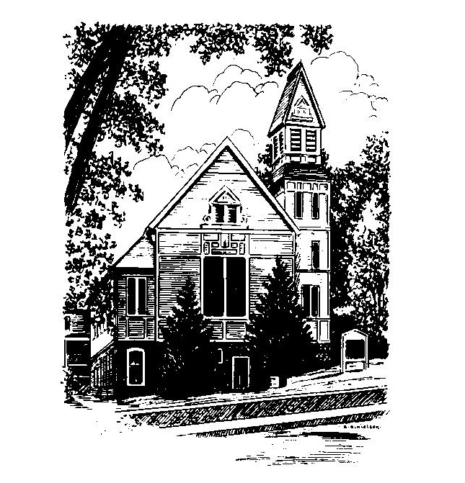
To Contact Us:
Church Office: 978-939-8821
Church website: www.baldwinvillecongochurch.org
Organist: Michelle Salvanelli
Videographer: Jeff Salvanelli
Church Wi-Fi password: Memorial 1874

Deacon of the Month: Barbara Woodbury
Liturgist: Barbara Woodbury
Our current pulpit supply preacher is Rev. Mike Scott.
Today: Coffee and conversation downstairs.

*denotes “All who are able please stand”. Masking is optional

COMMUNION TODAY -We take communion by intinction. We invite all who would share in Christ’s grace to come forward and take bread and dip it in the communion cup and eat with the blessing of Christ.

Meditation Thought

[Naomi] was a strong-willed old party, and when Ruth said she wanted to go to Israel with her, she tried to talk her out of it. Even if by some gynecological fluke she managed to produce another son for Ruth to marry, she said, by the time he was old enough, Ruth would be ready for the geriatric ward. But Ruth had a mind of her own too, besides which they'd been through a lot together, what with one thing and another, and home to her was wherever Naomi was. "Where you go, I go, and where you live, I live," Ruth told her, "and if your God is Yahweh, then my God is Yahweh too" (Ruth 2:10-17). So Naomi gave in, and when the two of them pulled in to Bethlehem, Naomi's hometown, there was a brass band to meet them at the station.

-Frederick Buechner (Originally published in Peculiar Treasures and later in Beyond Words)
MEMORIAL CONGREGATIONAL CHURCH
U.C.C. BALDWINVILLE, MA.
An Open and Affirming Church of
the United Church of Christ
November 3, 2024
All Saints Sunday

No Matter Who You Are, No Matter Where
You Are on Life’s Journey; You Are Welcome Here!

PRELUDE

WELCOME

CALL TO WORSHIP
Leader: We come to this sanctuary surrounded by a great
cloud of witnesses.
People: We come to run with perseverance the race that
is set before us.
Leader: The Spirit calls on us to follow in the steps of our
forebears in the faith.
People: Today, we remember them and rededicate
ourselves to building up the church they loved, and
furthering the ministry they bequeathed to us.
Leader: Come, let us worship.
People: Let us sing praise to the Author of our past and
of our future!

*HYMN O How Glorious, Full of Wonder Black #558

*UNISON PRAYER OF INVOCATION
Gathered in your name, O Lord, we ask that you would bless our worship, that in this hour we would be inspired by tradition, comforted by the familiar, awakened by the extraordinary, and challenged by your unbridled Spirit. Draw us into your presence and show us your way, we pray, in Jesus’ name. Amen.
*SHARING THE PEACE OF CHRIST

One: May the peace of Christ be with you!
Many: And also with you!
--Please “Pass the Peace” however you feel comfortable
as we sing Amen!
*AMEN (Sung twice) Red Hymnal #317

OFFERING OURSELVES AND OUR GIFTS

CALL TO GIVING

As our offering is brought forward let us sing:
Praise God, from whom all blessings flow;
Praise God, all creatures here below;
Alleluia! Alleluia!
Praise God above, you heavenly host;
Praise Father, Son, and Holy Ghost.
Alleluia! Alleluia! Alleluia!
Alleluia! Alleluia!

PRAYER OF DEDICATION

FIRST SCRIPTURE READING Ruth 1:1-18

SPECIAL MUSIC

GOSPEL READING Mark 12:28-34

MESSAGE Entropy, the Internet,
and the Wisdom of Disobedient Love

*HYMN Bread of the World, in Mercy Broken
Black Hymnal #346

SHARING OUR PRAYERS, OUR JOYS, OUR HOPES

PASTORAL PRAYER

THE LORD’S PRAYER

Our father who art in heaven hallowed be thy name. Thy kingdom come thy will be done on earth as it is in heaven. Give us this day our daily bread and forgive us our trespasses as we forgive those who trespass against us. And lead us not into temptation but deliver us from evil. For thine is the kingdom and the power and the glory forever. Amen.
-Response (singing)
Hear our Prayer, O Lord, Hear our prayer O Lord.
Incline thine ear to us, and grant us thy peace.
Amen

INVITATION TO THE TABLE
Everyone, of any age, who seeks Christ’s presence
is welcome at this table!.

WORDS OF INSTITUTION

DECLARATION:
Minister: And so, remembering what Christ has done for us,
we come to this table in thanksgiving and commitment,
affirming the ancient creed of our faith:
ALL: (Singing) Christ has died. Christ has Risen.
Christ will come again.

SHARING THE BREAD AND CUP

*HYMN: Sent Forth by God’s Blessing Black Hymnal #76

*BENEDICTION

POSTLUDE

