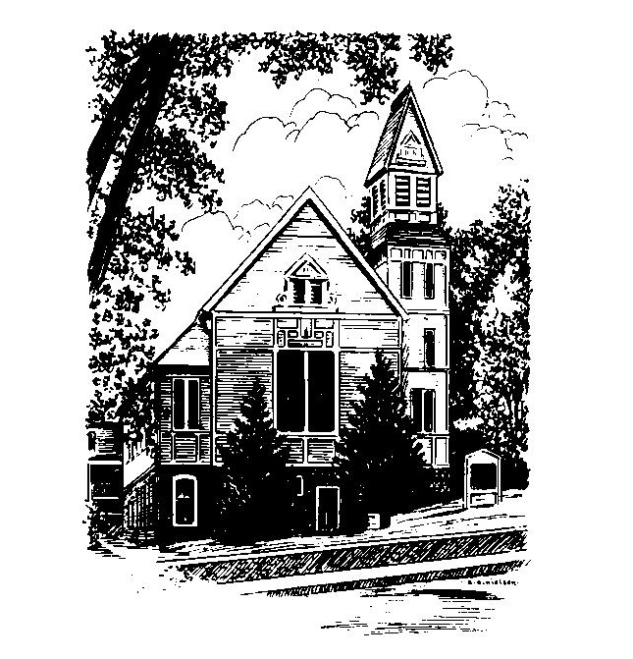
To Contact Us:
Church Office: 978-939-8821
Church website: www.baldwinvillecongochurch.org
Organist: Michelle Salvanelli
Videographer: Jeff Salvanelli
Church Wi-Fi password: Memorial 1874

Deacon of the Month: Nancy Heaney
Liturgist: Nancy Heaney
Our current pulpit supply preacher is Rev. Mike Scott.
Today:
Coffee and conversation downstairs.
Everyone is invited.

*denotes “All who are able please stand”. Masking is optional

Meditation Thought

Zaccheus . . . can stand for the whole cast of biblical characters who precede him. He's a sawed-off little social disaster with a big bank account and a crooked job, but Jesus welcomes him aboard anyway, and that's why he reminds you of all the others too.
Like Zaccheus, they're all of them peculiar as hell, to put it quite literally, and yet you can't help feeling that, like Zaccheus, they're all of them somehow treasured too. Why are they treasured? Who knows? But maybe you can say at least this about it—that they're treasured less for who they are and for what the world has made them than for what they have it in them at their best to be, because ultimately, of course, it's not the world that made them at all. "All the earth is mine!" says Yahweh, "and all that dwell therein," adds Psalm 24, and in the long run, presumably, that goes for you and me too.

-Frederick Buechner (Originally published in Peculiar Treasures and later in Beyond Words)

MEMORIAL CONGREGATIONAL CHURCH
U.C.C. BALDWINVILLE, MA.
An Open and Affirming Church of
the United Church of Christ

September 29, 2024

No Matter Who You Are, No Matter Where
You Are on Life’s Journey; You Are Welcome Here!

PRELUDE

WELCOME

CALL TO WORSHIP

Leader: May the Ground of All Being whose Word is
good news for us open our hearts
People: that we may listen and hear,
Leader: open our minds
People: that we may appreciate and understand how
blessed we are to join hands here and touch
holiness!

*HYMN For the Healing of the Nations
Red Hymnal #668

*UNISON PRAYER OF CONFESSION

Deliver us, we pray, from a lack of concern, from love of ease, from the need for power. Deliver us from too narrow a view, from too little to love, from intolerance to change. Deliver us from every kind of bondage, that we may find our freedom in you. Amen

*WORDS OF ASSURANCE

*SHARING THE PEACE OF CHRIST

One: May the peace of Christ be with you!
Many: And also with you!
--Please “Pass the Peace” however you feel comfortable
as we sing Amen!
*AMEN (Sung twice) Red Hymnal #317

OFFERING OURSELVES AND OUR GIFTS

CALL TO GIVING

As our offering is brought forward let us sing:
Praise God, from whom all blessings flow;
Praise God, all creatures here below;
Alleluia! Alleluia!
Praise God above, you heavenly host;
Praise Father, Son, and Holy Ghost.
Alleluia! Alleluia! Alleluia!
Alleluia! Alleluia!

PRAYER OF DEDICATION

FIRST SCRIPTURE READING
Numbers 11:4-6, 10-16, 24-29

SPECIAL MUSIC

GOSPEL READING Mark 9:38-50

MESSAGE Prophets All Mike Scott

*HYMN In Christ There Is No East or West
Red Hymnal #687

SHARING OUR PRAYERS, OUR JOYS, OUR HOPES

PASTORAL PRAYER

THE LORD’S PRAYER

Our father who art in heaven hallowed be thy name. Thy kingdom come thy will be done on earth as it is in heaven. Give us this day our daily bread and forgive us our trespasses as we forgive those who trespass against us. And lead us not into temptation but deliver us from evil. For thine is the kingdom and the power and the glory forever. Amen.
-Response (singing)
Hear our Prayer, O Lord, Hear our prayer O Lord.
Incline thine ear to us, and grant us thy peace.
Amen

*HYMN: Blest Be the Tie That Binds
Red Hymnal #433

*BENEDICTION

POSTLUDE

