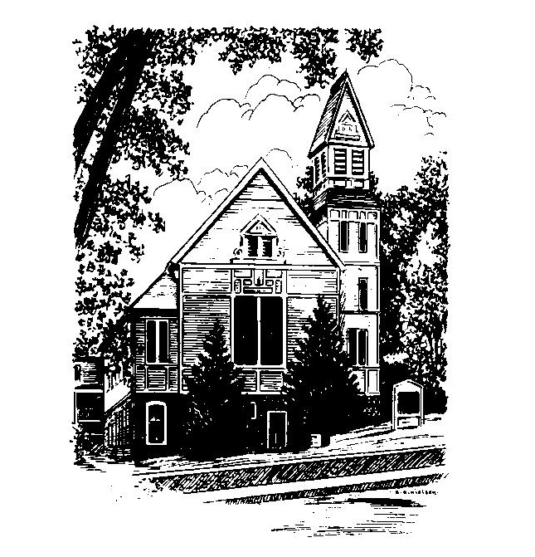
To Contact Us:
Church Office: 978-939-8821
Church website: www.baldwinvillecongochurch.org
Organist: Michelle Salvanelli
Videographer: Jeff Salvanelli
Church Wi-Fi password: Memorial 1874

Deacon of the Month: Nancy Heaney
Liturgist: Nancy Heaney
Our current pulpit supply preacher is Rev. Mike Scott.
Today:
Coffee and conversation downstairs.
Everyone is invited.

*denotes “All who are able please stand”. Masking is optional

Meditation Thought

The faith of a child taking your hand in the night is as moving as the faith of Mother Teresa among the untouchables, or Bernadette facing the skeptics at Lourdes, or Abraham, age seventy-five, packing up his bags for the Promised Land. And hope is the glimmer on the horizon that keeps faith plugging forward, of course, the wings that keep it more or less in the air.
Maybe it's only love that turns things around and makes the Seven Deadly Sins be the ones to look pale and unenterprising for a change. Greed, gluttony, lust, envy, pride are no more than sad efforts to fill the empty place where love belongs, and anger and sloth just two things that may happen when you find that not even all seven of them at their deadliest ever can.

-Frederick Buechner
(Originally published in Whistling in the Dark)

MEMORIAL CONGREGATIONAL CHURCH
U.C.C. BALDWINVILLE, MA.
An Open and Affirming Church of
the United Church of Christ

September 22, 2024

No Matter Who You Are, No Matter Where
You Are on Life’s Journey; You Are Welcome Here!

PRELUDE

WELCOME

CALL TO WORSHIP

Leader Let us sing the songs of our hearts!
People Songs of celebration, songs of joy!
Leader Gather all the melodies together into one great
harmony of praise. Let the music of our hearts
become part of the great song, pulsing through
all creation.
People Let us sing the songs of our hearts!

*HYMN Rejoice, You Pure in Heart
Black Hymnal #55

*UNISON PRAYER OF CONFESSION

We are reluctant, O Author of Love, to set aside our hurt, our anger, our disappointment. Heal us with your tender touch, that we might be remade. Open our eyes to the power of love, shown to us in the unselfish sacrifice of Christ our savior. Amen.

*SHARING THE PEACE OF CHRIST

One: May the peace of Christ be with you!
Many: And also with you!
--Please “Pass the Peace” however you feel comfortable
as we sing Amen!
*AMEN (Sung twice) Red Hymnal #317

OFFERING OURSELVES AND OUR GIFTS

CALL TO GIVING

As our offering is brought forward let us sing:
Praise God, from whom all blessings flow;
Praise God, all creatures here below;
Alleluia! Alleluia!
Praise God above, you heavenly host;
Praise Father, Son, and Holy Ghost.
Alleluia! Alleluia! Alleluia!
Alleluia! Alleluia!

PRAYER OF DEDICATION

FIRST SCRIPTURE READING Psalm 19

SPECIAL MUSIC

GOSPEL READING Mark 9:30-37

MESSAGE Making Your Mark Mike Scott

*HYMN Lord, I Want to Be a Christian
Black Hymnal #454

SHARING OUR PRAYERS, OUR JOYS, OUR HOPES

PASTORAL PRAYER

THE LORD’S PRAYER

Our father who art in heaven hallowed be thy name. Thy kingdom come thy will be done on earth as it is in heaven. Give us this day our daily bread and forgive us our trespasses as we forgive those who trespass against us. And lead us not into temptation but deliver us from evil. For thine is the kingdom and the power and the glory forever. Amen.
-Response (singing)
Hear our Prayer, O Lord, Hear our prayer O Lord.
Incline thine ear to us, and grant us thy peace.
Amen

*HYMN: This Little Light of Mine
Black Hymnal #524

*BENEDICTION

POSTLUDE

