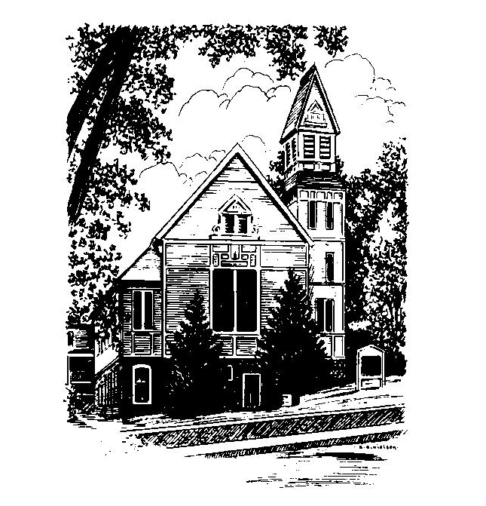
To Contact Us:
Church Office: 978-939-8821
Church website: www.baldwinvillecongochurch.org
Organist: Michelle Salvanelli
Videographer: Jeff Salvanelli
Church Wi-Fi password: Memorial 1874

Deacon of the Month: Nancy Heaney
Liturgist: Nancy Heaney
Our current pulpit supply preacher is Rev. Mike Scott.

Today:
Coffee and conversation downstairs.
Everyone is invited.

*denotes “All who are able please stand”. Masking is optional

Meditation Thought

Lamb of God, Rose of Sharon, Prince of Peace—none of the things people have found to call him has ever managed to say it quite right. You can see why when he told people to follow him, they often did, even if they backed out later when they started to catch on to what lay ahead. If you're religiously inclined, you can see why they went even so far as to call him Messiah, the Lord's Anointed, the Son of God, and call him these things still, some of them.

-Frederick Buechner
(Originally published in Peculiar Treasures and later in
Beyond Words)

MEMORIAL CONGREGATIONAL CHURCH U.C.C. BALDWINVILLE, MA.
An Open and Affirming Church of
the United Church of Christ

September 15, 2024

No Matter Who You Are, No Matter Where
You Are on Life’s Journey; You Are Welcome Here!

PRELUDE

WELCOME

CALL TO WORSHIP

Leader Jesus came to console the afflicted.
People Come, let us celebrate Christ our comforter!
Leader Jesus came to enlighten all people.
People Come, let us celebrate Christ our teacher!
Leader Jesus came to bind up the wounded.
People Come, let us celebrate Christ our healer!
Leader Jesus came to deliver the troubled.
People Come, let us celebrate Christ our Savior!

*HYMN All Hail the Power of Jesus’ Name
Red Hymnal #92

UNISON PRAYER OF CONFESSION

Merciful God, we admit the mistakes of our life which we cannot undo. Help us to accept their consequences without bitterness, and to see the opportunities you set before us and act upon them with joy. Through Jesus Christ, our Lord. Amen.

*SHARING THE PEACE OF CHRIST
One: May the peace of Christ be with you!
Many: And also with you!
--Please “Pass the Peace” however you feel comfortable
as we sing Amen!
*AMEN (Sung twice) Red Hymnal #317

OFFERING OURSELVES AND OUR GIFTS

CALL TO GIVING
As our offering is brought forward let us sing:
Praise God, from whom all blessings flow;
Praise God, all creatures here below;
Alleluia! Alleluia!
Praise God above, you heavenly host;
Praise Father, Son, and Holy Ghost.
Alleluia! Alleluia! Alleluia!
Alleluia! Alleluia!
PRAYER OF DEDICATION

FIRST SCRIPTURE READING John 3:14-21

SPECIAL MUSIC

SECOND SCRIPTURE READING Mark 8:27-38

MESSAGE Who Is Jesus, and Why Does It Matter?
Mike Scott

*HYMN Precious Lord, Take My Hand
Red Hymnal #628

SHARING OUR PRAYERS, OUR JOYS, OUR HOPES

PASTORAL PRAYER

THE LORD’S PRAYER

Our father who art in heaven hallowed be thy name. Thy kingdom come thy will be done on earth as it is in heaven. Give us this day our daily bread and forgive us our trespasses as we forgive those who trespass against us. And lead us not into temptation but deliver us from evil. For thine is the kingdom and the power and the glory forever. Amen.
-Response (singing)
Hear our Prayer, O Lord, Hear our prayer O Lord.
Incline thine ear to us, and grant us thy peace.
Amen

*HYMN: O Jesus, I Have Promised
Red Hymnal #612

*BENEDICTION

POSTLUDE

