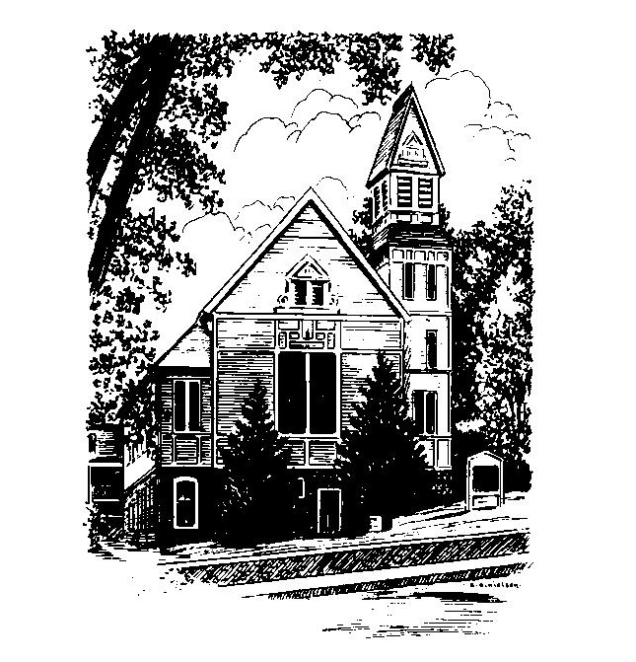
To Contact Us:
Church Office: 978-939-8821
Church website: www.baldwinvillecongochurch.org
Organist: Michelle Salvanelli
Videographer: Jeff Salvanelli
Church Wi-Fi password: Memorial 1874

Deacon of the Month: Nancy Heaney
Liturgist: Nancy Heaney
Our current supply preacher is Rev. Mike Scott.

Today:
Coffee and conversation at the tables. Everyone is invited.

*denotes “All who are able please stand”. Masking is optional

Meditation Thought

When somebody you've wronged forgives you, you're spared the dull and self-diminishing throb of a guilty conscience.

When you forgive somebody who has wronged you, you're spared the dismal corrosion of bitterness and wounded pride.

For both parties, forgiveness means the freedom again to be at peace inside their own skins and to be glad in each other's presence.

-Frederick Buechner
(Originally published in Wishful Thinking)

MEMORIAL CONGREGATIONAL CHURCH U.C.C. BALDWINVILLE, MA.
An Open and Affirming Church of
the United Church of Christ

September 8, 2024

No Matter Who You Are, No Matter Where
You Are on Life’s Journey; You Are Welcome Here!

PRELUDE

WELCOME

CALL TO WORSHIP

Leader: Let us offer praise for all the beauty of the earth.
People: Let us offer praise for constant reminders all
around us of grace woven into the fabric of
our world like a silver thread.
Leader: Let us offer praise for the majesty of creation.
People: We sing and celebrate the power of grace and
love in our lives! Let us worship together in
spirit and in truth.

*HYMN God of Grace and God of Glory
Red Hymnal #464

UNISON PRAYER OF INVOCATION

For earth we give you thanks, O Lord. For the turning seasons of the year we give you thanks. For meaning that is simple and sacred, for bonding of family and friendship and church, for possibility and hope and an unwritten future full of promise, we give you thanks. With thankful hearts, we turn to you in worship. Grant us, we pray, the grace to live fully into our days, and the presence of your Spirit of holiness to guide us on the way. Amen.

*SHARING THE PEACE OF CHRIST
One: May the peace of Christ be with you!
Many: And also with you!
--Please “Pass the Peace” however you feel comfortable
as we sing Amen!
*AMEN (Sung twice) Red Hymnal #317

OFFERING OURSELVES AND OUR GIFTS

CALL TO GIVING
As our offering is brought forward let us sing:
Praise God, from whom all blessings flow;
Praise God, all creatures here below;
Alleluia! Alleluia!
Praise God above, you heavenly host;
Praise Father, Son, and Holy Ghost.
Alleluia! Alleluia! Alleluia!
Alleluia! Alleluia!
PRAYER OF DEDICATION

FIRST SCRIPTURE READING James 2:1-17

SPECIAL MUSIC

GOSPEL READING Mark 7:24-37

MESSAGE The Law of Liberty Mike Scott

*HYMN O Breath of Life Red Hymnal #250

SHARING OUR PRAYERS, OUR JOYS, OUR HOPES

PASTORAL PRAYER

THE LORD’S PRAYER

Our father who art in heaven hallowed be thy name. Thy kingdom come thy will be done on earth as it is in heaven. Give us this day our daily bread and forgive us our trespasses as we forgive those who trespass against us. And lead us not into temptation but deliver us from evil. For thine is the kingdom and the power and the glory forever. Amen.
-Response (singing)
Hear our Prayer, O Lord, Hear our prayer O Lord.
Incline thine ear to us, and grant us thy peace.
Amen

*HYMN: Draw Us in the Spirit’s Tether
Red Hymnal #392

*BENEDICTION

POSTLUDE

