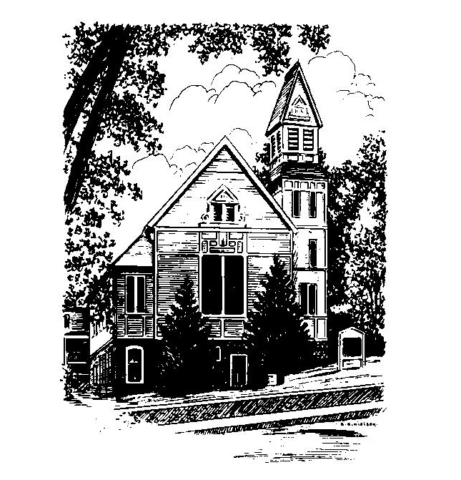
To Contact Us:
Church Office: 978-939-8821
Church website: www.baldwinvillecongochurch.org
Organist: Michelle Salvanelli
Videographer: Jeff Salvanelli
Church Wi-Fi password: Memorial 1874

Deacon of the Day: Nancy Heaney
Liturgist: Nancy Heaney
Our current supply preacher is Rev. Mike Scott.
Today: Coffee and conversation at the tables

COMMUNION TODAY -We take communion by intinction. We invite all who would share in Christ’s grace to come forward and take bread and dip it in the communion cup and eat with the blessing of Christ.

*denotes “All who are able please stand”. Masking is optional

Meditation Thought

There are mysteries you can solve by taking thought. For instance, a murder mystery whose mysteriousness must be dispelled in order for the truth to be known.

There are other mysteries that do not conceal a truth to think your way to, but whose truth is itself the mystery. The mystery of your self, for example. The more you try to fathom it, the more fathomless it is revealed to be. No matter how much of your self you are able to objectify and examine, the quintessential, living part of your self will always elude you, that is, the part that is conducting the examination. Thus you do not solve the mystery, you live the mystery. And you do that not by fully knowing yourself, but by fully being yourself.

-Frederick Buechner (Originally published in Wishful Thinking and later in Beyond Words).
MEMORIAL CONGREGATIONAL CHURCH U.C.C. BALDWINVILLE, MA.
An Open and Affirming Church of
the United Church of Christ
September 1, 2024
No Matter Who You Are, No Matter Where
You Are on Life’s Journey; You Are Welcome Here!

PRELUDE

WELCOME

CALL TO WORSHIP

Leader: Let us celebrate the gift of this good earth and all
that grows and runs upon it.
People: Thanks be to the Lord.
Leader: Let us celebrate the breath of life, spirits meant for
soaring, and music to stir our souls.
People: Thanks be to the Lord.
Leader: Let us celebrate this community of care and love.
People: Thanks be to the Lord.

*HYMN I Love Your Church, O God Red Hymnal #274

*UNISON PRAYER OF INVOCATION
Eternal Mother and Father of all Being, we gather as your people to worship you. By your Spirit break the bonds that hold our minds captive to the petty concerns of our lives that we may know the freedom of new possibilities. Quiet the din of our distracted spirits that we may hear your gentle voice calling us. Transform our very lives that we may go forth from this hour with deeper commitment to doing your will, with a firm assurance of your presence. Amen.

*SHARING THE PEACE OF CHRIST
One: May the peace of Christ be with you!
Many: And also with you!
--Please “Pass the Peace” however you feel comfortable
as we sing Amen!
*AMEN (Sung twice) Red Hymnal #317
Amen, Amen, Amen, Amen, Amen

OFFERING OURSELVES AND OUR GIFTS
CALL TO GIVING
As our offering is brought forward let us sing:
Praise God, from whom all blessings flow;
Praise God, all creatures here below;
Alleluia! Alleluia!
Praise God above, you heavenly host;
Praise Father, Son, and Holy Ghost.
Alleluia! Alleluia! Alleluia!
Alleluia! Alleluia!
PRAYER OF DEDICATION

FIRST SCRIPTURE James 1:17-27

SPECIAL MUSIC

GOSPEL READING Mark 7:1-8, 14-15, 21-23

MESSAGE Remembering Ourselves Mike Scott

*HYMN Take My Life Red Hymnal # 609

SHARING OUR CELEBRATIONS AND CONCERNS

PASTORAL PRAYER

THE LORD’S PRAYER
Our father who art in heaven hallowed be thy name. Thy kingdom come thy will be done on earth as it is in heaven. Give us this day our daily bread and forgive us our trespasses as we forgive those who trespass against us. And lead us not into temptation but deliver us from evil. For thine is the kingdom and the power and the glory forever. Amen.
-Response (sung)
Hear our Prayer, O Lord, Hear our prayer O Lord.
Incline thine ear to us, and grant us thy peace. Amen

INVITATION TO THE TABLE
Everyone, of any age, who seeks Christ’s presence
is welcome at this table!.

WORDS OF INSTITUTION

DECLARATION:
Minister: And so, remembering what Christ has done for us,
we come to this table in thanksgiving and commitment,
affirming the ancient creed of our faith:
ALL: (Singing) Christ has died. Christ has Risen.
Christ will come again.

SHARING THE BREAD AND CUP

*HYMN I Would Be True Red Hymnal # 608

*BENEDICTION

POSTLUDE

