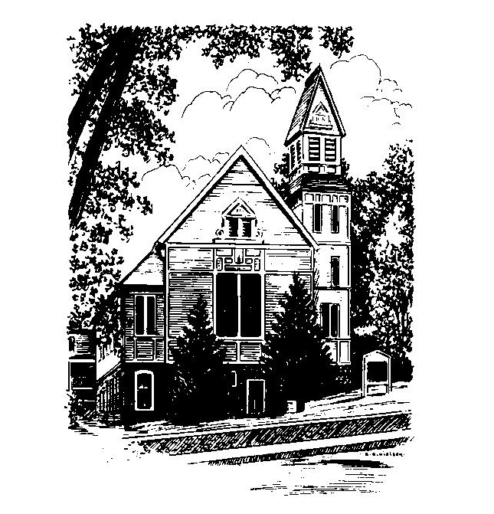
To Contact Us:
Church Office: 978-939-8821
Church website: www.baldwinvillecongochurch.org
Organist: Michelle Salvanelli
Videographer: Jeff Salvanelli
Church Wi-Fi password: Memorial 1874

Deacon of the Month: Joanne Francis
Liturgist: Joanne Francis
Our current supply preacher is Rev. Mike Scott.
Today:
Coffee and conversation at the tables. Everyone is invited.

*denotes “All who are able please stand”. Masking is optional

Meditation Thought

. . . for Jesus the only distinction between [people] that ultimately matters seems to be not whether they are churchgoers or non-churchgoers, communists or capitalists, Catholics or Protestants or Jews, but do they or do they not love - love not in the sense of an emotion so much as in the sense of an act of the will, the loving act of willing another's good even, if need arise, at the expense of their own. "Hell is the suffering of being unable to love," said old Father Zossima or, as John puts it in his first epistle, "He who does not love remains in death. . . . As you did it to one of the least of these my brethren, you did it to me. Just as Jesus appeared at his birth as a helpless child that the world was free to care for or destroy, so now he appears in his resurrection as the pauper, the prisoner, the stranger: appears in every form of human need that the world is free to serve or to ignore. -Frederick Buechner
(Originally published in The Faces of Jesus)

MEMORIAL CONGREGATIONAL CHURCH U.C.C. BALDWINVILLE, MA.
An Open and Affirming Church of
the United Church of Christ

August 25, 2024

No Matter Who You Are, No Matter Where
You Are on Life’s Journey; You Are Welcome Here!

PRELUDE

WELCOME

CALL TO WORSHIP

Leader: We have been called to walk in faithfulness
and choose the way of justice.
People: We are here because we believe strongly
that the Lord is good, and that we live in
that goodness.
We are here to proclaim our faith
and seek direction along this faith journey.
Leader: Come together, then, to be people of the Spirit.
Follow Christ and listen for the disclosure of
Divine grace. Rise up in praise and
thanksgiving!
People: We will share with others the goodness
that we have found in the Lord.
May our lives be an expression of that
goodness and love.
*HYMN O Worship the King Red Hymnal #17

*PRAYER OF ADORATION AND COMMITMENT

O Thou who is the Source of Life and Love, we are your children and you love us. So deep is your love that nothing we have done, or thought to do, can take away the peace you give. So strong is your love that no passing trouble can tear us from your arms. So precious is your love that all our life shall be lived in your service, and in sharing that love with your children everywhere. Amen.

*SHARING THE PEACE OF CHRIST
One: May the peace of Christ be with you!
Many: And also with you!
--Please “Pass the Peace” however you feel comfortable
as we sing Amen!
*AMEN (Sung twice) Red Hymnal #317

OFFERING OURSELVES AND OUR GIFTS

CALL TO GIVING
As our offering is brought forward let us sing:
Praise God, from whom all blessings flow;
Praise God, all creatures here below;
Alleluia! Alleluia!
Praise God above, you heavenly host;
Praise Father, Son, and Holy Ghost.
Alleluia! Alleluia! Alleluia!
Alleluia! Alleluia!
PRAYER OF DEDICATION

FIRST SCRIPTURE READING Joshua 24

SPECIAL MUSIC

SECOND SCRIPTURE READING Ephesians 6:10-20

MESSAGE "Serve the Lord" Mike Scott

*HYMN How Firm a Foundation
Red Hymnal #618

SHARING OUR PRAYERS, OUR JOYS, OUR HOPES

PASTORAL PRAYER

THE LORD’S PRAYER

Our father who art in heaven hallowed be thy name. Thy kingdom come thy will be done on earth as it is in heaven. Give us this day our daily bread and forgive us our trespasses as we forgive those who trespass against us. And lead us not into temptation but deliver us from evil. For thine is the kingdom and the power and the glory forever. Amen.
-Response (singing)
Hear our Prayer, O Lord, Hear our prayer O Lord.
Incline thine ear to us, and grant us thy peace.
Amen

*HYMN: Here I Am, Lord Red Hymnal #452

*BENEDICTION

POSTLUDE

