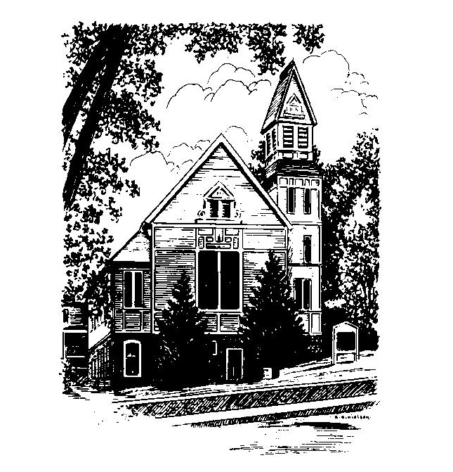
To Contact Us:
Church Office: 978-939-8821
Church website: www.baldwinvillecongochurch.org
Organist: Michelle Salvanelli
Videographer: Jeff Salvanelli
Church Wi-Fi password: Memorial 1874

Deacon of the Month: Joanne Francis
Liturgist: Joanne Francis
Our current supply preacher is Rev. Mike Scott.
Today:
Deacons meet following worship
Coffee and conversation at the tables. Everyone is invited.

*denotes “All who are able please stand”. Masking is optional

Meditation Thought

Whatever we do, to live is to do battle under many different flags, and of all our battles, there are two, I believe, that are major ones. . . . The first is a war of conquest. . . . But there is another war that we fight, of course, all of us . . . This other war is the war not to conquer but the war to become whole and at peace inside our skins. . . . This other war is the war to become a human being. This is the goal that we are really after and that God is really after. This is the goal that power, success, and security are only forlorn substitutes for. This is the victory that not all our human armory of self-confidence and wisdom and personality can win for us—not simply to be treated as human but to become at last truly human.”
-Frederick Buechner
(Originally published in The Magnificent Defeat)

MEMORIAL CONGREGATIONAL CHURCH U.C.C. BALDWINVILLE, MA.
An Open and Affirming Church of
the United Church of Christ

August 18, 2024

No Matter Who You Are, No Matter Where
You Are on Life’s Journey; You Are Welcome Here!

PRELUDE

WELCOME

CALL TO WORSHIP

Leader: Let us gather together in thanksgiving.
People: Let us give thanks to our Creator, and thanks for this earth which gives us nurture.
Leader: Let us encourage and support one another.
People: For we are all bearers of the Divine image,
and co-creators in the unfolding realm of peace and light. Let us praise the Lord; let us reach out in care and courage that all may share in the blessings of abundant life.

*HYMN Come, Thou Almighty King Red Hymnal #27

*UNISON PRAYER OF CONFESSION AND ASSURANCE

O Lord of Hosts, we your children have lived as if we did not need you, pretending that life is what we make it. We have often treated the world with indifference and our brothers and sisters with contempt. Awaken us by your Spirit to fuller dimensions of faith. Lead us to find in our neighbors the opportunities for love, in the social order the possibilities for justice, and in the affairs of nations the potential for peace. Reform our attitudes and behaviors until in every circumstance we may, by you grace, know your forgiving touch and be the instruments of your saving Word. Amen.

*SHARING THE PEACE OF CHRIST
One: May the peace of Christ be with you!
Many: And also with you!
--Please “Pass the Peace” however you feel comfortable
as we sing Amen!
*AMEN (Sung twice) Red Hymnal #317

OFFERING OURSELVES AND OUR GIFTS

CALL TO GIVING
As our offering is brought forward let us sing:
Praise God, from whom all blessings flow;
Praise God, all creatures here below;
Alleluia! Alleluia!
Praise God above, you heavenly host;
Praise Father, Son, and Holy Ghost.
Alleluia! Alleluia! Alleluia!
Alleluia! Alleluia!
PRAYER OF DEDICATION

SCRIPTURE READINGS Genesis 32:22-31
Job 13:3, 18-24

SPECIAL MUSIC

GOSPEL READING Mark 14:32-38

MESSAGE Wrestling Mike Scott

*HYMN "Are Ye Able," Said the Master
Red Hymnal #621

SHARING OUR PRAYERS, OUR JOYS, OUR HOPES

PASTORAL PRAYER

THE LORD’S PRAYER

Our father who art in heaven hallowed be thy name. Thy kingdom come thy will be done on earth as it is in heaven. Give us this day our daily bread and forgive us our trespasses as we forgive those who trespass against us. And lead us not into temptation but deliver us from evil. For thine is the kingdom and the power and the glory forever. Amen.
-Response (singing)
Hear our Prayer, O Lord, Hear our prayer O Lord.
Incline thine ear to us, and grant us thy peace.
Amen

*HYMN: Lift Every Voice and Sing Red Hymnal #631

*BENEDICTION

POSTLUDE

