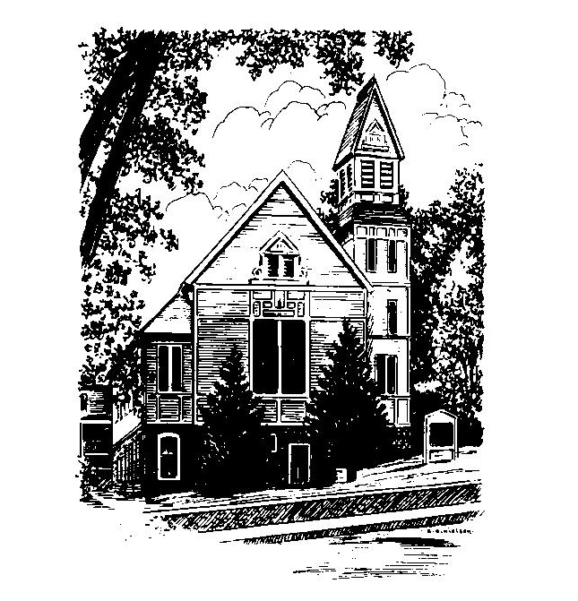
To Contact Us:
Church Office: 978-939-8821
Church website: www.baldwinvillecongochurch.org
Organist: Michelle Salvanelli
Videographer: Jeff Salvanelli
Church Wi-Fi password: Memorial 1874

Deacon of the Month: Joanne Francis
Liturgist: Joanne Francis
Our current supply preacher is Rev. Mike Scott.
Today:
Coffee and conversation at the tables. Everyone is invited.

*denotes “All who are able please stand”. Masking is optional

Meditation Thought

It wasn't because Ananias held back from the poor box some of the proceeds of his real-estate deal that Saint Peter came down on him so hard. The poor would get by somehow. They always had. What got the old saint's goat was that Ananias let on he was handing over his whole pile instead of only as much as he thought he wouldn't be needing himself.
"You do not lie to us but to God," Peter said (Acts 5:4), and the undeniable truth of the charge together with the unbearable shame of it were more than Ananias could take, so he dropped dead. His wife, Sapphira, had been in on the real-estate deal with him, and when she turned up three hours later and found out what had happened, she dropped dead too.
Lying to God is like sawing the branch you're sitting on. The better you do it, the sooner you fall.
-Frederick Buechner
-Originally published in Peculiar Treasures and later in Beyond Words

MEMORIAL CONGREGATIONAL CHURCH U.C.C. BALDWINVILLE, MA.
An Open and Affirming Church of
the United Church of Christ

August 11, 2024

No Matter Who You Are, No Matter Where
You Are on Life’s Journey; You Are Welcome Here!

PRELUDE

WELCOME

Call to Worship

Call to Worship
Leader: May the peace of the Lord rest upon our lives so that we may be quieted into prayer.
People: May the love of Christ flow through our worship words that they may be alive with opportunities for service.
Leader: May the grace of the Spirit seek out our every need and may the restless gospel set our hearts afire.
People: Amen.

*HYMN All Creatures of Our God and King
Red Hymnal #21

*UNISON PRAYER OF CONFESSION

Almighty and ever gracious Lord, we confess that we have failed to open our hearts to the power of your Spirit. We so often continue the divisions of Babel, speaking in tongues that confound rather than clarify, hurt rather than heal, separate rather than unite. We pray for the gift of fellowship that confirms your presence among us. Restore our fractured lives that we, with one voice, may give you thanks and praise. Amen

*WORDS OF ASSURANCE
The Lord of Life is present and active from generation to generation, always loving, always forgiving, always calling us to new life.

*SHARING THE PEACE OF CHRIST
One: May the peace of Christ be with you!
Many: And also with you!
--Please “Pass the Peace” however you feel comfortable
as we sing Amen!
*AMEN (Sung twice) Red Hymnal #317

OFFERING OURSELVES AND OUR GIFTS

CALL TO GIVING
As our offering is brought forward let us sing:
Praise God, from whom all blessings flow;
Praise God, all creatures here below;
Alleluia! Alleluia!
Praise God above, you heavenly host;
Praise Father, Son, and Holy Ghost.
Alleluia! Alleluia! Alleluia!
Alleluia! Alleluia!
PRAYER OF DEDICATION

FIRST SCRIPTURE READING Zechariah 8:16-17

SPECIAL MUSIC

SECOND SCRIPTURE READING Ephesians 4:25-32

MESSAGE “ Mostly, What We Need” Mike Scott

*HYMN To Us All, to Every Nation
Red Hymnal #634

SHARING OUR PRAYERS, OUR JOYS, OUR HOPES

PASTORAL PRAYER

THE LORD’S PRAYER

Our father who art in heaven hallowed be thy name. Thy kingdom come thy will be done on earth as it is in heaven. Give us this day our daily bread and forgive us our trespasses as we forgive those who trespass against us. And lead us not into temptation but deliver us from evil. For thine is the kingdom and the power and the glory forever. Amen.
-Response (singing)
Hear our Prayer, O Lord, Hear our prayer O Lord.
Incline thine ear to us, and grant us thy peace.
Amen

*HYMN: It Is Well with My Soul Red Hymnal #531

*BENEDICTION

POSTLUDE

