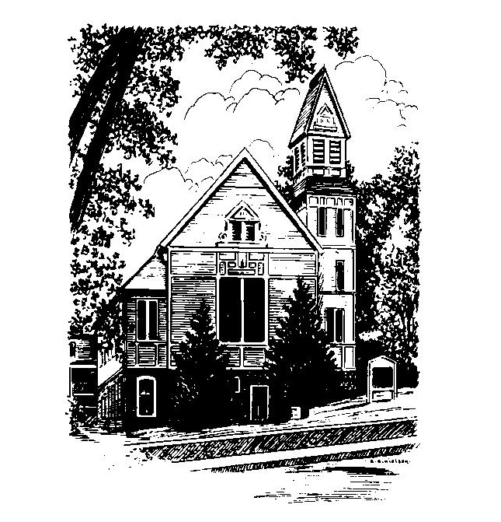
To Contact Us:
Church Office: 978-939-8821
Church website: www.baldwinvillecongochurch.org
Organist: Michelle Salvanelli
Videographer: Jeff Salvanelli
Church Wi-Fi password: Memorial 1874

Deacon of the Day: Nancy Heaney
Liturgist: Joanne Francis
Our current supply preacher is Rev. Mike Scott.
Today: Coffee and conversation at the tables

COMMUNION TODAY -We take communion by intinction. We invite all who would share in Christ’s grace to come forward and take bread and dip it in the communion cup and eat with the blessing of Christ.

*denotes “All who are able please stand”. Masking is optional

Meditation Thought

A good joke is one that catches you by surprise—like God's, for instance. Who would have guessed that Israel of all nations would be the one God picked or Sarah would have Isaac at the age of ninety or the Messiah would turn up in a manger? . . .
Satan's jokes, on the other hand, you can usually spot a mile off. As soon as the serpent came slithering up to Adam and Eve, almost anybody could tell that the laugh was going to be on them.
. . . In the last analysis, the only one who gets much of a kick out of Satan's jokes is Satan himself. With God's, however, even the most hardened cynics and bitterest pessimists have a hard time repressing an occasional smile. When God really gets going, even the morning stars burst into singing and all the sons of God shout for joy.

-Frederick Buechner (Originally published in Beyond Words)
MEMORIAL CONGREGATIONAL CHURCH U.C.C. BALDWINVILLE, MA.
An Open and Affirming Church of
the United Church of Christ
August 4, 2024
No Matter Who You Are, No Matter Where
You Are on Life’s Journey; You Are Welcome Here!

PRELUDE

WELCOME

CALL TO WORSHIP

Leader: This is the place and this is the time; here and now
the Spirit waits to break into our experience:
People: to change our minds, to change our lives,
to change our ways,
Leader: to make us see the world and the whole of life in a
new light,
People: to fill us with hope, joy, and confidence for the
future.
Leader: “Our hearts are ready, O Lord of Hosts.
Our hearts are ready.
People: Awake, my soul! Awake, O harp and lyre!
I will awake the dawn!”

*HYMN Alleluia! Hear God's Story Red Hymnal #330

*AFFIRMATION OF FAITH (Unison)
We profess that the Creator loved us before we were born and has high hopes for us. We celebrate the presence of the Spirit, and dare to claim the fullness of joy and the peace that passes all understanding. We have taken the name of Christ, and commit ourselves to follow in his way of justice and love and to seize the life that is life indeed.
*SHARING THE PEACE OF CHRIST
One: May the peace of Christ be with you!
Many: And also with you!
--Please “Pass the Peace” however you feel comfortable
as we sing Amen!
*AMEN (Sung twice) Red Hymnal #317
Amen, Amen, Amen, Amen, Amen

OFFERING OURSELVES AND OUR GIFTS
CALL TO GIVING
As our offering is brought forward let us sing:
Praise God, from whom all blessings flow;
Praise God, all creatures here below;
Alleluia! Alleluia!
Praise God above, you heavenly host;
Praise Father, Son, and Holy Ghost.
Alleluia! Alleluia! Alleluia!
Alleluia! Alleluia!
PRAYER OF DEDICATION

FIRST SCRIPTURE 2 Samuel 11:1-4a

SECOND SCRIPTURE Judges 6:4-10, 16-19, 21

THIRD SCRIPTURE Revelation 18:21- 19:4

MESSAGE Hallelujah Mike Scott

*HYMN Alleluia! Sing to Jesus Red Hymnal # 233

SHARING OUR CELEBRATIONS AND CONCERNS

PASTORAL PRAYER

THE LORD’S PRAYER
Our father who art in heaven hallowed be thy name. Thy kingdom come thy will be done on earth as it is in heaven. Give us this day our daily bread and forgive us our trespasses as we forgive those who trespass against us. And lead us not into temptation but deliver us from evil. For thine is the kingdom and the power and the glory forever. Amen.
-Response (sung)
Hear our Prayer, O Lord, Hear our prayer O Lord.
Incline thine ear to us, and grant us thy peace. Amen

INVITATION TO THE TABLE
Everyone, of any age, who seeks Christ’s presence
is welcome at this table!.

WORDS OF INSTITUTION

DECLARATION:
Minister: And so, remembering what Christ has done for us,
we come to this table in thanksgiving and commitment,
affirming the ancient creed of our faith:
ALL: (Singing) Christ has died. Christ has Risen.
Christ will come again.

SHARING THE BREAD AND CUP

*HYMN: O for a Thousand Tongues to Sing Red Hymnal # 5

*BENEDICTION

POSTLUDE

