WORSHIP LEADERS:
Rev. Michael Scott (Current supply preacher at:)
Memorial Congregational Church of Baldwinville
Rev. William Wright, Pastor
First Church, Templeton
Rev. Stephanie Flynn, Pastor
Congregational Church of Phillipston
Music: Michelle Salvanelli, MCC Baldwinville

Today:
Bring Your Own picnic: at the tables. Everyone is invited.

*denotes “All who are able please stand”. Masking is optional

Meditation Thought
-Frederick Buechner (From Secrets in the Dark)
(Commenting on Jesus’ words to Jairus’ dying daughter –“Little girl, get up!” -Mark 5:21-43)

Little girl. Old girl. Old boy. Old boys and girls with high blood pressure and arthritis, and young boys and girls with tattoos and body piercing. You who believe, and you who sometimes believe and sometimes don't believe much of anything, and you who would give almost anything to believe if only you could. You happy ones and you who can hardly remember what it was like once to be happy. You who know where you're going and how to get there and you who much of the time aren't sure you're getting anywhere. "Get up," he says, all of you - all of you! - and the power that is in him is the power to give life not just to the dead like the child, but to those who are only partly alive, which is to say to people like you and me who much of the time live with our lives closed to the wild beauty and miracle of things, including the wild beauty and miracle of every day we live and even of ourselves.

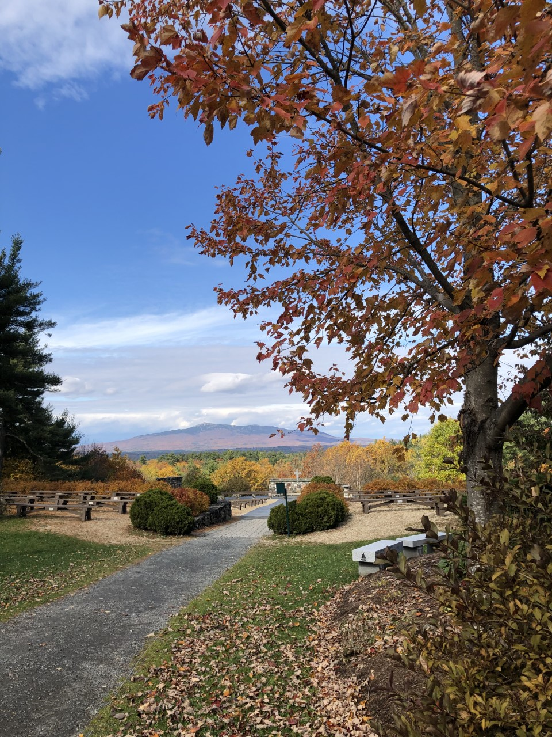
WORSHIPING TOGETHER AT
THE CATHEDRAL OF THE PINES

Memorial Congregational Church of Baldwinville
First Church UCC, Templeton
Congregational Church of Phillipston

July 28, 2024

PRELUDE

WELCOME Rev. Michael Scott

CALL TO WORSHIP Rev. William Wright

Leader: Sisters and brothers, we have come together to
worship the One who offers us freedom and grace.
People: For the Spirit has set us free to be the people
we are intended us to be.
Leader: Let our worship be a celebration of the joyful unity
we find in the power of the liberating Spirit.
People: Let us worship in spirit and in truth!

*HYMN God, Whose Giving Knows No Ending

*UNISON PRAYER OF INVOCATION

Creator and Sustainer of life, we rejoice in your love which renews us each day and calls us to share in abundant life. We are thankful for Jesus who revealed most fully your loving purpose for all people. We celebrate your Spirit of Holiness that draws all humanity into your circle of love. Make us open, we pray, to your presence in our lives and in our worship, that we might truly reflect your love in all we say and do. Amen.

*SHARING THE PEACE OF CHRIST
One: May the peace of Christ be with you!
Many: And also with you!
--Please “Pass the Peace” however you feel comfortable
as we sing Amen!
*AMEN (Sung twice)

OFFERING OURSELVES AND OUR GIFTS

CALL TO GIVING

As our offering is brought forward let us sing:
Praise God, from whom all blessings flow;
Praise God, all creatures here below;
Alleluia! Alleluia!
Praise God above, you heavenly host;
Praise Father, Son, and Holy Ghost.
Alleluia! Alleluia! Alleluia!
Alleluia! Alleluia!

PRAYER OF DEDICATION

FIRST SCRIPTURE READING Rev. Stephanie Flynn
2 Kings 4:42-44

SPECIAL MUSIC

GOSPEL READING John 6:1-21

MESSAGE “Give Your Lunch to Jesus” Mike Scott

*HYMN O for a World

SHARING OUR PRAYERS, OUR JOYS, OUR HOPES

PASTORAL PRAYER

THE LORD’S PRAYER

Our father who art in heaven hallowed be thy name. Thy kingdom come thy will be done on earth as it is in heaven. Give us this day our daily bread and forgive us our trespasses as we forgive those who trespass against us. And lead us not into temptation but deliver us from evil. For thine is the kingdom and the power and the glory forever. Amen.
-Response (singing)
Hear our Prayer, O Lord, Hear our prayer O Lord.
Incline thine ear to us, and grant us thy peace.
Amen

*HYMN: For the Fruit of All Creation

*BENEDICTION

POSTLUDE

