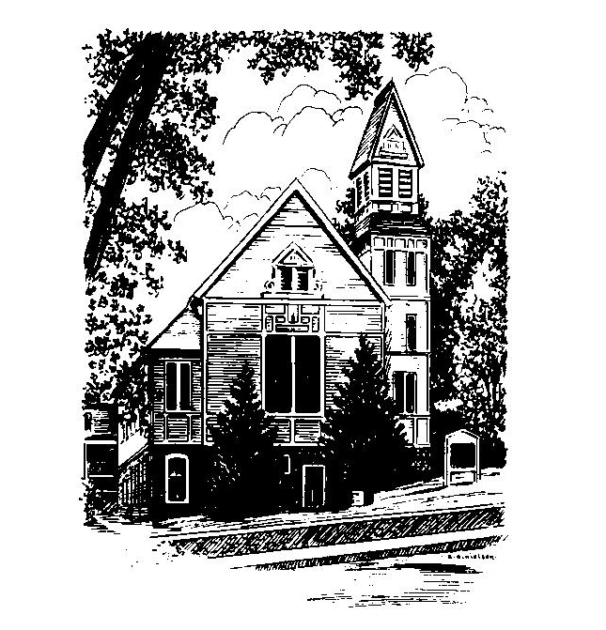
To Contact Us:
Church Office: 978-939-8821
Church website: www.baldwinvillecongochurch.org
Organist: Michelle Salvanelli
Videographer: Jeff Salvanelli
Church Wi-Fi password: Memorial 1874

Deacon of the Month: Barbara Woodbury
Liturgist: Sandy Skinner
Our current supply preacher is Rev. Mike Scott.
Today:
Coffee and conversation at the tables. Everyone is invited.

*denotes “All who are able please stand”. Masking is optional

Meditation Thought

The visible church is all the people who get together from time to time in God's name. Anybody can find out who they are by going to church to look.
The invisible church is all the people God uses for his hands and feet in this world. Nobody can find out who they are except God.
Think of them as two circles. The optimist says they are concentric. The cynic says they don't even touch. The realist says they occasionally overlap.
In a fit of high inspiration, the author of the book of Revelation states that there is no temple in the New Jerusalem, thus squelching once and for all the tedious quip that since heaven is an endless church service, anybody with two wits to rub together would prefer hell.
-Frederick Buechner
(Originally published in Wishful Thinking
and later in Beyond Words)

MEMORIAL CONGREGATIONAL CHURCH U.C.C. BALDWINVILLE, MA.
An Open and Affirming Church of
the United Church of Christ

July 21, 2024

No Matter Who You Are, No Matter Where
You Are on Life’s Journey; You Are Welcome Here!

PRELUDE

WELCOME

Call to Worship

Leader We come to this place seeking to know more
clearly the power of Divine Love;
People We come desiring to feel the Spirit stirring in
our lives;
Leader We come looking for enlightenment, for
wisdom, and for guidance;
People But more than anything, we come to
rededicate ourselves to the mission that has
been set before us!
Come, let us worship.

*HYMN Praise to the Lord, the Almighty
Red Hymnal #25

*Unison Prayer of Invocation

Eternal Spirit of Holiness, into the peace of your presence we bring our restless lives. Down through the ages men and women have sought you and found that your faithfulness has no end. Fill our imaginations with your beauty, we pray, our minds with your truth, and our hearts with your love. Refresh our faith, restore our confidence, and lay your guiding hand upon our lives. We ask this in the name of Jesus Christ, our companion and guide. Amen.

*SHARING THE PEACE OF CHRIST
One: May the peace of Christ be with you!
Many: And also with you!
--Please “Pass the Peace” however you feel comfortable
as we sing Amen!
*AMEN (Sung twice) Red Hymnal #317

OFFERING OURSELVES AND OUR GIFTS

CALL TO GIVING

As our offering is brought forward let us sing:
Praise God, from whom all blessings flow;
Praise God, all creatures here below;
Alleluia! Alleluia!
Praise God above, you heavenly host;
Praise Father, Son, and Holy Ghost.
Alleluia! Alleluia! Alleluia!
Alleluia! Alleluia!

PRAYER OF DEDICATION

FIRST SCRIPTURE READING Ephesians 2:11-22

SPECIAL MUSIC

GOSPEL READING Mark 6:30-34, 53-56

MESSAGE “Ally, Ally Outs in Free” Mike Scott

*HYMN When, in Awe of God's Creation
Red Hymnal #688

SHARING OUR PRAYERS, OUR JOYS, OUR HOPES

PASTORAL PRAYER

THE LORD’S PRAYER

Our father who art in heaven hallowed be thy name. Thy kingdom come thy will be done on earth as it is in heaven. Give us this day our daily bread and forgive us our trespasses as we forgive those who trespass against us. And lead us not into temptation but deliver us from evil. For thine is the kingdom and the power and the glory forever. Amen.
-Response (singing)
Hear our Prayer, O Lord, Hear our prayer O Lord.
Incline thine ear to us, and grant us thy peace.
Amen

*HYMN: Restless Weaver Red Hymnal #658

*BENEDICTION

POSTLUDE

