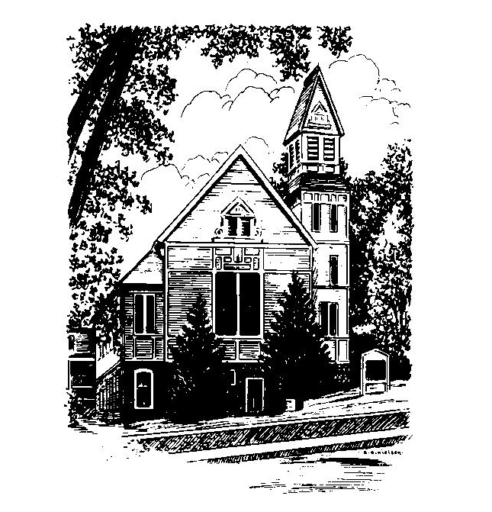
To Contact Us:
Church Office: 978-939-8821
Church website: www.baldwinvillecongochurch.org
Organist: Michelle Salvanelli
Videographer: Jeff Salvanelli
Church Wi-Fi password: Memorial 1874

Deacon of the Month: Barbara Woodbury
Liturgist: Barbara Woodbury
Our current supply preacher is Rev. Mike Scott.
Today:
Coffee and conversation at the tables. Everyone is invited.

*denotes “All who are able please stand”. Masking is optional

Meditation Thought

It is bats that are supposed to be found in belfries, but for a few incandescent moments in 1831 a man named Lyman Woodard was to be found in one that is still higher than any other building in Rupert, Vermont. The event is described in its proper place. Suffice it to say here only that one day he climbed up and stood on his head in that belfry. Why did he do it? Was he drunk? Was he crazy? Who knows? Who even cares? The point is that it was a gorgeous, clownish, inspired, and inspiring thing to do. It was a radically new way of looking at the mysteries of earth and heaven. It is Saint Paul writing, 'We are fools for Christ's sake.' It is David dancing naked before the ark. It is the rapturous shenanigans and holy abandon of faith kicking up its heels and considering the lilies of the field from an altogether different vantage.
-Frederick Buechner
(From The Clown in the Belfry: writings on faith and fiction)

MEMORIAL CONGREGATIONAL CHURCH U.C.C. BALDWINVILLE, MA.
An Open and Affirming Church of
the United Church of Christ

July 14, 2024

No Matter Who You Are, No Matter Where
You Are on Life’s Journey; You Are Welcome Here!

PRELUDE

WELCOME

CALL TO WORSHIP

Leader: Come, people of hope, and celebrate the journey of
faith. Bring a sense of expectancy and high hopes,
Bring an eye for promise and possibility, a vivid
imagination. For the work of creation is not done.
People: We are called to pioneer a future yet unnamed.
Leader: Let us join hands as sojourners,
led by the Author of our hopes and dreams.
People: May we be witnesses to the realm of light and
hope breaking in. Let us celebrate the journey of
faith, secure in the knowledge that we never
travel alone.

*HYMN Joyful, Joyful, We Adore Thee Red Hymnal #2

*OPENING PRAYER

O Lord of Life, we do not pretend to come before you with more faith than we really have. We do not come to make promises that are beyond our grasp. We do not come seeming to be more than we are. We come to offer ourselves to the great journey you set before us, trusting that you hold in your hands our faith, our promises, our lives. Amen.

*SHARING THE PEACE OF CHRIST
One: May the peace of Christ be with you!
Many: And also with you!
--Please “Pass the Peace” however you feel comfortable
as we sing Amen!
*AMEN (Sung twice) Red Hymnal #317

OFFERING OURSELVES AND OUR GIFTS

CALL TO GIVING

As our offering is brought forward let us sing:
Praise God, from whom all blessings flow;
Praise God, all creatures here below;
Alleluia! Alleluia!
Praise God above, you heavenly host;
Praise Father, Son, and Holy Ghost.
Alleluia! Alleluia! Alleluia!
Alleluia! Alleluia!

PRAYER OF DEDICATION

FIRST SCRIPTURE READING 2 Samuel 6:1-5, 12b-22

SPECIAL MUSIC

GOSPEL READING Mark 6:14-29

MESSAGE That’s What You Get for Dancing
Mike Scott

*HYMN Rejoice, the Lord Is King! Red Hymnal #699

SHARING OUR PRAYERS, OUR JOYS, OUR HOPES

PASTORAL PRAYER

THE LORD’S PRAYER

Our father who art in heaven hallowed be thy name. Thy kingdom come thy will be done on earth as it is in heaven. Give us this day our daily bread and forgive us our trespasses as we forgive those who trespass against us. And lead us not into temptation but deliver us from evil. For thine is the kingdom and the power and the glory forever. Amen.
-Response (singing)
Hear our Prayer, O Lord, Hear our prayer O Lord.
Incline thine ear to us, and grant us thy peace.
Amen

*HYMN: Rejoice You Pure in Heart Red Hymnal #15

*BENEDICTION

POSTLUDE

