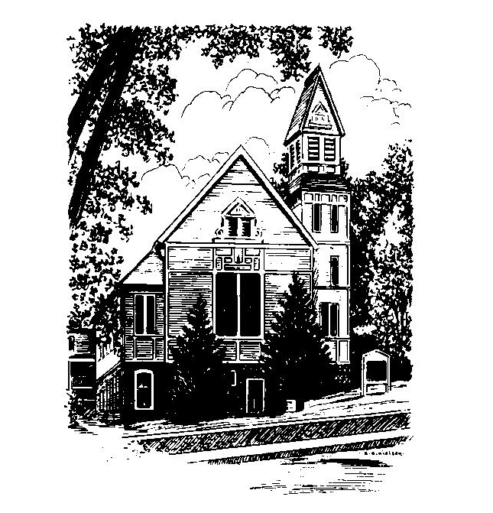
To Contact Us:
Church Office: 978-939-8821
Church website: www.baldwinvillecongochurch.org
Organist: Michelle Salvanelli
Videographer: Jeff Salvanelli
Church Wi-Fi password: Memorial 1874

Deacon of the Month: Nancy Heaney
Liturgist: Nancy Heaney

Our current supply preacher is Rev. Mike Scott.

Today:
Coffee and conversation at the tables. Everyone is invited.

*denotes “All who are able please stand”. Masking is optional

Meditation Thought

The biblical view of the history of humankind and of each individual man or woman is contained in the first three chapters of Genesis. We are created to serve God by loving God and each other in freedom and joy, but we invariably choose bondage and woe instead as prices not too high to pay for independence. To say that God drove Adam and Eve out of Eden is apparently a euphemism for saying that Adam and Eve, like the rest of us, made a break for it as soon as God happened to look the other way.
-Frederick Buechner

(Originally published in Wishful Thinking and later in Beyond Words)

MEMORIAL CONGREGATIONAL CHURCH U.C.C. BALDWINVILLE, MA.
An Open and Affirming Church of
the United Church of Christ

June 30, 2024

No Matter Who You Are, No Matter Where
You Are on Life’s Journey; You Are Welcome Here!

PRELUDE

WELCOME

CALL TO WORSHIP

Leader: We come this morning with hopes high and
imaginations intact.
People: We come ready to step boldly into the future.
Leader: Let us set aside every weight that hinders us and
journey together with grace and joy.
People: Let us come to worship in eagerness and
expectation.

*HYMN My Country, 'Tis of Thee Red Hymnal #721

*OPENING PRAYER

Lord of all times and all peoples, we come before you carrying our hopes and dreams, our plans and agendas. When we look at how ordered and predictable we try to make our lives and how unruly and capricious your Spirit of Holiness is, we are a little embarrassed. Open our eyes this day, and open our minds, that we might be receptive to the new thing you are about to do in our midst. Grant us, we pray, the grace of your creative spirit, that we might rejoice at your glorious surprises and become your own ambassadors of joy. Amen.

*SHARING THE PEACE OF CHRIST
One: May the peace of Christ be with you!
Many: And also with you!
--Please “Pass the Peace” however you feel comfortable
as we sing Amen!
*AMEN (Sung twice) Red Hymnal #317

OFFERING OURSELVES AND OUR GIFTS

CALL TO GIVING

As our offering is brought forward let us sing:
Praise God, from whom all blessings flow;
Praise God, all creatures here below;
Alleluia! Alleluia!
Praise God above, you heavenly host;
Praise Father, Son, and Holy Ghost.
Alleluia! Alleluia! Alleluia!
Alleluia! Alleluia!

PRAYER OF DEDICATION

FIRST SCRIPTURE READING 2 Samuel 1:1, 17-27

SPECIAL MUSIC

SECOND SCRIPTURE READING 2 Corinthians 8:7-15

MESSAGE Free Indeed Mike Scott

*HYMN For the Healing of the Nations
Red Hymnal #668

SHARING OUR PRAYERS, OUR JOYS, OUR HOPES

PASTORAL PRAYER

THE LORD’S PRAYER

Our father who art in heaven hallowed be thy name. Thy kingdom come thy will be done on earth as it is in heaven. Give us this day our daily bread and forgive us our trespasses as we forgive those who trespass against us. And lead us not into temptation but deliver us from evil. For thine is the kingdom and the power and the glory forever. Amen.
-Response (singing)
Hear our Prayer, O Lord, Hear our prayer O Lord.
Incline thine ear to us, and grant us thy peace.
Amen

*HYMN: Where Cross the Crowded Ways of Life
Red Hymnal #665

*BENEDICTION

POSTLUDE

