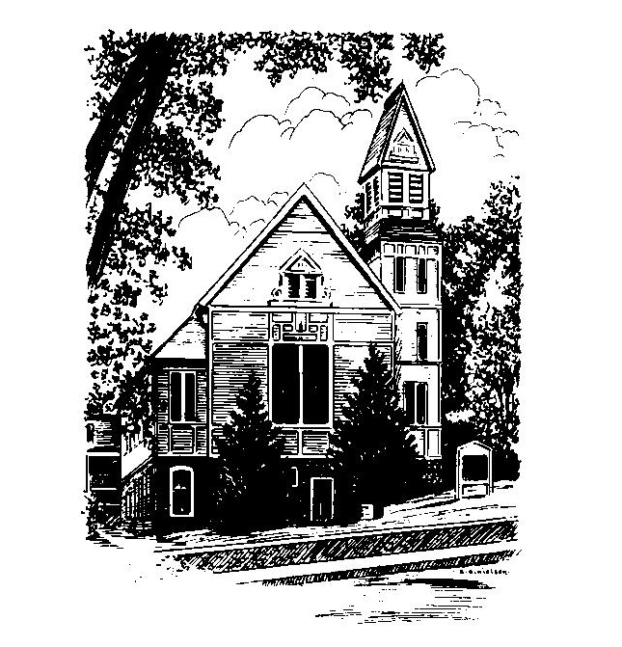
To Contact Us:
Church Office: 978-939-8821
Church website: www.baldwinvillecongochurch.org
Organist: Michelle Salvanelli
Videographer: Jeff Salvanelli
Church Wi-Fi password: Memorial 1874

Deacon of the Month: Nancy Heaney
Liturgist: Nancy Heaney
Our current supply preacher is Rev. Mike Scott.
Today:
Coffee and conversation at the tables. Everyone is invited.

*denotes “All who are able please stand”. Masking is optional

Meditation Thought

Mark ends his book, as he begins it, almost in the middle of a sentence. There was no time to gather up all the loose ends. The world itself was the loose ends, and all history would hardly be enough to gather them up in. . . . "for trembling and astonishment had come upon them, and they said nothing to anyone for they were afraid" (16:1-8). Later editors added a few extra verses to round things off, but that's where Mark ended it. In mid-air.
Mark's last word in his Gospel is afraid . . . Wonderful and terrible things were happening, and more were still to come. He knew what fear was all about—the scalp cold, the mouth dry, the midnight knock at the door—but he also knew that fear was not the last thing. It was the next to the last thing. The last thing was hope. "You will see him, as he told you," the young man in white said (16:7). If that was true, there was nothing else that mattered. So Mark stopped there.
-Frederick Buechner (originally published in Peculiar Treasures and later in Beyond Words)

MEMORIAL CONGREGATIONAL CHURCH U.C.C. BALDWINVILLE, MA.
An Open and Affirming Church of
the United Church of Christ

June 23, 2024

No Matter Who You Are, No Matter Where
You Are on Life’s Journey; You Are Welcome Here!

PRELUDE

WELCOME

CALL TO WORSHIP

Leader: We come this morning to celebrate the gift of
love, the bond that unites people
and leads them to commit deeply to one another.
People: We celebrate the gift of love.
Leader: We come this morning to celebrate diversity,
the differing backgrounds, experiences, passions
that make our community rich and vibrant.
People: We celebrate the gift of diversity.
Leader: We come this morning to celebrate the gift of the
Spirit, the burning fire and shifting wind of divine
intentions.
People: We celebrate the gift of the spirit.
Leader: We come as a diverse community,
committed to the rule of love,
and seeking the leadership of the Spirit.
People: Come, let us worship.

*HYMN Forward Through the Ages Black Hymnal #377

*OPENING PRAYER

O Lord of love and justice, we confess today that we have often denied your saving presence in our lives. Come to us in the fire of your love and set our minds on the things of the Spirit, that we may bear the Spirit’s fruit in love and joy and peace, and that we may truly become one through Jesus Christ, our Lord. Amen.

*SHARING THE PEACE OF CHRIST
One: May the peace of Christ be with you!
Many: And also with you!
--Please “Pass the Peace” however you feel comfortable
as we sing Amen!
*AMEN (Sung twice) Red Hymnal #317

OFFERING OURSELVES AND OUR GIFTS

CALL TO GIVING

As our offering is brought forward let us sing:
Praise God, from whom all blessings flow;
Praise God, all creatures here below;
Alleluia! Alleluia!
Praise God above, you heavenly host;
Praise Father, Son, and Holy Ghost.
Alleluia! Alleluia! Alleluia!
Alleluia! Alleluia!

PRAYER OF DEDICATION

FIRST SCRIPTURE READING Psalm 107:1-3, 23-32

SPECIAL MUSIC

GOSPEL READING Mark 4:35-41

MESSAGE On Faith and Fear Mike Scott

*HYMN The Storm Is Strong (Insert)

SHARING OUR PRAYERS, OUR JOYS, OUR HOPES

PASTORAL PRAYER

THE LORD’S PRAYER

Our father who art in heaven hallowed be thy name. Thy kingdom come thy will be done on earth as it is in heaven. Give us this day our daily bread and forgive us our trespasses as we forgive those who trespass against us. And lead us not into temptation but deliver us from evil. For thine is the kingdom and the power and the glory forever. Amen.
-Response (singing)
Hear our Prayer, O Lord, Hear our prayer O Lord.
Incline thine ear to us, and grant us thy peace.
Amen

*HYMN: I’ve Got Peace Like a River Black Hymnal #478

*BENEDICTION

POSTLUDE

