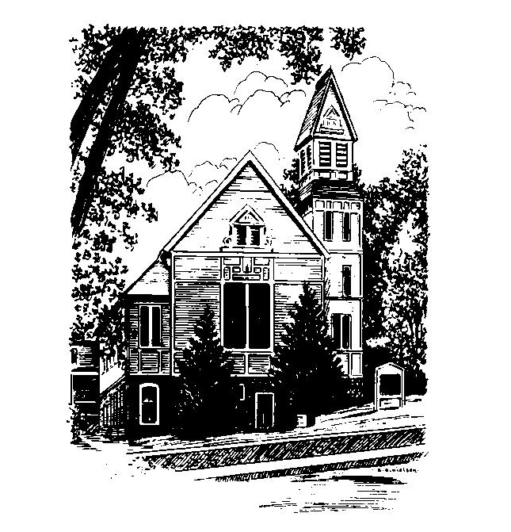
To Contact Us:
Church Office: 978-939-8821
Church website: www.baldwinvillecongochurch.org
Organist: Michelle Salvanelli
Videographer: Jeff Salvanelli
Church Wi-Fi password: Memorial 1874

Deacon of the Month: Nancy Heaney
Liturgist: Nancy Heaney
Our current supply preacher is Rev. Mike Scott.
Today:
Coffee and conversation at the tables. Everyone is invited.

*denotes “All who are able please stand”. Masking is optional

Meditation Thought

I am inclined to believe that God's chief purpose in giving us memory is to enable us to go back in time so that if we didn't play those roles right the first time round, we can still have another go at it now. We cannot undo our old mistakes or their consequences any more than we can erase old wounds that we have both suffered and inflicted, but through the power that memory gives us of thinking, feeling, imagining our way back through time we can at long last finally finish with the past in the sense of removing its power to hurt us and other people and to stunt our growth as human beings.
. . . It is through memory that we are able to reclaim much of our lives that we have long since written off by finding that in everything that has happened to us over the years God was offering us possibilities of new life and healing which, though we may have missed them at the time, we can still choose and be brought to life by and healed by all these years later.

-Frederick Buechner (Originally published in Telling Secrets)
MEMORIAL CONGREGATIONAL CHURCH U.C.C. BALDWINVILLE, MA.
An Open and Affirming Church of
the United Church of Christ

June 16, 2024

No Matter Who You Are, No Matter Where
You Are on Life’s Journey; You Are Welcome Here!

PRELUDE

WELCOME

CALL TO WORSHIP

Leader: We come to rejoice and celebrate the life
within us, and the presence of the Spirit.
People: In this time of worship the present is
infused with meaning, and the future comes
alive with hope.
Leader: We come to worship the One who is our
wisdom and our strength.
People: Let us praise the Lord of life,
the promise of joy and hope,
the Spirit of Love alive among us.

*HYMN Rejoice, You Pure in Heart Red Hymnal #15

*OPENING PRAYER

Bountiful Creator, who gathers your church and offers sustenance and support, fill us, we pray, with a profound awareness of your presence among us. Turn us from craving the things of this world to a hunger for that which satisfies the soul. As you have brought us to this place of peace and restoration, bring our minds clearly into focus, and fill our hearts with a desire to serve you, that our deeds may reflect our praise. Amen.

*SHARING THE PEACE OF CHRIST
One: May the peace of Christ be with you!
Many: And also with you!
--Please “Pass the Peace” however you feel comfortable
as we sing Amen!
*AMEN (Sung twice) Red Hymnal #317

OFFERING OURSELVES AND OUR GIFTS

CALL TO GIVING

As our offering is brought forward let us sing:
Praise God, from whom all blessings flow;
Praise God, all creatures here below;
Alleluia! Alleluia!
Praise God above, you heavenly host;
Praise Father, Son, and Holy Ghost.
Alleluia! Alleluia! Alleluia!
Alleluia! Alleluia!

PRAYER OF DEDICATION

FIRST SCRIPTURE READING 2 Corinthians 5:6-17

SPECIAL MUSIC

GOSPEL READING Mark 4:26-34

MESSAGE Fence Posts and Flowers Mike Scott

*HYMN Day By Day Red Hymnal #599
(Twice through)

SHARING OUR PRAYERS, OUR JOYS, OUR HOPES

PASTORAL PRAYER

THE LORD’S PRAYER

Our father who art in heaven hallowed be thy name. Thy kingdom come thy will be done on earth as it is in heaven. Give us this day our daily bread and forgive us our trespasses as we forgive those who trespass against us. And lead us not into temptation but deliver us from evil. For thine is the kingdom and the power and the glory forever. Amen.
-Response (singing)
Hear our Prayer, O Lord, Hear our prayer O Lord.
Incline thine ear to us, and grant us thy peace. Amen

*HYMN: Master, Let Me Walk with Thee
Red Hymnal #602

*BENEDICTION

POSTLUDE

