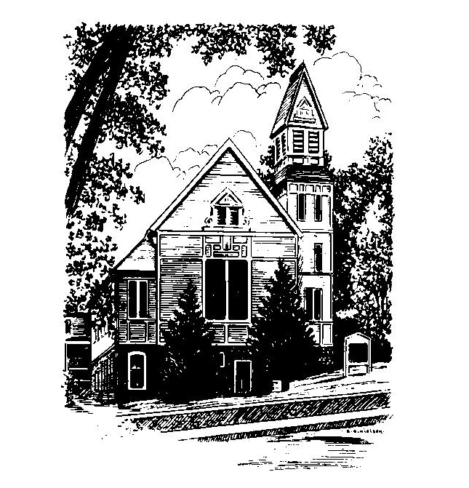
To Contact Us:
Church Office: 978-939-8821
Church website: www.baldwinvillecongochurch.org
Organist: Michelle Salvanelli
Videographer: Jeff Salvanelli
Church Wi-Fi password: Memorial 1874

Deacon of the Month: Nancy Heaney
Liturgist: Nancy Heaney
Our current supply preacher is Rev. Mike Scott.
Today:
Coffee and conversation at the tables. Everyone is invited.

*denotes “All who are able please stand”. Masking is optional

Meditation Thought

If you want to know what loving your neighbors is all about, look at them with more than just your eyes. The bag lady settling down for the night on the hot-air grating. The two children chirping like birds in the branches of a tree. The bride as she walks down the aisle on her father's arm. The old man staring into space in the nursing-home TV room. Try to know them for who they are inside their skins. Hear not just the words they speak, but the words they do not speak. Feel what it's like to be who they are. . .
When Jesus said, "All ye that labor and are heavy laden," he was seeing the rich as well as the poor, the lucky as well as the unlucky, the idle as well as the industrious. He was seeing the bride on her wedding day. He was seeing the old man in front of the TV. He was seeing all of us. The highest work of the imagination is to have eyes like that.
-Frederick Buechner
(Originally published in Whistling in the Dark and later in Beyond Words)
MEMORIAL CONGREGATIONAL CHURCH U.C.C. BALDWINVILLE, MA.
An Open and Affirming Church of
the United Church of Christ

June 9, 2024

No Matter Who You Are, No Matter Where
You Are on Life’s Journey; You Are Welcome Here!

PRELUDE

WELCOME

CALL TO WORSHIP

Leader: Come away in this hour from the tumult
of the world, that we may focus our minds on
things that are lasting.
People: We come to see our lives and our
world more clearly, and to reconnect to the
source of our strength and hope.
Leader: Let us emerge in this hour from the
isolation that so often fills our lives, and enter
into true community.
People: We come to share our journey with one
another, and to find together the
inspiration that lights our path.
Come, let us worship together!

*HYMN Spirit Red Hymnal #249

*OPENING PRAYER

Merciful Creator, we thank you for the example of Christ, and for the great love he revealed. We thank you that we can identify with him because of our shared experience of life. Open our eyes, our minds, and our hearts in this time of worship that we might see him more clearly, comprehend his love, and follow where he leads. Amen.

*SHARING THE PEACE OF CHRIST
One: May the peace of Christ be with you!
Many: And also with you!
--Please “Pass the Peace” however you feel comfortable
as we sing Amen!
*AMEN (Sung twice) Red Hymnal #317

OFFERING OURSELVES AND OUR GIFTS

CALL TO GIVING

As our offering is brought forward let us sing:
Praise God, from whom all blessings flow;
Praise God, all creatures here below;
Alleluia! Alleluia!
Praise God above, you heavenly host;
Praise Father, Son, and Holy Ghost.
Alleluia! Alleluia! Alleluia!
Alleluia! Alleluia!

PRAYER OF DEDICATION

FIRST SCRIPTURE READING 1 Samuel 8:4-20

SPECIAL MUSIC

GOSPEL READING Mark 3:20-35

MESSAGE On the Merits of Being Out of Your Mind
and The Curse of Theology
Mike Scott

*HYMN The Gift of Love Red Hymnal #526

SHARING OUR PRAYERS, OUR JOYS, OUR HOPES

PASTORAL PRAYER

THE LORD’S PRAYER

Our father who art in heaven hallowed be thy name. Thy kingdom come thy will be done on earth as it is in heaven. Give us this day our daily bread and forgive us our trespasses as we forgive those who trespass against us. And lead us not into temptation but deliver us from evil. For thine is the kingdom and the power and the glory forever. Amen.
-Response (singing)
Hear our Prayer, O Lord, Hear our prayer O Lord.
Incline thine ear to us, and grant us thy peace. Amen

*HYMN: Be Thou My Vision Red Hymnal #595

*BENEDICTION

POSTLUDE

