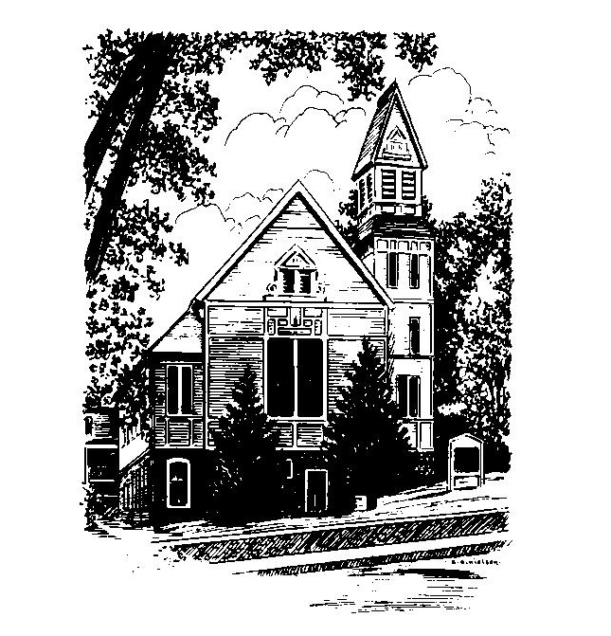
To Contact Us:
Church Office: 978-939-8821
Church website: www.baldwinvillecongochurch.org
Organist: Michelle Salvanelli
Videographer: Jeff Salvanelli
Church Wi-Fi password: Memorial 1874

Deacon of the Day: Joanne Francis
Liturgist: Joanne Francis
Our current supply preacher is Rev. Mike Scott.
Today: Coffee and conversation downstairs
COMMUNION TODAY -We take communion by intinction. We invite all who would share in Christ’s grace to come forward and take bread and dip it in the communion cup and eat with the blessing of Christ.
*denotes “All who are able please stand”. Masking is optional

Meditation Thought

We need to be reminded that at its heart Christianity is joy and that laughter and freedom and the reaching out of arms are the essence of it. We need to be reminded too that joy is not the same as happiness. . . Joy is where the whole being is pointed in one direction, and it is something that by its nature a man never hoards but always wants to share. . . joy is a mystery because it can happen anywhere, anytime, even under the most unpromising circumstances, even in the midst of suffering, with tears in its eyes. Even nailed to a tree.
What Jesus is saying is that men are made for joy and that anyone who is truly joyous has a right to say that he is doing God's will on this earth. Where you have known joy, you have known him.
- Frederick Buechner
(Originally published in The Hungering Dark)
MEMORIAL CONGREGATIONAL CHURCH U.C.C. BALDWINVILLE, MA.
An Open and Affirming Church of
the United Church of Christ
June 2, 2024
No Matter Who You Are, No Matter Where
You Are on Life’s Journey; You Are Welcome Here!

PRELUDE

WELCOME

CALL TO WORSHIP

Leader: Come now to share in the bread and cup of life,
and to worship in spirit and in truth.
People: Let us be open to the Spirit of Holiness filling
our hearts and binding us together in love.
Leader: May we seek and find in this time of worship some
glimmer of truth, and may that truth set us free.
People: Let our worship be filled with hope and promise!

*HYMN This Is the Day Red Hymnal #286

*OPENING PRAYER (Unison)
O thou who is the Ground of all Being, grant that we may hear your words in the everyday sacraments of our lives, and in the prayers and songs of this day. May simple things speak to us of your mercy, and tell us that life can be good and that your joy can anchor our souls. And may we be led to remember those whose lives are filled with aching every day. Challenge us in this hour, we pray, to live in gratitude, in love, and in service to your children: those who are near to us, and all throughout the world. Amen.
*SHARING THE PEACE OF CHRIST
One: May the peace of Christ be with you!
Many: And also with you!
--Please “Pass the Peace” however you feel comfortable
as we sing Amen!
*AMEN (Sung twice) Red Hymnal #317
Amen, Amen, Amen, Amen, Amen

OFFERING OURSELVES AND OUR GIFTS
CALL TO GIVING
As our offering is brought forward let us sing:
Praise God, from whom all blessings flow;
Praise God, all creatures here below;
Alleluia! Alleluia!
Praise God above, you heavenly host;
Praise Father, Son, and Holy Ghost.
Alleluia! Alleluia! Alleluia!
Alleluia! Alleluia!
PRAYER OF DEDICATION

FIRST SCRIPTURE Psalm 139:1-6, 13-18

SPECIAL MUSIC

GOSPEL READING John 15:9-12

MESSAGE Complete Joy Mike Scott

*HYMN Hymn to Joy (insert)

SHARING OUR CELEBRATIONS AND CONCERNS

PASTORAL PRAYER
THE LORD’S PRAYER
Our father who art in heaven hallowed be thy name. Thy kingdom come thy will be done on earth as it is in heaven. Give us this day our daily bread and forgive us our trespasses as we forgive those who trespass against us. And lead us not into temptation but deliver us from evil. For thine is the kingdom and the power and the glory forever. Amen.
-Response (sung)
Hear our Prayer, O Lord, Hear our prayer O Lord.
Incline thine ear to us, and grant us thy peace. Amen

INVITATION TO THE TABLE
Everyone, of any age, who seeks Christ’s presence
is welcome at this table!.

WORDS OF INSTITUTION

DECLARATION:
Minister: And so, remembering what Christ has done for us,
we come to this table in thanksgiving and commitment,
affirming the ancient creed of our faith:
ALL: (Singing) Christ has died. Christ has Risen.
Christ will come again.

SHARING THE BREAD AND CUP

*HYMN: Let Us Talents and Tongues Employ
Red Hymnal # 422

*BENEDICTION

POSTLUDE

