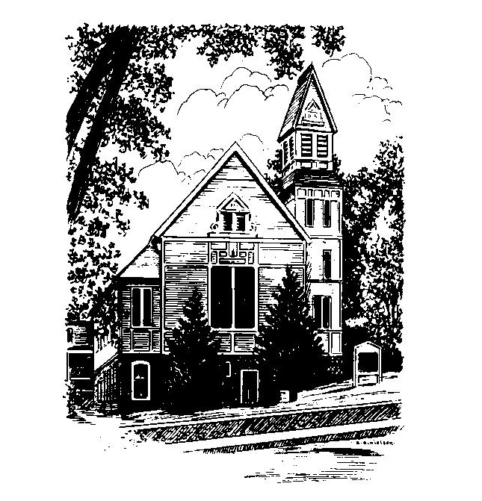
To Contact Us:
Church Office: 978-939-8821
Church website: www.baldwinvillecongochurch.org
Organist: Michelle Salvanelli
Videographer: Jeff Salvanelli
Church Wi-Fi password: Memorial 1874

Deacon of the Month: Lei Messer
Liturgist: Lei Messer
Our current supply preacher is Rev. Mike Scott.
Today: A brief time for Coffee and conversation. After that, we need some help. We will be meeting downstairs in the vestry for June, July, and August due to the heat. We need to set up this Sunday so we can start next Sunday, June 2nd. We need to move tables, set up chairs, and bring down hymnals. Any help is appreciated.

*denotes “All who are able please stand”. Masking is optional

Meditation Thought

Using the same old materials of earth, air, fire, and water, every twenty-four hours God creates something new out of them. If you think you're seeing the same show all over again seven times a week, you're crazy. Every morning you wake up to something that in all eternity never was before and never will be again. And the you that wakes up was never the same before and will never be the same again either.

-Frederick Buechner

-Originally published in Wishful Thinking and later in Beyond Words.

MEMORIAL CONGREGATIONAL CHURCH U.C.C. BALDWINVILLE, MA.
An Open and Affirming Church of
the United Church of Christ

May 26, 2024

No Matter Who You Are, No Matter Where
You Are on Life’s Journey; You Are Welcome Here!

PRELUDE

WELCOME

CALL TO WORSHIP

Leader: Let us be still before the mystery of life.

[Silence]

We come to celebrate the great gift of life,
and to peer into its depths for understanding.
People: We seek the spirit of the Lord
and the disclosure of Divine purposes.
Leader: With praise and thanksgiving
let us open our hearts and lives to the Spirit.
People: Come, let us worship.

*HYMN O Beautiful for Spacious Skies
Red Hymnal #720

*OPENING PRAYER

O Lord, you have placed in this “garden of Eden” that we call earth, and yet we so often find ourselves wandering in the desert. You have given us the “Light of the World,” and yet we are so often found stumbling in the dark. Renew within our hearts this day your covenant with us that we might know and feel in the depths of our being the liberating power of your Good News, and that we might be one in your shalom. Together, we affirm and celebrate that in your abounding grace we are all made free. Amen.

*SHARING THE PEACE OF CHRIST
One: May the peace of Christ be with you!
Many: And also with you!
--Please “Pass the Peace” however you feel comfortable
as we sing Amen!
*AMEN (Sung twice) Red Hymnal #317

OFFERING OURSELVES AND OUR GIFTS

CALL TO GIVING

As our offering is brought forward let us sing:
Praise God, from whom all blessings flow;
Praise God, all creatures here below;
Alleluia! Alleluia!
Praise God above, you heavenly host;
Praise Father, Son, and Holy Ghost.
Alleluia! Alleluia! Alleluia!
Alleluia! Alleluia!

PRAYER OF DEDICATION

FIRST SCRIPTURE READING Isaiah 6:1-8

SPECIAL MUSIC

GOSPEL READING John 3:1-17

MESSAGE Baby Steps Mike Scott

*HYMN Dear Lord and Father of Mankind
Red Hymnal #594

SHARING OUR PRAYERS, OUR JOYS, OUR HOPES

PASTORAL PRAYER

THE LORD’S PRAYER

Our father who art in heaven hallowed be thy name. Thy kingdom come thy will be done on earth as it is in heaven. Give us this day our daily bread and forgive us our trespasses as we forgive those who trespass against us. And lead us not into temptation but deliver us from evil. For thine is the kingdom and the power and the glory forever. Amen.
-Response (singing)
Hear our Prayer, O Lord, Hear our prayer O Lord.
Incline thine ear to us, and grant us thy peace. Amen

*HYMN: Rise Up, O Saints of God Red Hymnal #611

*BENEDICTION

POSTLUDE

