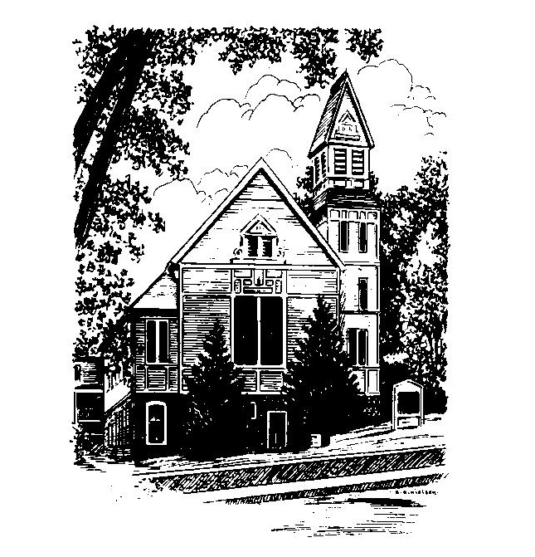
To Contact Us:
Church Office: 978-939-8821
Church website: www.baldwinvillecongochurch.org
Organist: Michelle Salvanelli
Videographer: Jeff Salvanelli
Church Wi-Fi password: Memorial 1874

Deacon of the Month: Lei Messer
Liturgist: Lei Messer
Our current supply preacher is Rev. Mike Scott.
Today: Coffee and conversation downstairs after worship.

*denotes “All who are able please stand”. Masking is optional

Meditation Thought
(Frederick Buechner commenting on the story of
the Good Samaritan)

“Is the point of Jesus' stories that they point to the truth about you and me and our stories? We are the ones who have been mugged, and we are also the ones who pass by pretending we don't notice. Hard as it is to believe, maybe every once in a while we are even the ones who pay an arm and a leg to help. The truth of the story is not a motto suitable for framing. It is a truth that one way or another, God help us, we live out every day of our lives. It is a truth as complicated and sad as you and I ourselves are complicated and sad, and as joyous and as simple as we are too. The stories that Jesus tells are about us. Once upon a time is our time, in other words. .”
― Originally published in Telling Secrets

MEMORIAL CONGREGATIONAL CHURCH U.C.C. BALDWINVILLE, MA.
An Open and Affirming Church of
the United Church of Christ

May 19, 2024

No Matter Who You Are, No Matter Where
You Are on Life’s Journey; You Are Welcome Here!

Pentecost Sunday

PRELUDE

WELCOME

CALL TO WORSHIP

Leader: Kindling Spirit, build well the fire in our
hearts this day.
People: Fan us to flame that all will see the
divine gift of love blazing in our midst.
Leader: May our tongues give witness to the
power of your grace.
People: May our hearts and our fellowship be
on fire with the power of devotion and
the joy of service.
Leader: Kindling Spirit, build well the fire in our
hearts this day.

*HYMN Sweet, Sweet Spirit Red Hymnal #261
*PENTECOST AFFIRMATION

At Pentecost, the Church blazed into being with passion and spirit. That Spirit is with us, renewing our hearts, moving us to faith, leading us toward truth, standing with us in our need, and making our devotion rich and meaningful. The Spirit thrusts Christ’s people into proclamation and mission. We delight in the creative work of that Spirit among us. We celebrate one another as gifted members of a universal family. We exult in the fellowship that binds our hearts to one another and to all people.

*SHARING THE PEACE OF CHRIST
One: May the peace of Christ be with you!
Many: And also with you!
--Please “Pass the Peace” however you feel comfortable
as we sing Amen!
*AMEN (Sung twice) Red Hymnal #317

OFFERING OURSELVES AND OUR GIFTS

CALL TO GIVING

As our offering is brought forward let us sing:
Praise God, from whom all blessings flow;
Praise God, all creatures here below;
Alleluia! Alleluia!
Praise God above, you heavenly host;
Praise Father, Son, and Holy Ghost.
Alleluia! Alleluia! Alleluia!
Alleluia! Alleluia!

PRAYER OF DEDICATION
FIRST SCRIPTURE READING Ezekiel 37:1-14

SPECIAL MUSIC

THE STORY OF PENTECOST Acts 2:1-21

MESSAGE Is It True? Mike Scott

*HYMN O Breath of Life Red Hymnal #250

SHARING OUR PRAYERS, OUR JOYS, OUR HOPES

PASTORAL PRAYER

THE LORD’S PRAYER

Our father who art in heaven hallowed be thy name. Thy kingdom come thy will be done on earth as it is in heaven. Give us this day our daily bread and forgive us our trespasses as we forgive those who trespass against us. And lead us not into temptation but deliver us from evil. For thine is the kingdom and the power and the glory forever. Amen.
-Response (singing)
Hear our Prayer, O Lord, Hear our prayer O Lord.
Incline thine ear to us, and grant us thy peace. Amen

*HYMN: Breathe on Me, Breath of God
Red Hymnal #254

*BENEDICTION

POSTLUDE

